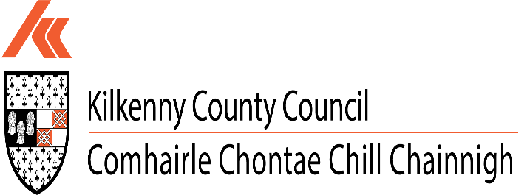
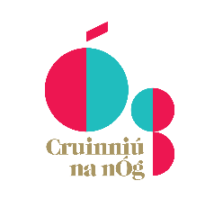
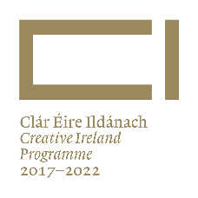

Kilkenny County Council
Creative Ireland & Cruinniú na nÓg
Grant Scheme 2022

Application Form & Guidance Notes

Closing Date: Mon 4th April 2022
Projects must be completed by Fri 14th October 2022

Completed applications, together with supporting documentation to: creativeireland@kilkennycoco.ie

Community & Culture Section, Kilkenny County Council
Telephone: 056-7794963 or Email: creativeireland@kilkennycoco.ie

Creative Ireland & Cruinniú na nÓg Grant Scheme 2022
Closing date 4th April 2022 at 5.00pm
Projects must be completed by Friday 14th October 2022

Purpose of the Scheme
The main purpose of the Kilkenny Creative Ireland Grant scheme is to provide financial support to local and community groups and individuals, artistic and creative practitioners, event organisers and those involved in creative, cultural and heritage activities and projects, in order to encourage cultural participation throughout Kilkenny, and support the delivery of the Creative Ireland Kilkenny Culture & Creativity Strategy 2018-2022. It supports the delivery of Pillar 2 of the national Creative Ireland Programme, i.e. “Enabling creativity in every community”.

This scheme also includes funding for projects which will deliver the Cruinniú na nÓg programme in Kilkenny. Cruinniú na nÓg (June 11th 2022) is the national day of free creative activity for children and young people up to 18 years of age, and is part of the national Creative Ireland Programme.

All initiatives and activities funded from this scheme must adhere to the public health guidance with regard to COVID-19, relevant at the time, as laid down by the HSE and the Government.

How will the decision on funding be made?
Grant applications will be assessed using the following criteria:
- The extent to which the proposed event/project is aligned to the Creative Ireland Programme/ Cruinniú na nÓg programme and the priorities of Kilkenny’s Culture and Creativity Strategy 2018-2022 programme. (20 marks)
- The scope of the project/event and the extent to which it maximises community/citizen engagement (including inclusivity and diversity in approach) (20 marks)
- The legacy potential of the proposed event/project in terms of ambition, innovation and the fostering of creativity (20 marks)
- The cost of the proposed event/project and its feasibility (20 marks)
Please note that there is no guarantee of funding for projects that nonetheless may have achieved the minimum criteria. The funding available is limited and eligible applications will be evaluated on a competitive basis.

What items and expenses are ineligible?
- Publications
- Spend on alcoholic beverages, fines, penalty payments, legal cost, audit fees, financial consultancy fees
- Any proposal where it is determined that the main beneficiary would be a private entity
- In general, the cost of items for resale are ineligible
- Projects that do not relate to the County’s Culture and/or the Creative Ireland Programme

Creative Ireland & Cruinniú na nÓg Grant Scheme 2022
Closing date 4th April 2022 at 5.00pm
Projects must be completed by Friday 14th October 2022

APPLICATION FORM

- APPLICANT DETAILS

Name of Applicant: ______________________________________________________

Organisation (if applicable) ________________________________________________

Name and Title of contact person (for payment purposes):

______________________________________________________________________

Tel: ______________________________ E-Mail_______________________________

Website: (if applicable) __________________________________________________

Social media: (if applicable) _______________________________________________

Address: ______________________________________________________________

______________________________________________________________________

______________________________________________________________________

2. Project Name and Type
Title of project
(the name that your project will be advertised by)
Type of Initiative
(e.g. Festival, talk, exhibition etc)
Genre
(film, archaeology, music etc)

3. Project Description
Please give a brief description of the project, addressing each of the following:
- An outline of your project/initiative.
- Demonstrate how it addresses Pillar 2 in the Creative Ireland Programme, or Cruinniú na nÓg, as appropriate.
- Demonstrate how it addresses the 5 Priorities and Key Principles outlined in Kilkenny’s Culture and Creativity Strategy 2018-2022 programme.

- Project Team, Audience and Outcomes
Who is facilitating the project?
Who will be involved in organising the project/event? (other team members, or partners)

Please provide details of your experience in delivering projects of this nature

Who are the target audience(s) for your project? (communities, children, families etc)

Estimated audience figures
(based on realistic estimates)
Describe the anticipated impact/outcome of the event for your community and audience:

- Promotion, Dates and Venue

How will you access participants/audiences?

How do participants get involved? (How do they sign up?)

Where can participants access online projects / events? (YouTube, Zoom etc.)

What equipment do participants need? (if any)

What links will you use for bookings/more info
(e.g http://)
How will the project be promoted? posters, radio, facebook, Instagram, twitter, newspaper, etc.
Start date
End date
Note: projects must be completed by & recouped by Friday 14th October 2022
Start & End Time (if appropriate)
Total running time (hrs/mins/ days as appropriate)
Venue (full address, including Eircode)

- FUNDING

What is the estimated overall cost of the event/project? € _______________

How much are you requesting from the Kilkenny Creative Ireland Grants Scheme? €________________
Grant amounts available under this scheme
- Creative Ireland Projects (€2,500 or €5,000)
- Cruinniú na nÓg Projects (max amount generally €5,000)

Are you applying for funding from any other sources? Yes _______  No__________

If YES, please give detail
Source: ______________________________ Amount: €____________

______________________________ Amount: € ____________

If NO, please indicate how you intend to fund the balance of your costs?

Source: ______________________________ Amount: €_____________

______________________________ Amount: € _____________

PROJECT COSTS
Please provide a detailed breakdown of costs. Where relevant, supply quotes or tenders if available. Please note that receipts (marked paid) are required on completion of the project.
Element of Work /Programme/ Item | Cost €
Total Estimated Cost €
INCOME Please provide a detailed breakdown of all income sources, if any:
ITEM (e.g. sponsorship, own resources, other funding sources) | ESTIMATED INCOME (€)
TOTAL ESTIMATED INCOME

- ACKNOWLEDGEMENT
Recognition must be given to Kilkenny County Council and Creative Ireland in all promotional material associated with the project/event. Relevant logos will be provided to projects which are awarded grants.
Please state how your organisation proposes to publicly acknowledge Kilkenny County Council’s Creative Ireland Community Event/Cruinniú na nÓg Grant Scheme contribution?
___________________________________________________________________________
___________________________________________________________________________
___________________________________________________________________________

- DISCLAIMER
Kilkenny County Council will not be liable in respect of any loss, damage or costs of any nature arising directly or indirectly from this application or the subject matter of the application. Kilkenny County Council, its servants or agents shall not at any time in any circumstances be held responsible or liable in relation to any matter whatsoever arising in connection with the development, planning, construction, operation, management and/or administration of individual projects.

I/we have read the above terms and conditions and I certify that the information supplied here is a true and fair representation of this organisation’s position.

Signed: -__________________________________ Date: ___________________________

- DATA PROTECTION
Kilkenny County Council collects some personal data during the application and processing of this grant scheme, particularly, names, addresses and contact details (emails and telephone numbers). These details are necessary for the consideration and adjudication on the grants scheme. The grant applications are sometimes shared between relevant County Council Departments for the purpose of supporting the application and also to ensure that similar events are not double funded, and in relation to other festival/events funded by the Council. At all stages the personal data is handled in full accordance with the Data Protection Legislation.
Your express consent is required, acknowledging that you understand that you may be submitting personal data. Please sign here by way of agreement.
Signed: ________________________________ Date: _____________________________

Please note if you intend to work with children and young people you must provide evidence of your child protection policy or the child protection policy of your partner organisation. Groups/organisations/self-employed individuals/artists must be tax compliant, have appropriate insurances in place and meet all Health & Safety requirements.

Advice Notes: MAKING YOUR APPLICATION

- Applications must comprise one PDF document only, which must be less than 10MB in size.
- All supporting material MUST be included in the PDF and attached to ONE email.
- On receipt of your application we will issue an acknowledgment of receipt.
- LATE AND INCOMPLETE APPLICATIONS (SECTIONS NOT COMPLETED/ALL RELEVANT SUPPORTING MATERIALS NOT ENCLOSED) WILL BE INELIGIBLE.
- If you do not adhere to the above requirements your application will not be accepted for adjudication

