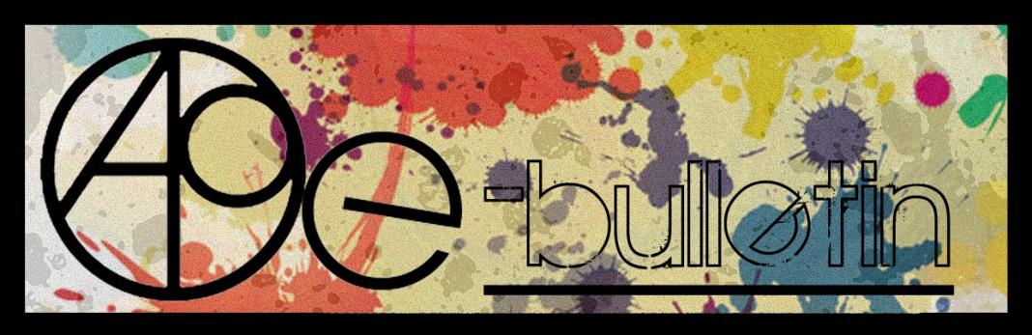

**Kilkenny County Council Arts Office E-bulletin 19th September 2014**

Dear All,   
  
Welcome to the fortnightly e-bulletin from Kilkenny County Council's Arts Office. Each bulletin is packed with the latest information on Kilkenny Arts Office activities, county events as well as news and opportunities for arts practitioners from around the country.

This service will be provided fortnightly. To include an item in the next e-bulletin please send a brief outline of your advert with relevant contact details, including any websites or pages with links to [**niamh.brophy@kilkennycoco.ie**](mailto:niamh.brophy@kilkennycoco.ie) **before 1st October**. The next e-bulletin will be on the **3rd October.**

While every effort has been made to ensure the accuracy of our information, we strongly advise readers to verify all details to their own satisfaction.

Regards,  
Niamh Brophy  
Arts Office,  
T: 056 7794138  
E: [niamh.brophy@kilkennycoco.ie](mailto:niamh.brophy@kilkennycoco.ie)   
W: [www.kilkennycoco.ie/eng/Services/Arts/](http://www.kilkennycoco.ie/eng/Services/Arts/)

BECOME PART OF IT, SUBMIT A POEM.....[www.rhymerag.net](http://kk-moss/Sites/arts_office/Shared%20Documents/Julianne%20Morgan/E-bulletin/30th%20May%20e-bulletin/www.rhymerag.net)  
Kilkenny County Council Arts Office Partner Local Authority of the ArtLinks Programme [www.artlinks.ie](http://www.artlinks.ie)

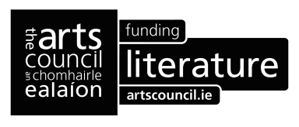

**Autumn 2014 Writers’ Workshop announced!**

**As part of our on-going commitment to Kilkenny writers, Kilkenny County Council Arts Office & Library Service would like to announce their adult Autumn 2014 Writers’ Workshop.**

**LAST CHANCE TO BOOK!!!!**

**Reading and Writing Poetry: Getting Started**

**Tutor:** **Derek Coyle**

**Commencing Tuesday 23rd September to Tuesday 2nd December (excluding mid-term)**

**Duration: 10 weeks**

**Venue: Graiguenamanagh Library, Kilkenny  
Time: 6pm - 8pm**

**Cost: €50**

This course will get you writing poems. Participants will start plenty of new work in the course of the ten weeks. In the workshops you will learn what to look at in a poem from a writer’s point of view. You will work on developing your skills as makers of poems by learning how to read and examine carefully the work of other makers. You will learn some new words and techniques so that you can become more confident readers, and thus writers, of poetry. Participants will learn about line-breaks, couplets and quatrains, dramatic monologues, metaphor and simile. Along the way you will look at a selection of poems by well-established poets from Ireland and abroad: Eamon Grennan, Harry Clifton, Derek Walcott, Constantinos Cavafy, John Montague, Dermot Healey, Seamus Heaney, Nuala Ni Dhomhnaill, Kerry Hardie, Thom Gunn, Mark Doty, and Mary Oliver, to name a few.

**Participants are expected to sign up and commit to the 10 weeks of their chosen course. There is a nominal fee of €50 to secure your place in the course. Places are limited to 12 participants per course so please book early to avoid disappointment.**

**To secure a place on the above courses please contact the Arts Office on 056 7794938/ or email** [niamh.brophy@kilkennycoco.ie](mailto:niamh.brophy@kilkennycoco.ie)

**\_\_\_\_\_\_\_\_\_\_\_\_\_\_\_\_\_\_\_\_\_\_\_\_\_\_\_\_\_\_\_\_\_\_\_\_\_\_\_\_\_\_\_\_\_\_\_\_\_\_\_\_\_\_\_\_\_\_\_\_\_\_\_\_\_\_\_\_\_\_\_\_\_\_\_\_\_\_\_\_\_\_\_\_\_\_\_**

**Rhyme Rag September published poem**

The Fire Dancer by Aoife Hughes is one of this month's published poems in Rhyme Rag.  
  
Rhyme Rag is now live. Be part of it and submit your poems to our new online poetry publication!  
  
Amazing poetry from young Kilkenny writers.   
  
<http://www.rhymerag.net/2014/09/the-fire-dancer/>

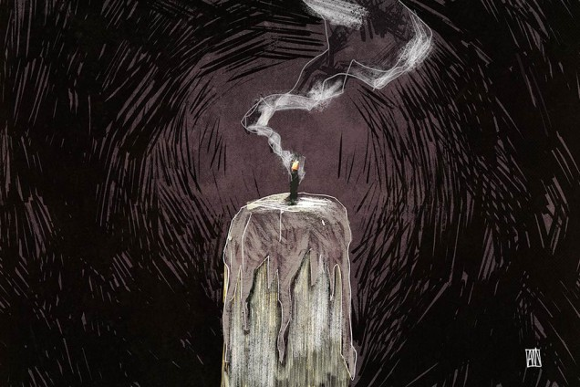

‘The Fire Dancer’

I dragged the match across the sandpaper coarse side of the box.  
Splintered sparks scattered outwards with a flare of life.  
An amber corona swaddled the match tip  
and the scent of sulfur coated my nose.  
I tipped the match gently against a ragged wick.  
The fire caught, throwing a white flame upwards. It waltzed in the wind.

Peering closer I saw the dancer hiding within the flickering light.  
She wore a dress of alabaster trimmed with golden lace.  
She danced to the wick’s faint crackling drums and the flutes of wind.  
She spun in the music, her shawl of light billowing around her.  
Her crimson hair fanned outwards whirling in the tempest of the fire’s song.

The glowing pearl cloth deepened to crimson, edged with ruby.  
The dancer donned a crown of copper light.  
She flung her arms outwards sending a swell of warmth over me.  
Fascinated I tipped my hand towards her flames.

She reached out with burning fingers and shook my outstretched hand.  
Her ember fingers grasped my curious arm and I yelped.  
On my palm burned her shining red greeting.

Hissing, I slammed a glass down around the candle.  
I watched as smoke trooped into the dance.  
He swirled and bowed to the flame dancer.  
She bowed back and left the wick’s pedestal.  
She left her dance behind her and slipped beneath the smoke’s grey cloak,  
leaving only a fading ember in her place.

### [Aoife Hughes](http://www.rhymerag.net/author/ahuges/)

Aoife Hughes is a seventeen-year-old student who attends Presentation Secondary, Loughboy. She is an avid reader and prolific writer, although most of her stories lounge under the bed gathering dust. One of her stories was recently broadcast on KCLR as a winning entry in the Wordplay short story competition. She dreams of pursuing a career as a writer in the future.

See more at <http://www.rhymerag.net/>

**ArtLinks announces new Training Programme for Artists in kilkenny**

Kilkenny Arts Office in association with ArtLinks is pleased to announce the reintroduction of its Training Programme for Artists which it launched earlier today. The programme is designed to meet the needs of artists living and working in the south east region and due to levels of funding available for the arts in recent years, had not formed part of the ArtLinks annual programme.

The programme will be delivered by industry experts for each session and will comprise programmes across the four partner counties of Carlow, Kilkenny, Waterford and Wexford. Training programmes which will be held this season include:

* Taxation for Artists
* Writing Successful Funding Applications
* Developing your Professional network
* Maximising your Online Presence
* Strategic Planning for your Artistic Business

Speaking earlier today Mary Butler, Arts Officer Kilkenny County Council stated.

*“Myself and my ArtLinks partner colleagues are really pleased to be in a position to reintroduce the ArtLinks Training Programme this Autumn. We have listened and responded to what artists on the ground are saying to us and have designed a programme which is suited specifically to their needs at the present time. In addition, ArtLinks is lending financial support to this programme to keep fees for programmes to a minimum. It is our intention to continue to develop this programme over the next number of years, funding permitting, and look forward to continuing to develop a programme which suits the needs of both professional and emerging artists in Kilkenny.”*

**Registration for the programme is essential as places for each training programme are limited.**

**Priority booking will be offered to ArtLinks members for a period of one week from Friday 12th September 2014.** Booking for non members will open onFriday 19th September.

**For further information on the programme or to place a registration log on to** [**www.artlinks.ie/traning**](http://www.artlinks.ie/traning)

ArtLinks is supported by the four Local County Councils of Arts Officers for Carlow, Kilkenny, Waterford and Wexford and the Arts Council / An Chomhairle Ealaíon.

# Programme

Training programmes to be run in Kilkenny this season are:

**Maximising Your Online Presence**

Trainer: Niall Flaherty

Date: Tuesday 30th September

Time: 10:00 - 17:00

Location: Council Chambers, Co. Hall, John St., Kilkenny

**Developing a Marketing Plan for your Artistic Business**

Trainer: Karan Thompson

Date: Thursday 6th November 2014

Time: 10:00 – 17:00

Location: Butler House, Kilkenny

Artists can also avail of other ArtLinks training programmes being run across the partner region. Further information on this programme is available at [www.artlinks.ie/training](http://www.artlinks.ie/training)

**Kilkenny Events**

**\_\_\_\_\_\_\_\_\_\_\_\_\_\_\_\_\_\_\_\_\_\_\_\_\_\_\_\_\_\_\_\_\_\_\_\_\_\_\_\_\_\_\_\_\_\_\_\_\_\_\_\_\_\_\_\_\_\_\_\_\_\_\_\_\_\_\_\_\_\_\_\_\_\_\_\_\_\_\_\_\_\_\_\_\_\_\_**

## Launch of Frank Marshall’s book ‘You’re Not Painting Between The Lines’

You’re Not Painting Between The Lines.

A Memoir of Sorts

by Frank Marshall

The title is a direct quotation from Frank’s four year old granddaughter when she admonished him as he laboured over one of her painting books.

In a series of short chapters ranging over the lives of his great grandparents who lived in Gooseberry Lane off Upper Patrick Street in Kilkenny in the early 1900’s. His grandfather Francis enlisted in the British Army in Kilkenny in 1892 serving until 1919 which included three periods in India and one in South Africa.

His maternal grandparents hailed from Fethard Co. Tipperary where his grandfather Paddy Kenrick worked as a Steward and driver for the owner of HI -1 a Ford Gladiator, the first registered car in South Tipperary in 1906.

In the words of the book’s Editor Brendan O Brien ‘Frank shines a light on some of the major events of his growing up in Clonmel, moving to Dublin and in the early days surviving the pitfalls of dances and romances. Enduring the tedium of life in the Civil Service in an office that was described ‘as a well run asylum,’ He describes campaigning on behalf of a jailed former classmate and visiting him in Swalside Prison accompanied by Billy Power of the Birmingham Six.

Visiting the USA frequently where his two sons lived he encountered some interesting characters spending a week almost snowbound on an American Indian Reservation outside Spokane in Washington State.

It is summed up by the Editor as ‘witty conversational, insightful, and recommended as an enjoyable read.

**The book will be launched in Laugton’s Set Theatre in John St. Kilkenny at 7.30 pm on Thursday 25th September by Andrew Small Artist and Teacher.**

**The 70th Anniversary of The Warsaw Uprising Exhibition**

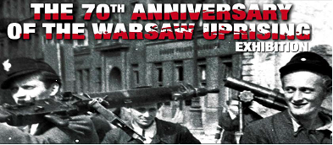

On

Thursday 11t September

 at 3pm in

City Library, John’s Quay

**Warsaw Uprising**

The Warsaw Uprising was a major World War 11 operation by the Polish Resistance Home Army to liberate Warsaw from Nazi Germany.  The Uprising was timed to coincide with the Soviet Union's Red Army approaching the eastern suburbs of the city and the retreat of German forces. However, the Soviet advance stopped short, enabling the Germans to regroup and demolish the city while defeating the Polish resistance, which fought for 63 days with little outside support. The Uprising was the largest single military effort taken by any European resistance movement during World War 11. It is estimated that about 16,000 members of the Polish resistance were killed and about 6,000 badly wounded. In addition, between 150,000 and 200,000 Polish civilians died. *Source:* *“Warsaw Uprising*." *Wikipedia, The Free Encyclopedia*, *24 Aug. 2014. Web. 2 Sep. 2014*.

## Young Irish Film Makers After School Workshops

## Inline image 1

## AFTER SCHOOL WORKSHOPS

## REGISTRATION DAY

Monday 22nd September (10:00am – 5:00pm)

YIFM Studios, St. Joseph's, Waterford Road, Kilkenny

T: 05677 64677

**COST:**€80 for 10 week term

**Classes Start:**

* Tuesday 24th September for Juniors
* Wednesday 25th September for Seniors

**TUESDAYS 4-6pm**

Juniors (9-12yrs)

**WEDS & FRI 4:30 – 6:30pm**

Seniors (13-18yrs)

## NEW TERM PROJECTS:

## Autumn Term – Drama production

## Spring – Film & Drama

## Summer – Open Door Policy – Personal & Group projects

## \*\*\*BIG NEWS\*\*\*

**NYCI YOUTH ARTS SHOWCASE:**

This year YIFM have been asked to bring 10 members of the cast and crew of the film ‘Still’ to Dublin to promote the work of YIFM.  YIFM candidates chosen to attend will speak to the Minister for Arts and other politicians about the importance of programmes such as Young Irish Film makers.

**TRIP TO INDIA:**

In April 2015, we are planning a trip to Calcutta, India with the senior group.  This trip is being planned in association with  [THE HOPE FOUNDATION](http://www.hopefoundation.ie/) as a film and photo documentary trip to promote the work of the foundation in helping street and slum children of Calcutta.  Provisionally booked for **April 2015 (dates to be confirmed)**, this unique trip will be a once in a lifetime experience for the young people involved.  **Spaces will be limited** and there will be a selection process put into place, so express your interest soon to make sure you are eligible to apply for a place.

**Kilkenny Choir welcomes new members**

Kilkenny Choir has just commenced rehearsals for their next concert which is in December. If you fancy joining, have a look at the website, [www.kilkennychoir.webs.com](http://www.kilkennychoir.webs.com)

**\_\_\_\_\_\_\_\_\_\_\_\_\_\_\_\_\_\_\_\_\_\_\_\_\_\_\_\_\_\_\_\_\_\_\_\_\_\_\_\_\_\_\_\_\_\_\_\_\_\_\_\_\_\_\_\_\_\_\_\_\_\_\_\_\_\_\_\_\_\_\_\_\_\_\_\_\_\_\_\_\_\_\_\_\_\_**

**The Art of Meditation & Meditative Art**

Every Friday 10am – 1.30pm  
From 5th September – 21 November 2014

Aanahata Yoga and Healing Centre, Castlecomer Discovery Park, Castlecomer, Co. Kilkenny.  
Contact Gillian Campden 087 9738342 for more information on this new and exciting class or to book a space on either session

10.00 am-11.00 am Guided Meditation Session  
Learn to meditate and develop an Insight Practice where you can start to experience a greater sense of concentration, focus, calm, clarity, compassion and happiness. Suitable for all levels, including beginners.

11.15 am- 1.15 pm Meditative Art Class  
Develop or enhance your own creativity and style with appreciation of the nature of things as they are. learn to express yourself without any struggle of thoughts, hesitation or fear. Free yourself from the battle of the competative mind and the insecurities that brings, become free to express yourself. Suitable for all levels and experience, don’t worry if you have no previous experience but would love to paint, please come along and discover your hidden potential.

T: 087 9738342

[www.gilliancampden.com](http://lists.visualartists.ie/lt.php?c=1204&m=4243&nl=1&s=e784eec6bf8bb9680747b324b9c9eee1&lid=94098&l=-http--www.gilliancampden.com)

**Diana Chambers at the Watergarden Gallery Thomastown**  
  
Opening on Thursday September 11th at 3pm-All welcome!  
  
Only one year ago Diana started to paint. At first she copied famous artists: Matisse, Hopper, Chagall. But today you will see her original naive work: a mix of looking at a photograph, inventing and telling a story, sometimes writing. Of her work Diana says "I look at a picture [a photograph or a picture from a magazine] and then I paint, using crayons, paint and pens. I am laughing when I do my painting, says Mary." Diana is dynamic and immediate with her paintings.

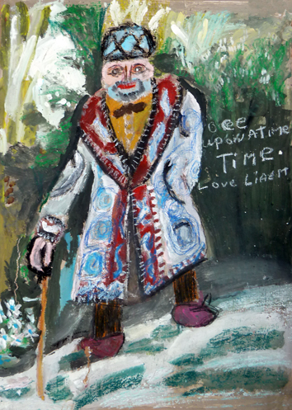

Diana was born 1954 in Dublin and lives since two years in Camphill Jerpoint.  
This year Diana will be a student in KCAT in Callan.  
  
The exhibition is at the Watergarden Gallery, Thomastown from 11th September 2014 for about 3 weeks.  
The Gallery is open during the normal business hours of The Watergarden Café (9.30am to 4.30pm, Tuesday to Friday, excluding Bank Holidays) and at other times by arrangement.

**Barnstorm presents ‘Monday’s Child’ theatre for children aged 4+ , their families and teachers!**

**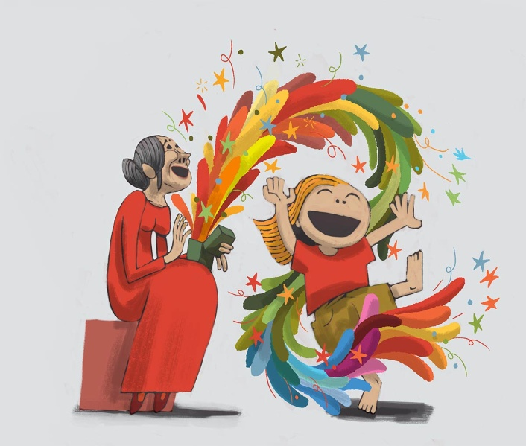**

**Barnstorm Theatre Company presents Monday’s Child by Brendan Murray**

***Monday’s Child*** tells a simple poetic story of the unique bond between an old woman and a little girl. Together in a dream-like garden, they sing and dance and dress up as they joyously explore a treasure trove of memories. This sensitive, imaginative yet funny story explores how we make and store memories as we grow up and discover the world; how these shape who we are, and how they help us meet the challenges of growing old.

Written by award-winning writer Brendan Murray, ***Monday’s Child*** has been made especially for children aged 4-7 years, their families and teachers.

Running Time: 45 minutes   
  
The Barn Theatre at Barnstorm, Church Lane, Kilkenny.

**Monday 6th – Friday 17th October**

10:00 & 11:30 Daily

Tickets: €6  
School Groups: €5 *(incl. 2 teachers free)*

**FAMILY PERFORMANCES:**

**Saturday 11th & Saturday 18th October**

2:30pm & 4:00pm

Tickets: €6  
Family of 4: €20

**BOOKING:** 056-7751266;   
E : [info@barnstorm.ie](mailto:info@barnstorm.ie)

W: [www.barnstorm.ie](http://www.barnstorm.ie)  
F: <https://www.facebook.com/barnstormtheatrecompany>

# Savour Kilkenny 2014 Literary Cake Competition

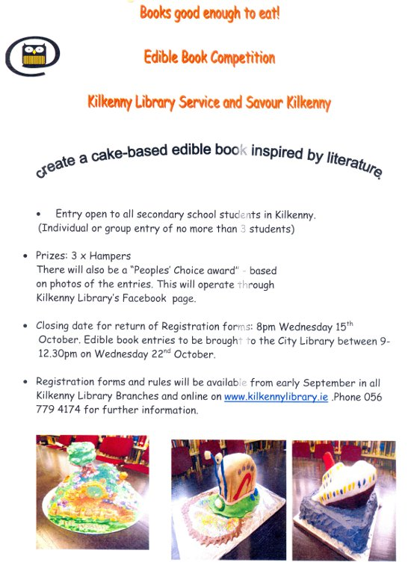

Please click on link below to access rules and entry form for the competition:

[Savour Kilkenny 2014 Rules and Entry Form.pdf (size 1.8 MB)](http://kilkennylibrary.kilkenny.ie/eng/Whats_On/Savour-Kilkenny-2014-Rules-and-Entry-Form.pdf)

**Library News**

****

# Autumn 2014 at Loughboy Library

**Computer Course-Benefit 4 IT Training** has commenced at Loughboy library. Funded by Kilkenny Leader Partnership this course covers e-mail, internet, digital photography basics, skype and introduction to online social networking. The course runs on Tuesdays from 10am-12 noon for five weeks. It is currently full but interested parties may put their names on a waiting list for further courses. Contact Connie McGee, KLP Development Officer 086 7718040 or Loughboy library 056 7794176.

Please note there will be NO computers available for the public at Loughboy library during the above class times.

**Patchwork Exhibition**-The South Midlands Branch of the Irish Patchwork Society are currently exhibiting at Loughboy Library. This exhibition is dedicated to Kathleen Delany, one of the society's founder members who died recently. The branch was formed in 2005 and they hold their meetings at 7pm on the first Thursday of the month (Sept-Dec and Feb-June) in the Springhill Court Hotel. All are welcome to go along for some sewing demonstrations and to listen to their various speakers. For further information please call Alison 087 2506999.

Loughboy library offers free exhibition space throughout the year.

**Science and Engineering Week 2014**-Mr Paul McDonald, engineer will present a lecture "Global Engineering, Science and Other Careers" at Loughboy, John's Quay and Castlecomer libraries on Wed November 12th. This lecture is free and is aimed at second-level schools. It will be most interesting for students who are considering a career in the science field. Teachers are invited to book at their preferred library.

Mobile Phone, Iphone, Notebook, I Pad etc-usage tips available on Fridays from 3.45pm on a drop-in basis.

**National Adult Literacy Agency NALA**-a learner ambassador from NALA is available at Loughboy Library to speak to adults who may be thinking of returning to education. As an adult learner herself she hopes by sharing her story that others will be encouraged to engage in further learning. She will outline the various supports that NALA provides to help adults improve their literacy, reading, writing, numeracy and IT skills. Enquiries to Loughboy library 056 7794176.

\*\*\*\*\*\*\*\*\*\*\*\*\*\*\*\*\*\*\*\*\*\*\*\*

# Ferrybank Library, September 2014 Newsletter

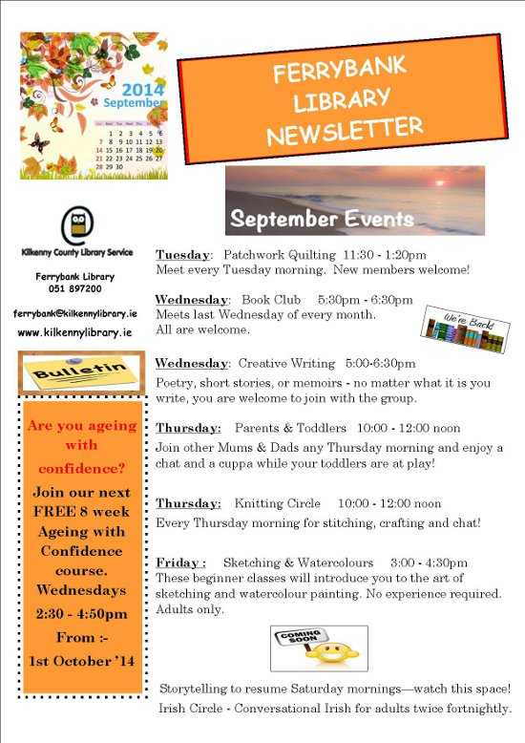

Craft Group Workshops in Kilkenny Libraries

* City Library, John’s Quay: Tuesday evenings **6-8pm**
* Castlecomer Library: Thursday mornings, year round, **10-12pm**
* Graiguenamanagh Library: Wednesday mornings **10.30am to 12.30pm**
* Ferrybank library: Patchwork quilting – Tues morning at **11.45-1.20**

Knitting – Thurs mornings **10-12.00**(Both groups taking a break for the summer.)

We also have once off workshops e.g. Origami class **Wed 6th, 13th & 20th Aug – 11.30 -1pm**

Contact details for libraries:

<http://kilkennylibrary.kilkenny.ie/eng/Libraries_Locations/>

**\_\_\_\_\_\_\_\_\_\_\_\_\_\_\_\_\_\_\_\_\_\_\_\_\_\_\_\_\_\_\_\_\_\_\_\_\_\_\_\_\_\_\_\_\_\_\_\_\_\_\_\_\_\_\_\_\_\_\_\_\_\_\_\_\_\_\_\_\_\_\_\_\_\_\_\_\_\_\_\_\_\_\_\_\_\_**

**DCC Arts Office presents ‘Natura natura’ by Saidhbhín Gibson**

Natura natura  
26 August – 8 November  
The Cube Space, The LAB Gallery, Foley Street, Dublin 1  
Opening hours: Monday to Friday 10am – 6pm, Saturday 10am – 5pm  
The Natural History Museum, Merrion Street, Dublin 2  
Opening hours: Tuesday to Saturday 10am – 5pm, Sunday 2pm – 5pm

Dublin City Council Arts Office presents Natura natura by Saidhbhín Gibson.

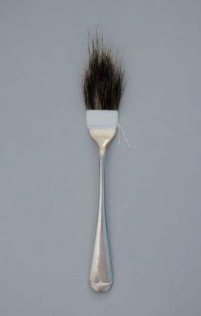

Dublin City Council Arts Office in collaboration with The Natural History Museum provided a temporary residency for artist Saidhbhín Gibson to explore the vast range of diverse species from the natural world featured in the museum’s exhibitions and collections.

The work developed in response to her residency, inspired by conversations with staff and time spent researching wildlife from Ireland, investigates our understanding and experience of nature in both rural and urban settings.

The exhibition is accompanied by a free programme of events at The LAB and The Natural History Museum exploring art and wildlife. For further information and bookings see: [http://naturanatura.eventbrite.ie](http://lists.visualartists.ie/lt.php?c=1200&m=4239&nl=1&s=d3c261c0eeb6b48867f449d29e09414b&lid=94004&l=-http--naturanatura.eventbrite.ie)

**Butler Gallery**

MARILYN LERNER**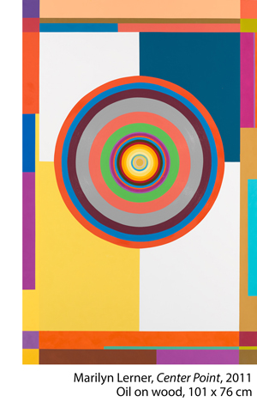  
August 9 – October 5, 2014**

The Butler Gallery is delighted to host Ireland’s first exhibition of the New York based painter Marilyn Lerner.

Lerner is an extraordinary artist who has been committed to making abstract geometric paintings for over forty years. Her oil paintings are painted on wooden panels with bevelled edges so that they almost float off the wall. They are highly skillful compositions that articulate her experiences through form, pattern and colour. Lerner has travelled extensively through North Africa and South East Asia and these trips have informed her work and made the language of geometry the focus of her work.

**\_\_\_\_\_\_\_\_\_\_\_\_\_\_\_\_\_\_\_\_\_\_\_\_\_\_\_\_\_\_\_\_\_\_\_\_\_\_\_\_\_\_\_\_\_\_\_\_\_\_\_\_\_\_\_\_\_\_\_\_\_\_\_\_\_\_\_\_\_\_\_\_\_\_\_\_\_\_\_\_\_\_\_\_\_\_\_**

**New Programme of Art and Craft Workshops with Tunde Toth at KOZO Studio**

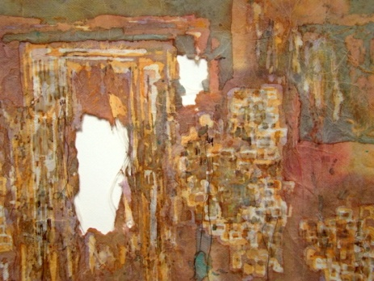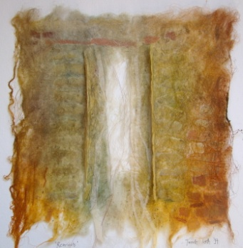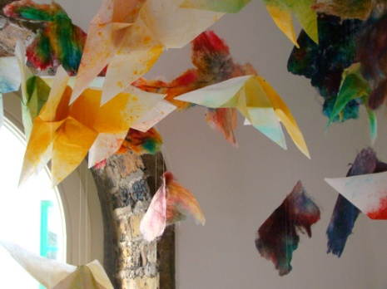​

KOZO Studio, The Estate Yard, Castlecomer Discovery Park, Castlecomer, Co. Kilkenny

28 September (Sunday) PAPERMAKING DAY | € 35 per workshop OR € 65 for the full day – including all materials  
This is a full day programme introducing traditional and contemporary hand papermaking techniques and related creative processes.  
10.30am – 1.30pm HAND PAPERMAKING using pure plant fibres and recycled materials  
2.30 – 5.30pm SILK FIBRE PAPERMAKING – creating unique, colourful, lightweight, striking silk fibre papers  
The days programme also includes a slideshow presentation on contemporary paper art forms and international artist`s practices. This course is suitable for beginners and participants with some level of previous experience in hand papermaking processes.

5 October (Sunday) BATIK | 10.30am – 5pm | € 65 for the full day – including all materials  
A full day workshop introducing traditional processes of BATIK, and an ancient fabric dyeing technique where hot wax is used as a resist on cloth.  
Suitable for beginners and participants with some previous experience.  
€ 65 for the full day – including all materials

12 October (Sunday) ADVANCED LEVEL PAPER MAKING and PAPER ART COURSE | 10.30am – 5.30pm | € 75 for the full day – including all materials  
This is a professional development programme for artists and crafts people: a follow-on, advanced level course in hand paper making and paper art. Suitable for participants with previous experience and those who took part at beginner`s workshops.  The course focuses on three dimensional and sculptural works, installations, contemporary paper art processes and interactive, collaborative projects.

KOZO Studio and Gallery OPENING RECEPTION: The Studio will be launched with a solo exhibition of Tunde`s new and recent works from 6pm on Friday 26th of September

–

Professional Courses for small groups of participants – suitable for adults and young people from 15 years of age  
Bookings and all info: 087-2543362 | [tundetune@gmail.com](mailto:tundetune@gmail.com)

[www.tundetoth.com](http://lists.visualartists.ie/lt.php?c=1207&m=4246&nl=1&s=d3c261c0eeb6b48867f449d29e09414b&lid=94339&l=-http--www.tundetoth.com) | [www.kozostudio.wordpress.com](http://lists.visualartists.ie/lt.php?c=1207&m=4246&nl=1&s=d3c261c0eeb6b48867f449d29e09414b&lid=94340&l=-http--www.kozostudio.wordpress.com)

### cid:ii_hz5op2470_147fe628ee8d47c0

**Barrow Consultancy and Training - Ongoing FETAC/QQI Courses**

Barrow Consultancy and Training - Ongoing FETAC/QQI Courses in Train the Trainer, Coaching, Supervisory Management and more…

Barrow Training – offer training programmes to companies and individuals in a wide range of areas.  
   
**We are currently offering:**

* Train the Trainer FETAC/QQI level 6 (Flyer attached)
* Professional Coaching Skills  FETAC/QQI level 6 (Flyer attached)
* Supervisory Management for Healthcare Managers FETAC/QQI level 6 (Flyer attached)
* Special Needs Assisting FETAC/QQI level 6 (Flyer attached)
* Non Violent Personal Safety and De-escalation Training  (Flyer attached)

Currently offering some special deals if you book online at [www.barrowtraining.ie](http://www.barrowtraining.ie/)

**Current schedule:** <http://www.barrowtraining.ie/schedule/>

**Region:**

Waterford, Wexford, Carlow, Kilkenny, Tipperary

**\_\_\_\_\_\_\_\_\_\_\_\_\_\_\_\_\_\_\_\_\_\_\_\_\_\_\_\_\_\_\_\_\_\_\_\_\_\_\_\_\_\_\_\_\_\_\_\_\_\_\_\_\_\_\_\_\_\_\_\_\_\_\_\_\_\_\_\_\_\_\_\_\_\_\_\_\_\_\_\_\_\_\_\_\_\_\_**

**Courses / Training / Jobs / Internships**

**\_\_\_\_\_\_\_\_\_\_\_\_\_\_\_\_\_\_\_\_\_\_\_\_\_\_\_\_\_\_\_\_\_\_\_\_\_\_\_\_\_\_\_\_\_\_\_\_\_\_\_\_\_\_\_\_\_\_\_\_\_\_\_\_\_\_\_\_\_\_\_\_\_\_\_\_\_\_\_\_\_\_\_\_\_\_\_**

**RUA RED Community and Outreach Programme | Call for Facilitators**

RUA RED, Blessington Rd, Tallaght, Co. Dublin

RUA RED South Dublin Arts Centre are developing their community and outreach programming and are looking for expressions of interest from facilitators working in the fields of visual arts, music, literature and theatre for all ages.

Interested parties should send on a CV, brief history of previous work and a short summary of particular interests for future projects – [info@ruared.ie](mailto:info@ruared.ie)

RUA RED South Dublin Arts Centre is a multi-disciplinary arts venue based in Tallaght, Dublin South. RUA RED promotes the development and exhibition of art and culture through providing unique and inspiring opportunities for artists to create, and for audiences to engage with an active, varied and high-quality cultural life for the people of South Dublin, Ireland and beyond. Over the past five years RUA RED has developed a reputation for its high quality and progressive exhibitions and projects, challenging perceptions and creating a home for visual arts and dance as well as championing emerging Irish artists and performers.

[www.ruared.ie](http://lists.visualartists.ie/lt.php?c=1207&m=4246&nl=1&s=d3c261c0eeb6b48867f449d29e09414b&lid=94315&l=-http--www.ruared.ie)

**Calling for applications to the 2014-2015 NUI Certificate in Youth Arts!**

The Certificate in Youth Arts is a part time, year long university accredited course of study in Irish Youth Arts Practice managed and delivered by the Arts Programme at NYCI.

(Accrediting body: NUI Maynooth, Dept of Applied Social Studies)

The Certificate in Youth Arts aims to introduce those working in the non-formal education sector to the concepts, principles and practice of youth arts using a context and practice approach.

We are now accepting applications for the Certificate in Youth Arts 2014- 2015.

The downloadable Prospectus for 2014-2015 includes information on Certificate content, dates and assessment. You can access the prospectus, application form and frequently asked questions  at [www.youtharts.ie/cert](http://www.youtharts.ie/cert)

If you have an application related query please contact Anne O'Gorman, Senior Project Officer, Youth Arts: [anneog@nyci.ie](mailto:anneog@nyci.ie) 01 4255932

**Lucinda Sly: Auditions**

Auditions will be held in October in Carlow for a new play, Lucinda Sly, set in the 1830's and based on the last public hanging of a woman - in Carlow - in 1835.

We require a cast of seven to nine actors.

The play will be rehearsed in Carlow in early 2015.

The play will open in the GBS Theatre, Carlow in late March 2015 and tour (mostly Thurs-Sat) between then and the end of May.

We require three females -

1. playing age 50's;

2. playing age 40's;

3. any playing age over 25

We require five males -

1. playing age 50 plus

2. playing age 40 plus

3. playing age 40 plus

4. playing age 30's

5. playing age 20's/30's

Please send a SHORT bio; a photo and contact details to: [lucindaslytheplay@gmail.com](mailto:lucindaslytheplay@gmail.com)

I will be in touch with all applicants by the end of September with audition details.

This is a profit share production.

**Association of Irish Festivals and Events (AOIFE): Masterclasses**

Taking place in the Ulster Hall in Belfast and regards Festival and Event Management with Sylvia Allen and Colm Croffy.

On the 24th of September Colm Croffy and Sylvia Allen will be hosting a masterclass in the Ulster hall in Belfast. The masterclass will go into depth on festival and event management

The course will cover:

* Introductions and outline of modules
* Understanding Event / Festival Management
* Cash flow projections and pricing events. – making a budget
* Delivering Sustainability
* What Marketers want from Your Event
* How do you retain a valued Commercial supporter of the Festival / Event
* Marketing & Advertising Events on a shoestring budget
* Using Facebook/Twitter/Youtube to promote your festival/ event
* Dealing With Your Business Community
* Pitching the correct concept
* Sponsor Optimisation
* Follow Up – Post Event Report and A Renewals Strategy
* Public Relations for Your Event
* The Press Release
* A to Z of Press Relations
* Q&A session
* And Much more

For More info on Colm and Sylvia's Masterclass visit AOIFE blog.

[www.aoifeonline.com](http://www.aoifeonline.com/)

**‘Help! It doesn’t pay – YOU need to think about your artistic career’ | 1 Day Workshop at Centre for Creative Practices**

Sat 27th of Sep at 10am-5pm  
Admission: €50 / €45  
Centre for Creative Practices, 15 Pembroke Street Lower, Dublin 2

Have you been trying to make a living from your art?  
Have you been trying to get an audience for your art?

This 1 day workshop will give you a basic insight into how to change this, the steps you need to take and what results you are looking for. It will also ask you the question, why am I doing this, for whom and why? Define your purpose and impact.

[http://cfcp.ie/events/869](http://lists.visualartists.ie/lt.php?c=1204&m=4243&nl=1&s=e784eec6bf8bb9680747b324b9c9eee1&lid=94090&l=-http--cfcp.ie/events/869)

**One Day Workshop on Marketing for Artistic Entrepreneurship at Centre for Creative Practices**

Sat 27th of Sep at 10am-5pm  
Admission: €50 / €45  
Centre for Creative Practices, 15 Pembroke Street Lower, Dublin 2

This 1 day intensive workshop on marketing will cover a lot of ground.

By the end of the day you will have the outline of your marketing strategy and also be aware of new methods and ideas on marketing that are specific to the arts sector.

The workshop is suitable for artists, arts professionals and arts organisations looking to take their marketing to the next level.

[www.cfcp.ie/events/864](http://lists.visualartists.ie/lt.php?c=1204&m=4243&nl=1&s=e784eec6bf8bb9680747b324b9c9eee1&lid=94091&l=-http--www.cfcp.ie/events/864)

**VAI: Professional Development Training Programme Autumn/Winter 2014**

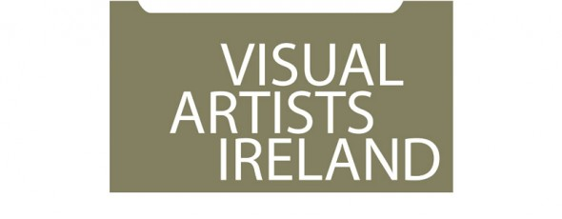

Visual Artists Ireland operates a wide range of professional development training and events throughout the year including **workshops, peer discussion groups, seminars and talks**. The delivery of this programme is greatly supported by our relationship with local and international visual art professionals and partner organisations throughout the island of Ireland. VAI works in partnership with Local Authorities, visual arts venues and others, combining resources to support the professional development of visual artists at regional level.

To register and for further information see: [http://visualartists.ie/professional-developmentp/](http://lists.visualartists.ie/lt.php?c=1191&m=4230&nl=1&s=d3c261c0eeb6b48867f449d29e09414b&lid=91545&l=-http--visualartists.ie/professional-developmentp/)

\*\*\*\*\*\*\*\*\*\*\*\*\*\*\*\*\*\*\*\*

**Dublin**

**Towards Sustainability – Mapping your Career** with Patricia Clyne-Kelly, John Daly and Brian Kennedy hosted *by Fingal Arts*

Thur. 9 Oct (10.30 – 16.30)

Venue to be confirmed

Places: 25 - 30

Cost: €60 / 30

[http://visualartists.ie/professional-developmentp/?ee=155](http://lists.visualartists.ie/lt.php?c=1191&m=4230&nl=1&s=d3c261c0eeb6b48867f449d29e09414b&lid=92517&l=-http--visualartists.ie/professional-developmentp/--Q-ee--E-155)

**Writing about Your Work** with Niamh O'Malley

Thur. 16 Oct (10.30 – 16.30) tbc

@ Visual Artists Ireland

Places: 10 - 12

Cost: €80 / 40 (VAI Members)

*Further information available on this session online in early Sept.*

**Developing Creative Proposals** with Annette Moloney

Wed. 19 Nov. (10.30 – 16.30)

@ Visual Artists Ireland

Places: 12 – 16

Cost: €80 / 40

[http://visualartists.ie/professional-developmentp/?ee=164](http://lists.visualartists.ie/lt.php?c=1191&m=4230&nl=1&s=d3c261c0eeb6b48867f449d29e09414b&lid=92518&l=-http--visualartists.ie/professional-developmentp/--Q-ee--E-164)

**Arts Council Funding Information Session -** Dublin

Wed. 5 Nov (time to be confirmed)

@Visual Artists Ireland

Places: 20 – 25

[http://visualartists.ie/professional-developmentp/?ee=166](http://lists.visualartists.ie/lt.php?c=1191&m=4230&nl=1&s=d3c261c0eeb6b48867f449d29e09414b&lid=92519&l=-http--visualartists.ie/professional-developmentp/--Q-ee--E-166)

\*\*\*\*\*\*\*\*\*\*\*\*\*\*\*\*\*\*\*\*

**Limerick**

*In partnership with LCGA, Limerick City & County Council and Clare and Tipperary County Councils*

**Developing Creative Proposals** with Annette Moloney

Tues. 21 Oct. (10.30 – 16.30)

Venue to be confirmed

Places: 12 - 16

Cost: €10 / 5 (VAI Members)

[http://visualartists.ie/professional-developmentp/?ee=162](http://lists.visualartists.ie/lt.php?c=1191&m=4230&nl=1&s=d3c261c0eeb6b48867f449d29e09414b&lid=92524&l=-http--visualartists.ie/professional-developmentp/--Q-ee--E-162)

\*\*\*\*\*\*\*\*\*\*\*\*\*\*\*\*\*\*\*\*

**Meath**

*Events in partnership with Meath County Council Arts Office*

**Presenting yourself & Your Work** with Patricia Clyne-Kelly

Tues. 18 Nov (10.30 – 16.30) tbc

Places: 10 - 12

Cost: €80 / 40 (VAI Members)

*Further information available on this session online in early Sept.*

**Developing Opportunities for your Work** with Elaine Grainger and Elaine Leader

Tues. 11 Nov (10.30 – 16.30)

Places: 15 - 20

Cost: €50 / 25 (VAI Members)

[http://visualartists.ie/professional-developmentp/?ee=158](http://lists.visualartists.ie/lt.php?c=1191&m=4230&nl=1&s=d3c261c0eeb6b48867f449d29e09414b&lid=92525&l=-http--visualartists.ie/professional-developmentp/--Q-ee--E-158)

**Documenting your Work** with Tim Durham

Date to be confirmed

Places: 10 - 12

Cost: €80 / 40 (VAI Members)

*Further information available on this session online in early Sept.*

\*\*\*\*\*\*\*\*\*\*\*\*\*\*\*\*\*\*\*\*

**Roscommon**

*Event in partnership with Roscommon Visual Artists Forum*

**Developing Opportunities for your Work** with Geraldine O'Reilly and Elaine Grainger

Thur. 2 Oct (11.30 – 17.00)

@ Roscommon Arts Centre

Places: 12 - 16

[http://visualartists.ie/professional-developmentp/?ee=153](http://lists.visualartists.ie/lt.php?c=1191&m=4230&nl=1&s=d3c261c0eeb6b48867f449d29e09414b&lid=92528&l=-http--visualartists.ie/professional-developmentp/--Q-ee--E-153)

**Protecting and Caring for Your Work** (half day) with Alan Ragget

Wed. 22 Oct (11.30 – 17.00)

@ King House, Boyle

Places: 15 - 20

[http://visualartists.ie/professional-developmentp/?ee=165](http://lists.visualartists.ie/lt.php?c=1191&m=4230&nl=1&s=d3c261c0eeb6b48867f449d29e09414b&lid=92529&l=-http--visualartists.ie/professional-developmentp/--Q-ee--E-165)

FREE to visual artists based in Roscommon

**Visiting Curators Sept & Nov, 2014**

**Dublin Live Art Fesitival**

In addition to these events above we also look forward to welcoming visiting Curators **Jonas Stampe** in September working in conjunction with the Dublin Live Art Festival.

**Bea de Souza** from The Agency Gallery London who will meet with artists connected with our regional partners in Galway in November.

**To register and for further information see:** [http://visualartists.ie/professional-developmentp/](http://lists.visualartists.ie/lt.php?c=1191&m=4230&nl=1&s=d3c261c0eeb6b48867f449d29e09414b&lid=91545&l=-http--visualartists.ie/professional-developmentp/)

 \*\*\*\*\*\*\*\*\*\*\*\*\*\*\*\*\*\*\*\*

**Bookings  Payments**

Booking and payment is required in advance for all sessions.  We encourage artists to register online where possible and if you wish to make payments off line following registration please do provide a mobile phone number on the registration form. We accept payment in the following ways: through PayPal online; by stg£ or Euro cheque made out to Visual Artists Ireland or by credit card over the phone.

 If an event is not listed on our online system please email [monica@visualartists.ie](mailto:monica@visualartists.ie) to register interest in an event. State the full title of the event, the location and date and provide your name and mobile number in your email.   
  
To register online for Republic of Ireland training: [http://visualartists.ie/professional-developmentp/](http://lists.visualartists.ie/lt.php?c=1191&m=4230&nl=1&s=d3c261c0eeb6b48867f449d29e09414b&lid=91545&l=-http--visualartists.ie/professional-developmentp/)  
To register online for Northern Ireland training: [http://visualartists.org.uk/services/professionaldevelopment/current/](http://lists.visualartists.ie/lt.php?c=1191&m=4230&nl=1&s=d3c261c0eeb6b48867f449d29e09414b&lid=91546&l=-http--visualartists.org.uk/services/professionaldevelopment/current)

**Fees:**

VAI members receive preferential discount of 50% on fees for all training and professional development events.  
  
  
**Tell us about your training needs!**

If you are interested in training please do get in touch with us directly or forward an expression of interest in a topic/s through the Professional Development Training web page.  We often repeat workshops when there is a strong demand for a topic.    
  
**Artist & Tutors Panel**

Visual Artists Ireland has an ongoing open submission process for artists and arts professionals interested in being part of an available panel of tutors contributing to the VAI Professional Development Training Programme. For details go to our training registration page and click on Register for the PDT Artists Panel: [http://visualartists.ie/professional-developmentp/?ee=71](http://lists.visualartists.ie/lt.php?c=1191&m=4230&nl=1&s=d3c261c0eeb6b48867f449d29e09414b&lid=91547&l=-http--visualartists.ie/professional-developmentp/--Q-ee--E-71)

# National Youth Council of Ireland: Child Protection and Web Safety Training

#### [Child Protection Programme - National Youth Council of Ireland logo](http://www.childprotection.ie/)

#### [Child Protection Awareness Programme](http://www.nycitraining.org/courses/child-protection-awareness-programme-1)

Date: **24th September 2014**

**Training Event:** Child Protection Awareness Programme  
**Venue:** Carmelite Centre  
   
This four hour basic awareness course is the standardised child protection training programme for the youth work sector. It aims to create a basic awareness about the key issues in relation child protection. It is suitable for volunteers and staff members in youth work organisations.

#### [Websafety in Youth Work - Cork](http://www.nycitraining.org/courses/websafety-youth-work-cork)

Date: **1st December 2014**

**Description:** This 3.5 hour course is designed to raise awareness among youth leaders about young people’s online life, to identify on line risks and opportunities and to deal with cyberbullying. This training is supported by the free online resource website for youth workers <http://websafety.youth.ie/>  
   
**Venue:** Metropole Hotel, Cork

Please contact Geraldine Mahon at 01-4784122 to register or email [training@nyci.ie](mailto:training@nyci.ie)

**Training Programmes with Irish Times Training**  
  
Business to Arts Affiliates are eligible for discounts of up to 70% on programmes delivered by Irish Times Training.  
   
Popular upcoming courses include:

* [Dealing with the Media](http://cts.vresp.com/c/?BusinesstoArts/0ed1120d3d/608128ad7e/b28d94adb6) 25 Sept, €475 reduced to €250
* [Negotiation Skills](http://cts.vresp.com/c/?BusinesstoArts/0ed1120d3d/608128ad7e/dc6d861e3d) 22/23 Sept, €650 reduced to €250
* [Finance for the non-Financial Manager](http://cts.vresp.com/c/?BusinesstoArts/0ed1120d3d/608128ad7e/9acb9636d3) 20/21 Oct, €750 reduced to €250

The Irish Times also have a series of well respected programmes in Digital Marketing, for which there is a 15% discount available for Business to Arts Affiliates.  
  
[Digital Marketing Evening Programme](http://cts.vresp.com/c/?BusinesstoArts/0ed1120d3d/608128ad7e/f150c8d0cb) Monday Evenings (6-9pm), 22 Sept- 15 Dec  
  
Check the [Irish Times Training site](http://cts.vresp.com/c/?BusinesstoArts/0ed1120d3d/608128ad7e/97c2f4e8b6) for the complete list of courses. Discounts can only be secured for Business to Arts affiliates, and must be booked via our office. Email [Rowena](mailto:rowena@businesstoarts.ie?subject=Training%20Booking) if you would like to book a place on a programme.

**Call for Submissions / Residencies**

**\_\_\_\_\_\_\_\_\_\_\_\_\_\_\_\_\_\_\_\_\_\_\_\_\_\_\_\_\_\_\_\_\_\_\_\_\_\_\_\_\_\_\_\_\_\_\_\_\_\_\_\_\_\_\_\_\_\_\_\_\_\_\_\_\_\_\_\_\_\_\_\_\_\_\_\_\_\_\_\_\_\_\_\_\_\_\_**

**Film commission opportunity in Kildare**

Under the Department of the Environment, Community and Local Government Per Cent for Art scheme for Castlewarden to Ballygoran, Kildare County Council wishes to commission a series of original films to be made in North County Kildare.

Stage 1 Deadline: Monday 6th  October 2014.

<http://www.kildare.ie/ArtsService/Filmcommission2014-BriefingDocument-STAGE1.html>

**Killeshin NS, Laois: Per Cent for Art Commission**

Call for Interest document for a Per Cent for Art Commission in Scoil Chomhgháin Naofa – Killeshin NS, Killeshin, Co.Laois. This commission is aimed at Professional Artists who have experience working with schools and in the creation of permanent artworks. Budget is €15,000 and closing date for Stage 1 applications is 12 noon, Friday 7th November, 2014.

Scoil Chomhgháin Naofa, Killeshin NS, Co.Laois wish to commission a site specific public artwork/s under the ‘Per Cent for Art Scheme’, funded by the Department of Education and Science. The artwork/s will be site specific with a permanent element to be sited in or/and around the buildings and environs. The brief asks the artist/s to:

* Reflect the previous and future history of the school, it’s students, teachers and community
* Reflect the strong ethos, vision and identity of the school
* Respond to the location of the school
* Partake in an element of interaction with the pupils
* That the artwork (s) are of an interactive nature

 Applicants can make enquiries regarding the commission to Rina Whyte, email [rinawhyte@yahoo.com](mailto:rinawhyte@yahoo.com) or by telephone + 353 87 238 9591.

You can [Download the brief here](http://lists.visualartists.ie/lt.php?c=1207&m=4246&nl=1&s=d3c261c0eeb6b48867f449d29e09414b&lid=94313&l=-http--visualartists.ie/wp-content/uploads/2014/09/KilleshinNS_Commissions.pdf)

Closing date for Stage 1 applications is 12 noon, Friday 7th November, 2014.

**TACTIC – 2014/2015 Artistic Programme | Call for Submissions**

TACTIC, 3rd Floor, Sample-Studios, Former Gov Buildings, Sullivan’s Quay, Cork

TACTIC Gallery announces it’s open call for curator led exhibitions to take place 2014/2015. It also invites proposals for other artist led events, such as a series of talks.

The program is open to practicing artists and curators of any medium. Proposals for new work as well as existing works will be considered. Preference will be given to artists adopting a new approach and advancement in their practice. TACTIC Gallery hopes to promote the emergence of curators as well as artists, and so ask for only curator led exhibitions be proposed.

Selection is based on the strength of the application, the suitability of the project for the space as well as the resolution of the ideas underpinning the curator’s/artist’s proposal.

Submission Guidelines – Please submit the following:  
– An exhibition proposal that out lines both the background and plan for the exhibition. (max 500 words)  
– Artists statements/biographical info of participating artists/curator  
– C.V.  
– Images of previous projects and/or of artists work you may wish to include.  
– Estimated time frame that exhibition will run, specifying when the project would be realised.

Submissions to be sent to: [tactic@sample-studios.com](mailto:tactic@sample-studios.com)

Deadline: October 10th 2014

[www.tactic-art.info](http://lists.visualartists.ie/lt.php?c=1207&m=4246&nl=1&s=d3c261c0eeb6b48867f449d29e09414b&lid=94316&l=-http--www.tactic-art.info) | [www.sample-studios.com/tactic-about.html](http://lists.visualartists.ie/lt.php?c=1207&m=4246&nl=1&s=d3c261c0eeb6b48867f449d29e09414b&lid=94317&l=-http--www.sample-studios.com/tactic-about.html) | [www.facebook.com/TACTICart](http://lists.visualartists.ie/lt.php?c=1207&m=4246&nl=1&s=d3c261c0eeb6b48867f449d29e09414b&lid=94318&l=-http--www.facebook.com/TACTICart%20)

**UK/Irish Printmaker Residency at BPW | Call for Applications**

Belfast Print Workshop, Waring St, Belfast BT1 2ED

This Artist-in-Residence Program is seeking an artist printmaker with at least 2 years’ professional experience from the UK or Ireland. The residency will conclude with a month-long exhibition in October 2015 in BPW Gallery.

Duration: The residency will last between 2-4 weeks. (Commencement date negotiable from August the 1st 2015 to September 30th 2015)

Artist Stipend: £150 sterling per week. The residency does not include accommodation or travel expenses. Whilst Belfast Print Workshop will endeavour to assist the artist in every way to secure affordable accommodation, the selected artist must make their own travel and living arrangements. All expenses incurred are the responsibility of the selected artist.

Responsibilities:  
The recipient artist will be required to give a demonstration and provide a talk on their practice during their residency,  
The recipient will donate one work from each edition produced to Belfast Print Workshop’s Archive and editions for fund raising.  
The selected artist will not be an employee of the studio or its funding bodies, and any taxes or contributions that may be due from any fees paid are the sole responsibility of the artist.

For a list of BPW equipment & resources please visit [http://bpw.org.uk/the-workshop/](http://lists.visualartists.ie/lt.php?c=1207&m=4246&nl=1&s=d3c261c0eeb6b48867f449d29e09414b&lid=94328&l=-http--bpw.org.uk/the-workshop/) for further info.

All applications and accompanying materials must arrive by 4.00pm Friday 6th February 2015.

How to Apply: Application form is available to download from [http://bpw.org.uk/BPW-AIR/](http://lists.visualartists.ie/lt.php?c=1207&m=4246&nl=1&s=d3c261c0eeb6b48867f449d29e09414b&lid=94329&l=-http--bpw.org.uk/BPW-AIR/)

**Printmaking Residency for a ‘Non-Printmaker’ at BPW | Call for Applications**

Belfast Print Workshop, Waring St, Belfast BT1 2ED

This Artist-in-Residence Programme is seeking a non-printmaking artist (i.e. a painter, photographer, sculptor etc) who is looking to explore the medium of printmaking. The residency will conclude with an exhibition at BPW Gallery in April 2015.

Duration: The residency will last for 4 weeks. Commencement date negotiable between January to March 2015.

Artist stipend £100 sterling per week. The residency will include materials. The residency does not include accommodation or travel expenses. Whilst Belfast Print Workshop will endeavour to assist the artist in every way to secure affordable accommodation, the selected artist must make their own travel and living arrangements. All expenses incurred are the responsibility of the selected artist.

Responsibilities:  
– The recipient artist will be required to give a demonstration and provide a talk on their practice during their residency,  
– The recipient will donate one work from each edition produced to Belfast Print Workshop’s Archive and editions for fund raising.  
– The selected artist will not be an employee of the studio or its funding bodies, and any taxes or contributions that may be due from any fees paid are the sole responsibility of the artist.

For a list of BPW equipment & resources please visit [http://bpw.org.uk/the-workshop/](http://lists.visualartists.ie/lt.php?c=1207&m=4246&nl=1&s=d3c261c0eeb6b48867f449d29e09414b&lid=94328&l=-http--bpw.org.uk/the-workshop/) for further info.

All applications and accompanying materials must arrive by 4.00pm Monday 3rd November 2014.

How to Apply:

Application form is available to download from [http://bpw.org.uk/BPW-AIR/](http://lists.visualartists.ie/lt.php?c=1207&m=4246&nl=1&s=d3c261c0eeb6b48867f449d29e09414b&lid=94329&l=-http--bpw.org.uk/BPW-AIR/)

|  |
| --- |
| **SiarScéal Festival 2014 and Hanna Greally Literary Awards**Opportunity to have Your Book Published in Print and E-Book Editions |
| SiarScéal Festival 2014 will take place in Roscommon Town, on Saturday, 25 October, with an exciting programme of events lined up. The main venue is Roscommon County Library, Abbey Street, Roscommon Town but full details of times and venues are available from the [SiarScéal website](http://www.siarsceal.com/festival). A brochure containing the Programme of Events is also available to [download](https://drive.google.com/file/d/0BxVSOzr3iM7WMUNaM3RxdGlXOUE/edit?usp=sharing).  A further date has been added for Friday, 28 November, when the Trinity Arts Centre in nearby Castlerea will host a Water Music exhibition: a study of the River Suck through mixed media and haiku with artist, Anne Rigney and poet, Gwen Bond.  A centre-piece of the SiarScéal Festival, now in its eight year, is the Hanna Greally Literary Awards. This takes place annually in conjunction with the festival, honouring the life of Athlone-born writer best remembered for her memoir, Bird Nest Soup, a moving personal account of life inside Ireland’s psychiatric hospitals in the 1940s and 1950s.  The overall winner of this years award will have their book published, in print and e-book editions, courtesy of [The Manuscript Publisher](http://www.themanuscriptpublisher.com/), the publishing solutions and author services provider who are sponsoring the prize. Entries for the Awards, which should consist of no more than 1000 words for prose submissions or 100 lines for poetry, must be received before Friday, 17 October. Up to three entries per person will be accepted. Full details, including competition rules of entry are available from the [SiarScéal website](http://www.siarsceal.com/competitions).  Another highlight of this years festival will be the launch of the book, The Battle for Coman's Wood by Mario Corrigan. This is a work of historical fiction inspired by students from Castleplunkett National School and Abbey National School, both in Roscommon. Signed copies of the book will be on sale at the festival launch. It will also be available to buy online, in print and e-book editions from October.  Writers workshops, open mic, an evening concert recital featuring Lilibulero are among the other events being organised.  SiarScéal celebrates the history and the people of Roscommon. The festival extends a warm welcome to anyone with links to Roscommon or even just an affinity for its unique culture and heritage. However it is also open to the general public and promises fun, entertainment, relaxation for all ages and interests. |

**HUGH O’FLAHERTY SOCIETY MEMORIAL**

**LITERARY AND ART COMPETITIONS - 2014**

The **7th** **Hugh O’Flaherty Memorial Programme** will take place in Killarney between **Thursday October 30th and Sunday November 16th 2014**.

The **Hugh O’Flaherty Memorial Society** has three elements to its Mission Statement – the third one of these is:

***Through the Annual Hugh O’Flaherty Memorial Weekend we will ensure the continuous promotion of the inspirational story of the Monsignor, through various art forms i.e., Drama, Literature, Film and Art, etc.***

In line with its Mission Statement, the Society will hold a number of Literary & Art Competitions as part of its 2014 Memorial Programme. This will be done through a series of open and confined competitions

The Memorial Society invites entries across the four categories detailed below, embracing literature and visual arts (further categories may be added in future years).

All entries will be independently assessed and a shortlist will be selected in each category which will be exhibited as part of the 2014 Memorial Week Programme. From these short lists, one winner will be selected per category and the winner will receive a framed scroll and a modest cash award.

The Competitions open on **Friday August 8th** and from that date, the **Rules & Conditions** for each competition will be available on [**www.killarney.ie**](http://www.killarney.ie/) and on [**www.hughoflaherty.com**](http://www.hughoflaherty.com/)   Each entry must be accompanied by a completed **Entry Form**, a copy of which will also be available on [**www.hughoflaherty.com**](http://www.hughoflaherty.com/)

Hard copies will be available from the office of the **Killarney Chamber of Tourism & Commerce**, 2nd Floor, Tourist Office, Beech Road, Killarney.

**The Categories and basic requirements for this year are:**

NB: Full Rules Conditions available on [www.hughoflaherty.com](http://www.hughoflaherty.com) )

* **Hugh O’Flaherty Open Art Competition**
  + Entrants are invited to submit a painting or drawing which they believe represents the Monsignor as he went about his humanitarian work in Rome during the latter years of WW2.
  + Entries should not be framed.
  + Open competition
  + Lower age limit of 16 years (***On the closing date for entries October 3rd 2014***)
* **Hugh O’Flaherty Secondary School Essay Competition**
  + Entrants are invited to write an essay; no more than 750 words in length on a humanitarian theme in which you write about what you believe can be learned from Monsignor O’Flaherty’s selfless actions.
  + Confined to 2nd Level School Students (***At date of submitting entry***)
* **Hugh O’Flaherty Primary School Essay Competition**
  + Entrants are invited to write an essay; no more than two handwritten **or** one typed page, on why Monsignor Hugh O’Flaherty is considered a Hero.
  + Confined to Primary Level School Students – 5th / 6th Classes (***At date of submitting entry***)
* **Hugh O’Flaherty Open Poetry Competition.** 
  + In 1994, Poet Brendan Kennelly penned a poem titled “Hugh O’Flaherty’s Trees”. This poem was specifically written to mark the planting of a Grove of Italian / Mediterranean Trees in Muckross Arboretum to commemorate the Monsignor. Entrants are invited to compose a poem on the theme of the Monsignor’s work and his legacy.
  + Open Competition
  + Lower age limit of 16 years.(***On the closing date for entries October 3rd 2014***)
* **Closing Date for Entries:**

The Closing Date for receipt of entries for all categories is **5.00.p.m. on** **Friday October 3rd 2014.**

* **Literary Entries:**

Literary Entries together with completed Entry Forms must be delivered by the above deadline in a sealed envelope to:

Hugh O’Flaherty Competitions

c/o Killarney Chamber of Tourism & Commerce

2nd Floor Tourist Information Office

Beech Road

Killarney

Co. Kerry, Ireland

Alternatively, Entries and completed Entry Forms may also be submitted by the above deadline to [jerry@killarney.ie](mailto:jerry@killarney.ie)

* **Art Entries (No Online Entry Option):**

Art Entries together with completed Entry Forms should be delivered by the above deadline to:

Hugh O’Flaherty Competitions

c/o Killarney Chamber of Tourism & Commerce

2nd Floor Tourist Information Office

Beech Road

Killarney

Co. Kerry, Ireland

**Public Art Commission - Stage 1 Expression of Interest**

Deadline: 8 October

Web: <http://www.cavanarts.ie/Default.aspx?StructureID_str=6&guid=91>

Email: [catrionaoreilly@cavancoco.ie](mailto:catrionaoreilly@cavancoco.ie)

Bailieborough BPttA Steering Committee is now inviting expressions of interest from artists or groups of artists for

a public artwork to be sited at the Market House, Bailieborough, County Cavan.

Front of the Market House (Library Building), Bailieborough, and view of proposed site to the side of the building

(disabled parking bays to be relocated).

The theme for this artwork is 'Forging Ahead'.

'Forging Ahead' - From Bailieborough's Divided Pasts towards our Shared Future'   acknowledges the segregation that once affected Bailieborough's communities, its industrial craft heritage and the determination of the community to shape a positive future. The people consider themselves to be resilient and determined and this attitude has shaped the development of the town and its many businesses and creative endeavours.

There is no payment to artists submitting the initial Expression of Interest (Stage 1). No more than 3 artists will be selected to proceed to Stage 2 and will be asked to develop a full proposal with sketches and a maquette. £500 is available for each artist selected for Stage 2.

Artists/Groups of Artists interested in submitting an Expression of Interest should read the following Artist Brief carefully and follow the guidelines for submission.

Bailieborough BPttA Artist Brief

The total value of the commission will be up to £40,000 (including VAT). This figure must also allow for all necessary design, treatment of surfaces, installation, erection and all fixings to secure the feature etc. There will be a six month timeframe for delivery of the artwork.

All queries should be directed via email only to Catriona O' Reilly at email address above

**Marymount University Hospital & Hospice: Percent for Art Commission**

Artists are invited to submit CV’s and images for consideration to be placed on a shortlist for creating a permanent outdoor artwork for the above well-known development for eldery care and palliative services. The aggregate value of the commission is €61,500.

It is an open brief for an outdoor permanent artwork in any medium, considered appropriate to outdoor exposure and longevity.

Deadline 4pm Friday 31 October 2014

Marymount University Hospital & Hospice, Curraheen, Co. Cork

For all details see: [www.marymount.ie](http://lists.visualartists.ie/lt.php?c=1204&m=4243&nl=1&s=e784eec6bf8bb9680747b324b9c9eee1&lid=94063&l=-http--www.marymount.ie)

**Cló & The Living Archive: Call for Applications for Artist in Residence Programme**

Artist in Residency Autumn Programme at Cló & The Living Archive Print Studio

Cló & The Living Archive invites applications for the following:

Artist in Residence Programme.  
This programme offers accommodation in Cló Ceardlann’s artist-in-residence house and full technical facilities at their workshop based in scenic North West Donegal, IRELAND. This residency is offered on a self-funded basis. We will help interested applicants to apply for funding.

Interested applicants should forward their C.V. and a detailed proposal to [cloceardlann@eircom.net](mailto:cloceardlann@eircom.net).

For an information pack please contact Leanne Mc Laughlin at 07495 – 31271 or e-mail [cloceardlann@eircom.net](mailto:cloceardlann@eircom.net)

**Applications for Project Studios, TBG+S**

Deadline: 15 October 2014

Web: <http://www.templebargallery.com/studios/apply>

Email: [info@templebargallery.com](mailto:info@templebargallery.com)

TBG+S is now accepting applications for Project Studios.

Project Studios are generally awarded to artists at an earlier point in their career, who demonstrate talent and potential.

Project Studios are awarded for one year in duration and do not confer company membership on the awardee.

Monthly studio rents at TBG+S are considerably subsidised and are inclusive of heating, electricity and WiFi.

Successful applicants will be informed by end October 2014

Artists must be available to take up residency at the beginning of January 2015

Applications for Project Studios 2014 must be made online.

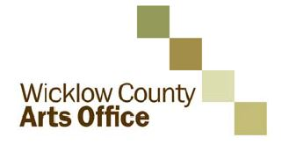

**Call for proposals: new initiatives for WCAO programme 2015**

As part of its plan for the development of the arts, Wicklow County Arts Office invites applications from interested parties for funding to develop and deliver new projects of high quality and impact during 2015 which will enhance and complement the strategic development of the arts in the County.

This call is open to organisations and individuals from any part of Ireland across all arts disciplines. Proposals should add significant value to arts practice, experience and/or participation in the arts in County Wicklow and support the Council’s strategic goals for the arts 2014-2016. 2015 is the second year that this initiative has been offered, for information on projects which were awarded in 2014 see [www.wicklow.ie](http://www.wicklow.ie), select Other Services and Arts Office. The information is under New Strategic Projects 2014. Projects include a new commission *Medicated Milk* for dance practitioner Áine Stapleton, a collaborative commission with Arklow Silver Band by composer Ian Wilson, a residency exchange between Wicklow and Cork based artists by Cork Printmakers and a series of Literary Events by Poetry IReladn.

Reflecting the balance of other elements of its programme, the Arts Office would particularly welcome strong applications in literature, film, architecture, and artist development. The Arts Office is also interested in proposals in the visual arts and music.

The Arts Office is particularly interested to hear from **national resource organisations, individual curators and artist** **collectives** who have the potential to propose projects which will nurture practice, create connectivity, generate new perspectives and voices within the cultural life of the county and support a diversity of approach.

The total amount of the fund available is subject to finalisation of Wicklow County Arts Office own funding for 2015, but is likely to be a maximum of €60,000. It is intended that a number of projects may be supported through this call to a maximum of €15,000.00 per project.

The closing date for applications is **4pm on Wednesday the 24th of September 2014**. Decisions will be made by Wicklow County Arts Office during September 2014 and applicants will be notified of the Arts Office decision shortly thereafter.

The application process is being managed for Wicklow County Arts Office by Interactions. Guidelines and application forms should downloaded from www.wicklow.ie under Other Services/Arts Office. Any queries on the application process should also be directed by email to: [wicklow@inter-actions.biz](mailto:wicklow@inter-actions.biz).

**Waterford Healing Arts Trust invites you to share your feel-good poetry and prose**

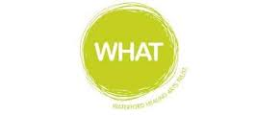

The Waterford Healing Arts Trust, Ireland’s leading arts and health programme, is inviting people to send them those pieces of poetry and prose that bring solace and joy in preparation for a public reading as part of the second Well Festival of Arts and Wellbeing in Waterford.

Cassandra Clare once said “it was books that made me feel that perhaps I was not completely alone” and it is in the spirit of this link between reading and wellbeing that the Waterford Healing Arts Trust is organising this very special event which they are calling ‘We haven’t had an earthquake lately…’ .

If you reach for a favourite poem or prose when you need cheering up, please e-mail it to [WHAT@hse.ie](mailto:WHAT@hse.ie) by **Wednesday 24 September** with ‘earthquake’ in the subject line.  State who the author is and why you chose it. Prose pieces should be no longer than 200 words.

A selection of submissions will be read at a public event in The Book Centre Waterford on World Mental Health Day, Friday 10 October at 6.30pm.

This is the second time that Waterford Healing Arts Trust is hosting this unique literary event which forms part of the programme of the Well Festival of Arts and Wellbeing.  The Well Festival, a joint initiative between Garter Lane and Waterford Healing Arts Trust, celebrates the benefits of participation in the arts for both individuals and the community. It is funded by the Arts Council and will run from 6 – 10 October.

For more information contact:

051-842664,

[WHAT@hse.ie](mailto:WHAT@hse.ie)

[www.waterfordhealingarts.com](http://www.waterfordhealingarts.com)

**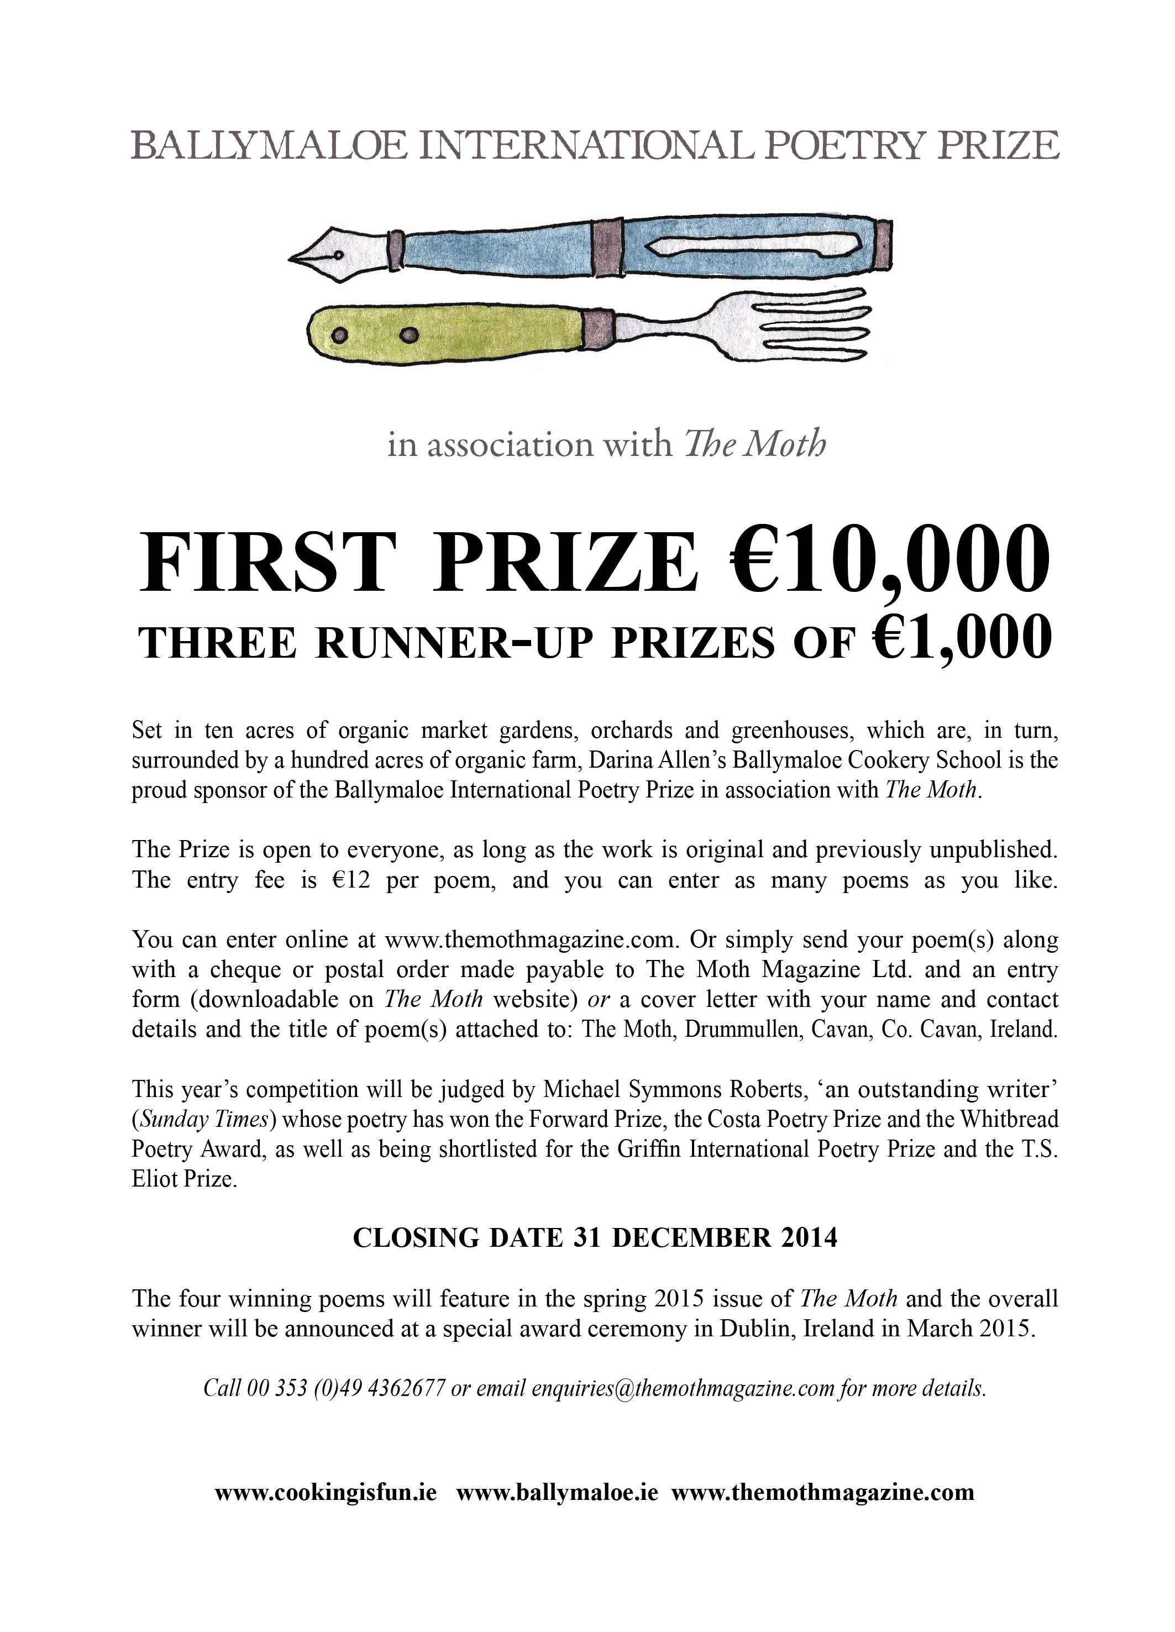**

**CUISLE YOUNG POET OF THE YEAR COMPETITION**

**Closing Date 29th September 2014**

**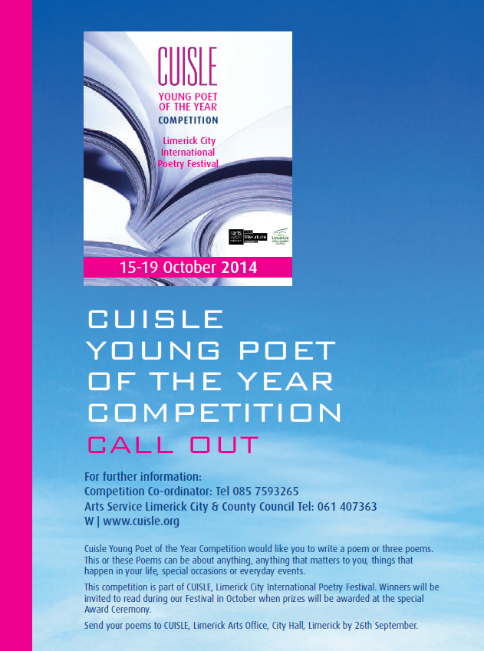**

CUISLE Young Poet of the Year Competition would like you to write a poem or three poems. This or these Poems can be about anything, anything that matters to you, things that happen in your life, special occasions or everyday events. This competition is part of CUISLE, Limerick City International Poetry Festival.

More info at <http://tinyurl.com/l84bncr>

## \_\_\_\_\_\_\_\_\_\_\_\_\_\_\_\_\_\_\_\_\_\_\_\_\_\_\_\_\_\_\_\_\_\_\_\_\_\_\_\_\_\_\_\_\_\_\_\_\_\_\_\_\_\_\_\_\_\_\_\_\_\_\_\_\_\_\_\_\_\_\_\_\_\_\_\_\_\_\_\_\_\_\_\_\_\_\_

**Awards / Bursaries / Schemes**

**\_\_\_\_\_\_\_\_\_\_\_\_\_\_\_\_\_\_\_\_\_\_\_\_\_\_\_\_\_\_\_\_\_\_\_\_\_\_\_\_\_\_\_\_\_\_\_\_\_\_\_\_\_\_\_\_\_\_\_\_\_\_\_\_\_\_\_\_\_\_\_\_\_\_\_\_\_\_\_\_\_\_\_\_\_\_\_**

**Music Capital Scheme 2014**

The Music Capital Scheme, supported by the Department of Arts, Heritage and the Gaeltacht and managed by Music Network, provides funding for the purchase of musical instruments to both non-professional performing groups/ensembles and professional musicians.

The Music Capital Scheme was established by The Arts Council, The IRMA Trust and Music Network in 2008 as an action-research initiative designed to provide support for the purchase of musical instruments.  In response to the success of the initial pilot scheme, funding has been made available since 2011 by the Department of Arts, Heritage and the Gaeltacht.

The Music Capital Scheme is now open for applications and the closing date is Friday 10th October 2014. THE CLOSING DATE IS 4 PM FRIDAY 10th OCTOBER 2014.

Application forms and guidelines can be found at [www.musicnetwork.ie](http://www.musicnetwork.ie). For further details, please contact Music Network Tel 01 475 0224.

**Information Clinics for Music Network Music Capital Scheme 2014**

*Sept 22nd   An Taibhdhearc, 19 Middle Street, Galway                                                                   11.00am – 2.00pm*

*Sept 24th   Music Network, National Concert Hall Building, Earlsforth Terrace, Dublin 2          11.00am – 2.00pm*

*Sept 25th   Triskel Christchurch, Tobin Street, Cork City                                                                   11.00am – 2.00pm*

Music Network will be hosting a series of free information clinics in Galway, Dublin and Cork. The clinics will be presented by the Music Network Programmes Manager and the Programmes Administrator.

The aim of the clinics will be to offer advice to both Stream 1 and Stream 2 applicants to the Music Capital Scheme.  They are primarily intended for applicants who are at a relatively advanced stage in the development of their application to the Music Capital Scheme and/or those who have already begun the process of filling in the application/expression of interest forms. Clinics will involve a brief presentation about the scheme after which a Q & A style session will take place. The event will provide practical advice relating to the Music Capital Scheme, expanding on the information outlined in the guidelines while also addressing specific queries that may not be covered in detail in the guidelines.

For additional information about the Music Capital Scheme and to download a copy of the guidelines please visit <http://www.musicnetwork.ie/musicians/funding/>

Please note that the clinics are free but places are limited. In order to reserve a place please contact the Programmes Administrator, Aoife Faughnan, by September 16th.    
**Note:** It is important to read the guidelines carefully and to confirm your eligibility before reserving a place.

**Email:** [programmesadmin@musicnetwork.ie](mailto:programmesadmin@musicnetwork.ie)  **Phone:** 01 4750224

**David Manley Emerging Entrepreneur Awards** **call for applications**

In 2002, the David Manley Emerging Entrepreneur Awards were established to nurture Ireland’s entrepreneurial spirit in the Business, Arts and the Social spheres. Since then, the awards have provided over €1 million in support to high-potential emerging entrepreneurs. This has been in the form of cash supports and through the gift of time from the awards partners, making lasting impacts on the businesses of our award winners.

The David Manley Emerging Entrepreneur Awards are open to all Arts, Business and Social Enterprises that have been in operation for between 1 and 3 years.  
  
Closing date for applications is 3 October 2014. Application forms available <http://www.davidmanleyawards.ie/>

# Arts Council’s Artist in the Community Scheme - Bursary Award 2014 : Collaborative Dance

The Arts Council Artist in the Community Scheme Bursary Award 2014: Collaborative Dance aims to support individual professional dance artists working in the area of collaborative dance or with groups of non-dancers . This is the fifth year that the Arts Council has provided a €10,000 bursary award as part of the Artist in the Community Scheme, which is managed by Create. This year for the first time the focus will be artform specific as opposed to focusing on a social or community context.

### Purpose and priorities of the award

The purpose of the Bursary Award is to support and nurture professional arts practice and it is specifically aimed at a dance artist/s who have a track record of worked collaboratively with groups to produce dance works/performances.

The Bursary Award of €10,000 provides the selected artist with the time and resources to carry out research, and to reflect on and re-consider the questions associated with creating dance work with non-dancers or those who are not professionally trained.

It is expected that the successful applicant will share the learning arising from the Bursary with the wider dance community and collaborative arts sector.

[Create](http://www.create-ireland.ie/) will work in partnership with [Dance Ireland](http://www.danceireland.ie/) in providing information sessions and on the selection process.

For further information, contact Katherine Atkinson, Professional Development, [support@create-ireland.ie](mailto:support@create-ireland.ie)

**Deadline for applications: 24 October at 5pm.**

### INFORMATION SESSIONS Arts Council’s Artist in the Community Scheme Bursary Award 2014 : Collaborative Dance

In partnership with Dance Ireland Create are hosting two information and discussion events for interested artists Limerick and Dublin:

Date: Sept 24  
Time: 3-4.30pm  
Dance Ireland, Foley Street, Dublin,

Date: Sept 26  
Time: 3-4.30pm  
Dance Limerick, 1 & 2 John's Square, Limerick

Katherine Atkinson Professional Development Create will talk on the Arts Council Artist in the Community Scheme Bursary Award 2014 : Collaborative Dance, on the application process and on how a Bursary can help facilitate and support experiment, research and professional development

[**http://www.create-ireland.ie/bursary-award/artist-in-the-community-scheme-bursary-awardcollaborative-dance-information-sessions-%E2%80%93-september-24-26**](http://www.create-ireland.ie/bursary-award/artist-in-the-community-scheme-bursary-awardcollaborative-dance-information-sessions-%E2%80%93-september-24-26)

**Arts Council of Ireland – Reel Art 2014**

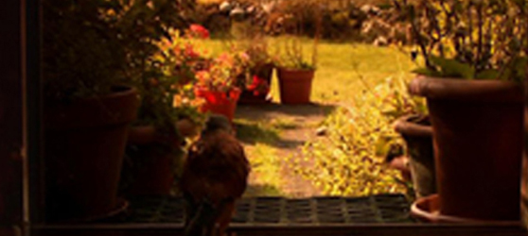

Deadline for receipt of applications: **Friday 17th October 2014, 17:00**.

Reel Art is an Arts Council scheme designed to provide film artists with a unique opportunity to make highly creative, imaginative and experimental documentaries on an artistic theme. Operated in association with Filmbase and the Jameson Dublin International Film Festival, Reel Art will support two films with a grant of **€70-80,000** per project.

Updated guidelines for Reel Art 2014, together with application forms for the scheme are available for download from the website [www.filmbase.ie/reelart](http://newsletter.artscouncil.ie/17xca9zxkab1eenva7sbzm?a=6&p=47682585&t=17684704)  as are details of previous Reel Art projects.

**Arts Council of Ireland – Visual artists in prisons scheme**

Maximum awarded: **€2,400**

This scheme provides financial support to selected visual artists to conduct workshops over a period of 10 days in the education units in any of the Republic’s prisons.

More info of the above funding and contact details at <http://miniurl.com/4b062>

**Arts Council of Ireland –** Writers in schools scheme

Maximum awarded: **€304**

The Writers in Schools Scheme part-funds visits by writers and storytellers to schools throughout the Republic of Ireland.

More info of the above funding and contact details at <http://miniurl.com/4b062>

**Arts Council of Ireland –** [Writers in prisons scheme](http://www.artscouncil.ie/funds/Writers-in-prisons-scheme/)

Maximum awarded: **€1,000**

The scheme offers writers the opportunity to work with prisoners in prison/detention centres and complements an existing arts and education programme in the Education Units within the prison system.

More info of the above funding and contact details at <http://miniurl.com/4b062>

**\_\_\_\_\_\_\_\_\_\_\_\_\_\_\_\_\_\_\_\_\_\_\_\_\_\_\_\_\_\_\_\_\_\_\_\_\_\_\_\_\_\_\_\_\_\_\_\_\_\_\_\_\_\_\_\_\_\_\_\_\_\_\_\_\_\_\_\_\_\_\_\_\_\_\_\_\_\_\_\_\_\_\_\_\_\_\_**

|  |
| --- |
| **Announcing the Jack Harte Bursary** |

|  |
| --- |
| **We are delighted to announce the Jack Harte Bursary -**  **Awarded by the Irish Writers Centre in association with the Tyrone Guthrie Centre.**  The Irish Writers’ Centre and the Tyrone Guthrie Centre at Annaghmakerrig have come   together to offer a two-week fully resourced Writer-in-Residence Bursary to take place in spring 2015. The award is named in honour of Jack Harte, founder of the Irish Writers Centre, in celebration and acknowledgement of his contribution to Irish literature.  **Who Can Apply:**  This is an open call to writers resident in Ireland with a proven track record and at least one book of fiction or short stories published by a recognised publisher.  **How to Apply:** Applications are accepted by email only to [director@writerscentre.ie](mailto:director@writerscentre.ie) .    **Application Deadline:**  **26th September, 2014 at 5pm**.  No late applications will be considered. Applications will be acknowledged  For all other queries, please contact [events@writerscentre.ie](mailto:events@writerscentre.ie)  **\_\_\_\_\_\_\_\_\_\_\_\_\_\_\_\_\_\_\_\_\_\_\_\_\_\_\_\_\_\_\_\_\_\_\_\_\_\_\_\_\_\_\_\_\_\_\_\_\_\_\_\_\_\_\_\_\_\_\_\_\_\_\_\_\_\_\_\_\_\_\_\_\_\_\_\_\_\_\_\_\_\_\_\_\_\_\_** |

# Crafts Council of Ireland – External Exhibitions Fund

# **Deadline 19 September**

[Design & Crafts Council of Ireland](http://www.dccoi.ie/)

**The Crafts Council of Ireland is inviting funding proposals for exhibitions featuring Irish craft in Ireland or abroad.**

**The Crafts Council of Ireland (CCoI) is the main champion of the craft industry in Ireland, fostering its growth and commercial strength, communicating its unique identity and stimulating quality design, innovation and competitiveness. CCoI’s  activities are funded by the Department of Enterprise, Trade and Innovation via Enterprise Ireland.**

The Design & Crafts Council of Ireland’s (DCCoI) External Exhibitions Fund has been established to assist the development of high-quality, independent exhibitions run by individuals, organisations or groups including DCCoI Guilds, Associations, Networks & Societies (GANS).

Funding proposals are invited for exhibitions featuring Irish craft/design in Ireland or abroad. This annual fund will support a small number of professionally produced exhibitions featuring Irish craft/design in Ireland or abroad. This call will fund activities due to take place in 2015. The maximum that will be allocated to any individual proposal is €5,000.

Projects must demonstrate match-funding, revenue or funding from other sources. Exhibitions can be in recognised venues or one-off/ site-specific projects, organised by individuals, groups, partnerships or organisations.

In 2015, priority will be given to exhibitions that engage in collaborative practice and/or explore the future landscape, role and value of craft and design and its wider relationships with innovation.

### How to Apply

[Visit the Council website](http://www.dccoi.ie/craftspeople/opportunities/funding-proposals-invited-for-exhibitions-featuring-irish-craft-design-in-i)  http://www.dccoi.ie/

### Arts Council's Artist in the Community Scheme - Bursary Award 2014: Collaborative Dance

Deadline:  **24th October (5pm)**

Web: [www.create-ireland.ie](http://www.create-ireland.ie)

The Arts Council Artist in the Community Scheme Bursary Award 2014: Collaborative Dance aims to support individual professional dance artists working in the area of collaborative dance or with groups of non dancers . This is the fifth year that the Arts Council has provided a **€10,000** bursary award as part of the Artist in the Community Scheme, which is managed by Create. This year for the first time the focus will be art-form specific as opposed to focusing on a social or community context.

The Bursary Award of **€10,000** provides the selected artist with the time and resources to carry out research, and to reflect on and re-consider the questions associated with creating dance work with non dancers or those who are not professionally trained.It is expected that the successful applicant will share the learning arising from the Bursary with the wider dance community and collaborative arts sector.

Create will work in partnership with Dance Ireland in providing information sessions and on the selection process and details on the dates for the sessions will be announced on

[www.create-ireland.ie](http://r20.rs6.net/tn.jsp?f=001m_3HN6KNk-_p-lEuScFgF_UY6xVp4vNqCYfvI774zvPzJRuBVTviPmR0bhAhK4xEKkLqk7V1qB_nULsCET51obKdkVpOPftQSyf2BNHXd1BoAPVYvcbRMI1B7QkcCrbu_mu-VoT-BtoybBJfGs04rnhjzQLVlM0W6QdTSBfnhdquK8poMUydjg==&c=b3o4qYKY5DRFLoW7qs_or2gpbar_P3jxMjR9oNqZJG2uemcoc1SpNQ==&ch=V-wO1x9Pap4bDqoHf7ynABRbSPcRgTxqSOSf5GaLTsQnSKlON1G8ww==)

[www.danceireland.ie](http://r20.rs6.net/tn.jsp?f=001m_3HN6KNk-_p-lEuScFgF_UY6xVp4vNqCYfvI774zvPzJRuBVTviPm0ghaMIryxQhbp6zz_4FBRPZoJ39XwBzTHvIiwNKwoqGC3HlWBx8OoT_FRc84jCQPxI1SDDUIxecWzdycw44t-qt8veRy9wAaNlt5_BmQ9CXqmDkwkLs6I=&c=b3o4qYKY5DRFLoW7qs_or2gpbar_P3jxMjR9oNqZJG2uemcoc1SpNQ==&ch=V-wO1x9Pap4bDqoHf7ynABRbSPcRgTxqSOSf5GaLTsQnSKlON1G8ww==)

For further information on the application, contact Katherine Atkinson, Professional Development, [support@create-ireland.ie](mailto:support@create-ireland.ie)

**\_\_\_\_\_\_\_\_\_\_\_\_\_\_\_\_\_\_\_\_\_\_\_\_\_\_\_\_\_\_\_\_\_\_\_\_\_\_\_\_\_\_\_\_\_\_\_\_\_\_\_\_\_\_\_\_\_\_\_\_\_\_\_\_\_\_\_\_\_\_\_\_\_\_\_\_\_\_\_\_\_\_\_\_\_**

**European Union Prize for Cultural Heritage / Europa Nostra Awards**

[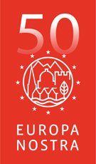](http://www.europanostra.org/)

The **European Union Prize for Cultural Heritage / Europa Nostra Awards** is Europe’s most prestigious prize in the heritage field. Every year, it honours the most outstanding heritage achievements from all over Europe. It recognises the excellence and dedication by architects, craftsmen, cultural heritage experts, volunteers, schools, local communities, heritage owners and the media. It stimulates creativity and innovation, through the power of example.

**DEADLINE 15th OCTOBER 2014**

In 2015, the Awards will be given to up to 30 remarkable heritage projects and initiatives in four categories. Up to seven will be selected as Grand Prix winners and receive **€10,000 each**. One will get the Public Choice Award.

More info at <http://www.europanostra.org/apply-for-an-award-2015/>

**European Cultural Foundation – STEP travel grants – ongoing**

[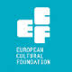](http://www.google.ie/url?url=http://sideshow-circusmagazine.com/research/funding-sources/step-beyond-travel-grants&rct=j&frm=1&q=&esrc=s&sa=U&ei=nYDGU4mnCtKe7AbIhYDoCw&ved=0CCAQ9QEwBg&usg=AFQjCNGnthfC8RitJQx109ixVGPR1pNiAA)

**STEP Beyond Travel grants fund up and coming artists and cultural workers – giving priority to individuals up to 35 years and/or in the first 10 years of their career – to travel between EU and countries bordering the EU.**

There is no deadline for this grant scheme, so you can apply at any time but at least one month before your planned travel. The selection process takes up to one month.

For more information on how to apply, a list of eligible travel destinations and to access the application form, go to the “how to apply guidelines”: [http://tinyurl.com/p26gd7n](http://tinyurl.com/p26gd7n%20)

These guidelines are also available in Russian but please note that the final application has to be in English. You can also access the application form directly here – [ecflabs.org/step-beyond-apply?gids[]=4707#group\_step\_1](http://ecflabs.org/step-beyond-apply?gids%5b%5d=4707#group_step_1)

**\_\_\_\_\_\_\_\_\_\_\_\_\_\_\_\_\_\_\_\_\_\_\_\_\_\_\_\_\_\_\_\_\_\_\_\_\_\_\_\_\_\_\_\_\_\_\_\_\_\_\_\_\_\_\_\_\_\_\_\_\_\_\_\_\_\_\_\_\_\_\_\_\_\_\_**

**The Golden Fleece Award - Call for Applications for the 2015 Award**

****

The Golden Fleece Award aims to support and promote the diversity of contemporary Irish creativity in the arts and crafts. Its mission is to help artists of innovative talent, needing support at strategic stages of their careers. Applicants will normally have been born on the island of Ireland and must maintain a strong connection with Ireland. They should be artists or researchers working in the area of figurative visual art or of the traditional crafts.

Closing date for applications: **Friday, 21st November 2014**

Full details of submission requirements and procedures can be found on our website at www.goldenfleeceaward.com.

# \_\_\_\_\_\_\_\_\_\_\_\_\_\_\_\_\_\_\_\_\_\_\_\_\_\_\_\_\_\_\_\_\_\_\_\_\_\_\_\_\_\_\_\_\_\_\_\_\_\_\_\_\_\_\_\_\_\_\_\_\_\_\_\_\_\_\_\_\_\_\_\_\_\_\_\_\_\_\_\_\_\_\_\_\_\_\_

**Of Interest**

# \_\_\_\_\_\_\_\_\_\_\_\_\_\_\_\_\_\_\_\_\_\_\_\_\_\_\_\_\_\_\_\_\_\_\_\_\_\_\_\_\_\_\_\_\_\_\_\_\_\_\_\_\_\_\_\_\_\_\_\_\_\_\_\_\_\_\_\_\_\_\_\_\_\_\_\_\_\_\_\_\_\_\_\_\_\_\_

[](http://www.newrosspianofestival.com/NRPF/)



Beatrice Berrut (Photo: Aline Fournier)

The ninth New Ross Piano Festival will turn its attention to music for piano and wind instruments, as we welcome **Cassiopeia Winds**, a group of five bright stars from Dublin. They will partner our pianists in music by Mozart, Rimsky-Korsakov, Caplet and Poulenc. And what wonderful pianists we have for you this year! Young titans **Lise de la Salle** from France and **Joseph Moog** from Germany will make their Irish débuts, while seasoned Singaporean **Melvyn Tan** will make a long-overdue return. **Beatrice Berrut** is making waves in Switzerland. Artistic Director **Finghin Collins** needs no introduction.

This year we also launch a new project: The **Ros Tapestry Suite**. The first five panels of the Ros Tapestry have inspired the creation of five new solo piano pieces (each lasting five minutes) by five very different Irish composers: **Sebastian Adams, Elaine Agnew, Gerald Barry, John Kinsella and Gerry Murphy**. Five world premieres by five pianists across the weekend. This is an additional reason, if any is needed, not to miss this wonderful weekend.

Help us spread the word – follow us on Twitter and like us on Facebook. We will launch on board the Dunbrody Famine Ship in New Ross on Wednesday August 20th at 6.30pm. All are welcome.

<http://www.newrosspianofestival.com/>

**Sculpture in Context 2014 at the National Botanic Gardens**

4th September – 17th October 2014  
National Botanic Gardens, Glasnevin, Dublin 9.  
Opening Times: Monday – Friday 9am to 5pm; Saturday & Sunday 10am – 6pm; (Botanic Garden Café open daily)

Sculpture in Context 2014 returns once again to the National Botanic Gardens this September, showcasing the work of Irish and international artists, it is the largest and most exciting outdoor sculpture exhibition in Ireland.

For the duration of the exhibition, the 50 acre botanical paradise will be transformed into a magnificent outdoor gallery, providing a striking backdrop for the sculptures. This quiet oasis is just 3.5 km from the centre of Dublin City and provides a wonderful venue for artists to create work in response to specific surroundings. Visitors will discover sculptures in the most unexpected and surprising places. Over 150 sculptures will be displayed in the gardens, ponds, Great Palm House, and Curvilinear Range of glasshouses. Smaller pieces are exhibited in the gallery above the visitors’ centre.

Sculpture in Context is a thought provoking, inspirational and unique experience and offers an unparalleled opportunity to view Ireland’s well established and most promising artists.

This year will see the addition of a major new award – The New Ireland Assurance Sculpture Award

Guided Tours: Saturdays at 3pm, and Tuesday mornings at 10.30 for the duration of the exhibition.

ADMISSION FREE | Car Park €2.

The National Botanic Gardens are located 3 Kilometres North of Dublin city centre, 10 minutes by bus from O’Connell Street (Nos. 4, 9 and 83)

For further information please see [www.sculptureincontext.com](http://lists.visualartists.ie/lt.php?c=1200&m=4239&nl=1&s=d3c261c0eeb6b48867f449d29e09414b&lid=94008&l=-http--www.sculptureincontext.com)

**Arts Council Announces Appointment of New Arts Director**

The Arts Council has announced the appointment of Liz Meaney as its new Arts Director to join its senior management team.

Liz is an experienced Arts Manager, who has worked in both the private and public sectors. Following graduation she worked with the Cork Film Centre, Cork Film Festival and was Development Officer with the Kino Cinema. She was Manager of the Galway Film Centre from 1997-2001. Returning to Cork in 2001 she took up her position as Cork City Council Arts Officer and was involved both in the bid for the nomination and the realisation of Cork as European Capital of Culture 2005.

During her time with Cork City Council their support for the arts has increased as part of overall budget provision, particularly post European Capital of Culture 2005. These levels of support were substantially maintained in recent years, with increased support for project, bursary and arts in context funding being announced in 2013.

She has served on the boards of Cork 2005 European Capital of Culture, the Association of Irish Festivals and Events, and Cork Midsummer Festival. She has served as Chair of the Association of Local Authority Arts Officers. Her experience ranges from the commissioning of large scale public spectacles with audiences in excess of 150,000 to long term strategic planning for the arts as well as grand aid management and execution.

Capital cultural development projects on which she has worked include Triskel Christchurch, the Munster Literature Centre and the Guesthouse Project Space. Events managed include A Cork Christmas Celebration, winner of Best Festival in Ireland from Chamber Ireland in 2010, to Culture Night, which attracted in excess of 37,000 individual visits to venues in 2012. She also was responsible for the Arts & Cultural Strategy of Cork City Council 2011 – 15.

Liz has commissioned cultural work for the Shanghai Expo 2010 and for the Cork programme during the Irish tenure as President of the EU 2013.

A graduate of University College Cork, Liz has a Masters in Irish History. She is a certified IPI Project Manager, and has a Diploma in Irish Local Government Studies through the Institute of Public Administration. She was selected by Business to Arts for a leadership development programme in 2007.

Liz will take up her position as Arts Director for Performing and Local Arts in October.

[www.artscouncil.ie](http://lists.visualartists.ie/lt.php?c=1204&m=4243&nl=1&s=e784eec6bf8bb9680747b324b9c9eee1&lid=93874&l=-http--www.artscouncil.ie)

**Ethics & Transition: Read All About it**

Full reports of the AICA / VAI panel discussions – 'Artists and Ethics' and 'Art in Time of Transition' – held at the VAI Get Together 2014 (23 May); have been posted to the [AICA Ireland website.](http://lists.visualartists.ie/lt.php?c=1219&m=4258&nl=1&s=bad97c655476f96a390a72c05a742011&lid=94917&l=-http--www.aica.ie/category/articles/)

'**Art in a Time of Transition**' brought together UK art historian / theorist Paul Wood, critic / artist James Merrigan and curator / arts manager Cliodnha Shaffrey to consider the following questions: Is the present typified by socio-political, economic and environmental crises? How is current art practice, mediation, curating, criticism and collecting reflecting upon this geo-cultural turmoil? What are the alternatives to neo-liberal blandishments that posit consumerism and capitalism as the eternal order? Critic and academic Declan Long chaired the discussion.

The panellists for '**Artists and Ethics**' were: Elaine A King (Carnegie Mellon University, USA), a specialist in the field of art and ethics; socially engaged Irish artist Brian Maguire and the writers Gemma Tipton (Irish Times, RTE, Artforum) and Fionola Meredith (Irish Times, Belfast Telegraph, Guardian, BBC NI). Artist Alan Phelan chaired the discussion. The event focused on: the ethics of art production; the relationships between artists, subjects and audiences; and how art world super-structures – professional individuals, institutions and the market – influence the financial and reputational value of art and artists.

[www.aica.ie/category/articles](http://lists.visualartists.ie/lt.php?c=1219&m=4258&nl=1&s=bad97c655476f96a390a72c05a742011&lid=94918&l=-http--www.aica.ie/category/articles)