**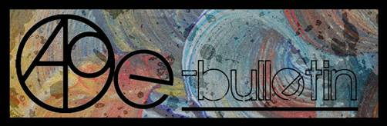**

**Kilkenny County Council Arts Office- E-bulletin 2nd May, 2014**

Dear All,   
  
Welcome to this week’s e-bulletin from Kilkenny County Council's Arts Office. Each bulletin is packed with the latest information on Kilkenny Arts Office activities, county events as well as news and opportunities for arts practitioners from around the country.

We have decided to shorten information included in the e-bulletin for easier use. This should particularly work well for those reading off tablets and smartphones.

This service will be provided fortnightly. To include an item in the next e-bulletin please send a brief outline of your advert with relevant contact details, including any websites or pages with links to [julianne.morgan@kilkennycoco.ie](mailto:julianne.morgan@kilkennycoco.ie) **before 14th May**. The next e-bulletin will be on **16th May**.

**PLEASE NOTE THE NEW EMAIL ADDRESS TO SEND INFORMATION FOR INCLUSION IN THE E-BULLETIN.**

While every effort has been made to ensure the accuracy of our information, we strongly advise readers to verify all details to their own satisfaction.  
Regards,  
Julianne Morgan  
Arts Office  
T: 056 7794938  
E: [Julianne.Morgan@kilkennycoco.ie](mailto:Julianne.Morgan@kilkennycoco.ie)   
W: [www.kilkennycoco.ie/eng/Services/Arts/](http://www.kilkennycoco.ie/eng/Services/Arts/)  
Kilkenny County Council Arts Office Partner Local Authority of the ArtLinks Programme [www.artlinks.ie](http://www.artlinks.ie)

**\_\_\_\_\_\_\_\_\_\_\_\_\_\_\_\_\_\_\_\_\_\_\_\_\_\_\_\_\_\_\_\_\_\_\_\_\_\_\_\_\_\_\_\_\_\_\_\_\_\_\_\_\_\_\_\_\_\_\_\_\_\_\_\_\_\_\_\_\_\_\_\_\_\_\_**

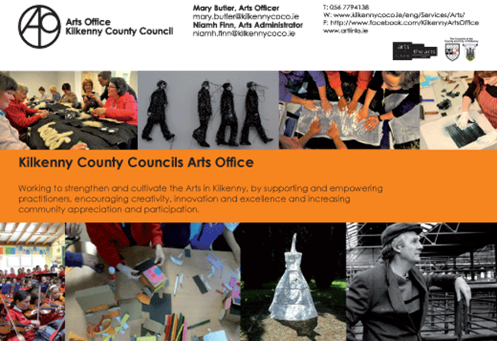

**\_\_\_\_\_\_\_\_\_\_\_\_\_\_\_\_\_\_\_\_\_\_\_\_\_\_\_\_\_\_\_\_\_\_\_\_\_\_\_\_\_\_\_\_\_\_\_\_\_\_\_\_\_\_\_\_\_\_\_\_\_\_\_\_\_\_\_\_\_\_\_\_\_\_\_**

**Exhibition ‘THE UNHAPPY ISLAND’, works by Saturio Alonso**

**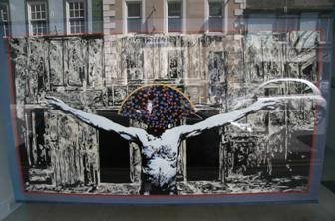**

An exhibition by Saturio Alonso is now on display in windows of Kilkenny Arts Office, no.76, John Street.

Images will change every few days/weeks.

**\_\_\_\_\_\_\_\_\_\_\_\_\_\_\_\_\_\_\_\_\_\_\_\_\_\_\_\_\_\_\_\_\_\_\_\_\_\_\_\_\_\_\_\_\_\_\_\_\_\_\_\_\_\_\_\_\_\_\_\_\_\_\_\_\_\_\_\_\_\_\_\_\_\_\_**

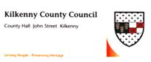

**Call for Submissions: Kilkenny Poetry Broadsheet Issue 14**

Kilkenny County Council Arts Office is delighted to announce a call for submissions for the publication of the fourteenth issue of the very popular **Kilkenny Poetry Broadsheet**. The aim of the publication is to give local writers a platform for their work. Each poem selected is included in the broadsheet which is available free throughout the County. One hundred and three poems were submitted for inclusion by forty one writers for the 2013 edition.

This fourteenth issue of Kilkenny Poetry Broadsheet will be edited by Enda Coyle-Greene.

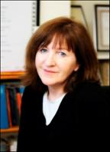    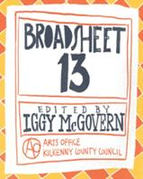

Enda Coyle-Greene lives in Co. Dublin. Published widely in print and online journals, she is also a frequent contributor to programmes on RTÉ Radio.

Her work featured in anthologies such as *Sunday Miscellany – a Selection from 2004 -2006* (2006), *The Echoing Years* – *An Anthology of Contemporary Poetry and Translation from Canada and Ireland* (2007), *The Quiet Quarter – Ten Years of Great Irish Writing,* (2009), *Shine On* – *Irish Writers for Shine* (2011) and, most recently, *If Ever You Go – A Map of Dublin in Poetry and Song*, the UNESCO City of Literature, Dublin: One City, One Book title for 2014.

Her first collection of poetry, *Snow Negatives,* won the Patrick Kavanagh Award in 2006 and was published by the Dedalus Press the following year. Her second collection, *Map of the Last*, also from Dedalus, was published in 2013.

We are now accepting submissions from poets born or based in Kilkenny City and County.

Application forms and submission rules are available from the Arts Office, John’s Green house, John’s Green, Kilkenny. T: 056 7794138 E: [niamh.finn@kilkennycoco.ie](mailto:niamh.finn@kilkennycoco.ie) / [julianne.morgan@kilkennycoco.ie](mailto:julianne.morgan@kilkennycoco.ie)

Or can be downloaded from:

[www.kilkennycoco.ie/eng/Services/Arts](http://www.kilkennycoco.ie/eng/Services/Arts)

No electronic submissions accepted.

**Closing date for receipt of submissions is no later than 4pm on Friday 23rd May.**

**Ends.**

Images:  Enda Coyle-Greene and Broadsheet 2013

For further information or images please contact The Arts Office

T: 056 7794138 / E: [niamh.finn@kilkennycoco.ie](mailto:niamh.finn@kilkennycoco.ie)

**\_\_\_\_\_\_\_\_\_\_\_\_\_\_\_\_\_\_\_\_\_\_\_\_\_\_\_\_\_\_\_\_\_\_\_\_\_\_\_\_\_\_\_\_\_\_\_\_\_\_\_\_\_\_\_\_\_\_\_\_\_\_\_\_\_\_\_\_\_\_\_\_\_\_\_**

# Open Circle Community arts collective

# Open Circle Community arts collective

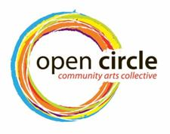

**Open Circle Community Arts Collective is a community-based, for-impact organisation whose mission is to inspire interest and maximum participation in the arts both locally and nationally for Kilkenny women.** We are committed to offering programmes that are characterised by quality arts learning experiences and inspiring arts participatory engagements.

Open Circle Community Arts was founded in 2013. It is a small community arts organisation based in Kilkenny City which seeks to make the arts available and accessible to woman of all ages and from all walks of life. The heart of the project is our community art space the Open Circle Art House.

The Open Circle Art House is a social space for learning and creating communally. It aims to provide an outlet for creative community involvement, while seeking to produce quality arts learning experiences and inspiring arts participatory engagements.

Embroidered self portraits from textile artist Dee Harte's workshop in February 2014

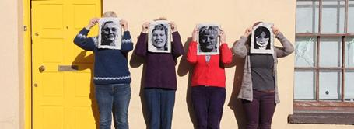

Read more about Open Circle at <http://www.kilkennycoco.ie/eng/Services/Arts/Programmes/>

E: [opencirclearts@gmail.com](mailto:opencirclearts@gmail.com)

LIKE us on [facebook/OpenCircleCommunityArts](https://www.facebook.com/OpenCircleCommunityArts" \t "_blank)

Follow us [@opencirclearts](https://twitter.com/opencirclearts)

**\_\_\_\_\_\_\_\_\_\_\_\_\_\_\_\_\_\_\_\_\_\_\_\_\_\_\_\_\_\_\_\_\_\_\_\_\_\_\_\_\_\_\_\_\_\_\_\_\_\_\_\_\_\_\_\_\_\_\_\_\_\_\_\_\_\_\_\_\_\_\_\_\_\_\_**

**Siamsa 2014**

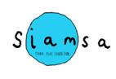

***“Now that your children have covered the laws of Physics, we are introducing them to environmental chemistry”***

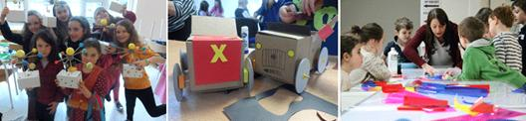

Kilkenny County Council Arts Office is delighted to be hosting its 2014 ‘Siamsa’ programme for 5 to12 year olds. This year a five week programme runs on Sunday’s March 23rd and 30th, May 4th, 11th, and 18th. The programme will offer children the opportunity to learn about the natural environment around them through the integration of science and art using a variety of exciting workshops and projects.

‘Siamsa’ has been part of the Arts Office’s programme since 2011. This fun programme has supported children in developing numerous skills including drawing, painting and making in a diverse range of media. The workshops have included origami, clay modelling, Lego art as well as textile work. Our most recent workshop included arts and science working together.

Following the positive experiences of previous participants, this year’s workshops include practical, hands-on learning experience through scientific experiments and art making projects. Participants will learn about the water cycle and plants by creating their own mini greenhouse garden, explore the secret lives of flowers, get down and dirty with the surprising science of soil, extract DNA from a strawberry and more curious discoveries!

**Ends.**

For further information contact:

Mary Butler

E: [mary.butler@kilkennycoco.ie](mailto:mary.butler@kilkennycoco.ie)

W: <http://miniurl.com/c4kI>

Kilkenny County Council Arts Office Partner Local Authority of the ArtLinks Programme [www.artlinks.ie](http://www.artlinks.ie)

**\_\_\_\_\_\_\_\_\_\_\_\_\_\_\_\_\_\_\_\_\_\_\_\_\_\_\_\_\_\_\_\_\_\_\_\_\_\_\_\_\_\_\_\_\_\_\_\_\_\_\_\_\_\_\_\_\_\_\_\_\_\_\_\_\_\_\_\_\_\_\_\_\_\_\_**

# Spring 2014 Writers' Workshops

# Spring 2014 Writers' Workshops



**As part of our on-going commitment to Kilkenny writers, Kilkenny County Council Arts Office & Library Service programmed their Spring 2014 Writers' Workshops. This year's Spring workshops were facilitated by two professional writers.**

Creative Prose with Ken Bourke

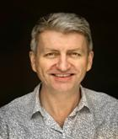

Over six weeks, participants had the opportunity to develop their prose-writing skills in a relaxed atmosphere. They were encouraged to identify their writing objectives in terms of how, where, what and when they will write. The workshops focused on shorter prose forms, but there were opportunities to discuss other aspects of story-telling, and the focus and objectives of the workshop were tailored to the needs of the participants. All levels of experience were welcome, the diversity of the group was one of their key resources, and numbers were limited to encourage full participation by all present. Thomastown library hosted these workshops.

Ken Bourke has been a professional writer for over twenty years. He is an experienced facilitator and has worked with a wide range of groups. He lives in Kilkenny.

Creative Prose workshop participants

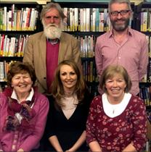

'Poetry for Spring: Getting Started' with Derek Coyle

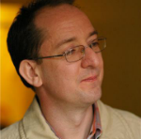

Participants started plenty of new work in the course of six weeks. They began many short pieces, but also started a longer poem and continued working on it. In the workshops they learned what to look at in a poem from a writer's point of view. They worked on developing their skills as makers of poems by learning how to read and examine carefully the work of other makers. Participants learned some new words and techniques so that they can become more confident readers and writers of poetry. Participants learned about line-breaks, couplets, quatrains, irony and satire. Along the way they looked at a selection of poems by well established poets from Ireland and abroad. St. Mary's Day Care Centre hosted these workshops.

Derek Coyle lectures in English Literature and Irish Studies at Carlow College. Recently, he has had poems published in Mexico, in Cuadrivio, in their Irish issue. He has been shortlisted for the Patrick Kavanagh Award (2010), and the Bradshaw Prize (2011).

**Ends.**

For further information contact:   
Mary Butler   
Arts Officer  
E: [mary.butler@kilkennycoco.ie](mailto:mary.butler@kilkennycoco.ie)

W: <http://miniurl.com/7Sby>

Kilkenny County Council Arts Office Partner Local Authority of the ArtLinks Programme [www.artlinks.ie](http://www.artlinks.ie)

**\_\_\_\_\_\_\_\_\_\_\_\_\_\_\_\_\_\_\_\_\_\_\_\_\_\_\_\_\_\_\_\_\_\_\_\_\_\_\_\_\_\_\_\_\_\_\_\_\_\_\_\_\_\_\_\_\_\_\_\_\_\_\_\_\_\_\_\_\_\_\_\_\_\_\_**

**Kilkenny Events**

**\_\_\_\_\_\_\_\_\_\_\_\_\_\_\_\_\_\_\_\_\_\_\_\_\_\_\_\_\_\_\_\_\_\_\_\_\_\_\_\_\_\_\_\_\_\_\_\_\_\_\_\_\_\_\_\_\_\_\_\_\_\_\_\_\_\_\_\_\_\_\_\_\_\_\_**

**Upstairs Gallery – ‘More is More’**

***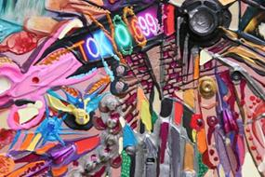***

Venue:The Upstairs Gallery, The Watergate Theatre, Parliament Street, Kilkenny City

Date: **Thursday May 1st**

Time: **6pm**

Catherine Ryan invites you to her art exhibition, ‘More is More’ taking place in the Upstairs Gallery, at the Watergate Theatre, Parliament Street, in the beautiful city of Kilkenny. Catherine Ryan is a mixed media painter whose main obsession is with city life. Her painting/collages consist of small objects incorporated into intricate playful pieces.

Catherine has just returned from her first international exhibition in New York City.

W: [www.catherineryanart.com](http://www.catherineryanart.com)

[www.thecopperhousegallery.com](http://www.thecopperhousegallery.com)

Email: [redzer3@gmail.com](mailto:redzer3@gmail.com)

Mobile: 0857053979

Watergate: [www.watergatetheatre.com](http://www.watergatetheatre.com)

Upstairs gallery: <http://www.upstairs-gallery.org/>

**\_\_\_\_\_\_\_\_\_\_\_\_\_\_\_\_\_\_\_\_\_\_\_\_\_\_\_\_\_\_\_\_\_\_\_\_\_\_\_\_\_\_\_\_\_\_\_\_\_\_\_\_\_\_\_\_\_\_\_\_\_\_\_\_\_\_\_\_\_\_\_\_\_\_\_**

**Watergarden Art Group Exhibition 2014**

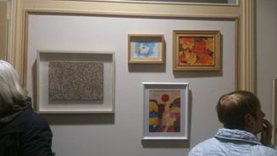

Venue: The Watergarden, Thomastown.

Exhibition Opening: **11th April- 9th May 2014**

**\_\_\_\_\_\_\_\_\_\_\_\_\_\_\_\_\_\_\_\_\_\_\_\_\_\_\_\_\_\_\_\_\_\_\_\_\_\_\_\_\_\_\_\_\_\_\_\_\_\_\_\_\_\_\_\_\_\_\_\_\_\_\_\_\_\_\_\_\_\_\_\_\_\_\_**

**Kilkenny Youth Theatre presents Romeo & Juliet**

**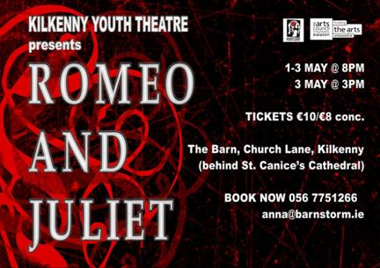**

***Love, hate, death, youth, kissing, fighting - Shakespeare, now he knew how to write a play!***

Barnstorm’s Kilkenny Youth Theatre present the ultimate tale of star-crossed lovers, William Shakespeare’s **‘Romeo and Juliet’**. Following on from the success of the twisted Gormenghast and the noir KoHL, Kilkenny Youth Theatre look forward to taking on The Bard.

‘Romeo & Juliet’ is running from **Thurs 1st May to Sat 3rd May, 8pm**, with a matinee on 3rd May, 3pm, at The Barn, Church Lane, Kilkenny (behind St. Canice’s Cathedral).

Tickets are **€10/€8 conc**., and can be booked at 056 7751266 or by emailing [anna@barnstorm.ie](http://kk-moss/Sites/arts_office/Shared%20Documents/Julianne%20Morgan/E-bulletin/4th%20April/anna@barnstorm.ie).

**\_\_\_\_\_\_\_\_\_\_\_\_\_\_\_\_\_\_\_\_\_\_\_\_\_\_\_\_\_\_\_\_\_\_\_\_\_\_\_\_\_\_\_\_\_\_\_\_\_\_\_\_\_\_\_\_\_\_\_\_\_\_\_\_\_\_\_\_\_\_\_\_\_\_\_**

**Sessions House Arts Centre - Thomastown**

**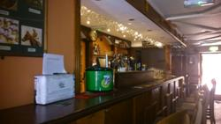**

By now you may have seen these mysterious boxes around town??  
  
Voices of the Session House is reaching out to you – the community to help gather as much information as possible about the old court house before all the important stories, he...roes, villains or cases which have helped shape our town are forgotten. If you have a story you would like to share please write it on one of the attached sheets and pop it into the box or send a facebook message to Rachel.  
  
We look forward to all your stories – the good, the bad and the ugly!!!

Facebook: <http://tinyurl.com/knbrlcg>

**\_\_\_\_\_\_\_\_\_\_\_\_\_\_\_\_\_\_\_\_\_\_\_\_\_\_\_\_\_\_\_\_\_\_\_\_\_\_\_\_\_\_\_\_\_\_\_\_\_\_\_\_\_\_\_\_\_\_\_\_\_\_\_\_\_\_\_\_\_\_\_\_\_\_\_**

# Karen Morgan - Relocation

[](http://karenmorganceramics.us2.list-manage.com/track/click?u=ba39b6c28a49b548e4a224b3d&id=6410e64451&e=6557abd8d2)

Relocation

As of **21st April** this year we will be relocating to Jerpoint Church in Thomastown. Please keep an eye on our facebook page to see developments and new opening hours etc. Open to visit from **12th May 2014.**  
[Karen Morgan Porcelain,  
Market St,  
Thomastown  
karenmorganporcelain@gmail.com](mailto:Karen%20Morgan%20Porcelain,%0bMarket%20St,%0bThomastown%0bkarenmorganporcelain@gmail.com)  
[https://www.facebook.com/karenmorganporcelain](http://karenmorganceramics.us2.list-manage.com/track/click?u=ba39b6c28a49b548e4a224b3d&id=50fa510270&e=6557abd8d2)

[https://www.facebook.com/theirishmakersmarket](http://karenmorganceramics.us2.list-manage1.com/track/click?u=ba39b6c28a49b548e4a224b3d&id=420c509314&e=6557abd8d2)  
[0861663691](http://karenmorganceramics.us2.list-manage2.com/track/click?u=ba39b6c28a49b548e4a224b3d&id=b8897c429f&e=6557abd8d2)

**\_\_\_\_\_\_\_\_\_\_\_\_\_\_\_\_\_\_\_\_\_\_\_\_\_\_\_\_\_\_\_\_\_\_\_\_\_\_\_\_\_\_\_\_\_\_\_\_\_\_\_\_\_\_\_\_\_\_\_\_\_\_\_\_\_\_\_\_\_\_\_\_\_\_\_**

**Bealtaine Festival, 1st – 31st May**

[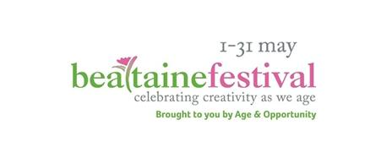](http://bealtaine.com/)

May belongs to the Bealtaine festival, celebrating creativity as we age! Over 120,000 people now take part in Bealtaine. From dance to cinema, painting to theatre, Bealtaine showcases the talents and creativity of both first-time and professional older artists. There will be many events taking place throughout Kilkenny City and County during the month of May.

For a listing of Kilkenny events, see <http://tinyurl.com/nesy8rt>

**\_\_\_\_\_\_\_\_\_\_\_\_\_\_\_\_\_\_\_\_\_\_\_\_\_\_\_\_\_\_\_\_\_\_\_\_\_\_\_\_\_\_\_\_\_\_\_\_\_\_\_\_\_\_\_\_\_\_\_\_\_\_\_\_\_\_\_\_\_\_\_\_\_\_\_**

## Smithwick’s Kilkenny Roots Festival, 2nd – 5th May

## Smithwick’s Kilkenny Roots Festival 2014

The 17th Smithwick’s Kilkenny Roots Festival runs from the **2nd to 5th May 2014**.  The festival features a mix of Irish and International acts from USA, Canada and the UK.  In addition to 20 ticketed show, over 60 free performances will take place on the Music Trail in venues throughout the City.

**Friday 2nd May**

* **8pm** - The Webb Sisters - The Watergate Theatre, Parliment St - **€20**
* **8pm** - Hidden Highways - Billy Byrnes, John St - **€10**
* **9pm** - My Darling Clementine - Ryans Bar, Friary St - **€12**
* **10pm** - Trad Session - Bollards, Kieran St

**Web**: [www.kilkennyroots.com](http://www.kilkennyroots.com)  
**Facebook**: [facebook.com/KilkennyRootsFestival](https://www.facebook.com/KilkennyRootsFestival)  
**Twitter**: [twitter.com/KilkennyRoots](https://twitter.com/KilkennyRoots)  
**E-Mail**: [info@kilkennyroots.com](mailto:info@kilkennyroots.com)  
**Contact Number**: 056 7763669/086 814 6421

Hear Spotify playlist featuring some of the artists -> [play.spotify.com/](https://play.spotify.com/user/1155798557/playlist/7cY77QFQflUPLZVlr8Zeir)

**\_\_\_\_\_\_\_\_\_\_\_\_\_\_\_\_\_\_\_\_\_\_\_\_\_\_\_\_\_\_\_\_\_\_\_\_\_\_\_\_\_\_\_\_\_\_\_\_\_\_\_\_\_\_\_\_\_\_\_\_\_\_\_\_\_\_\_\_\_\_\_\_\_\_\_**

**Live Music: Acoustic Folk Ballad & Blues Set from Philip Coulter, the Dylan Whisky Bar, John St.**

**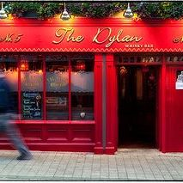**

Venue: The Dylan Whisky Bar

Date: **Friday,** **2nd May, 9pm**

### The Dylan Whisky Bar

5 John Street, Kilkenny City, Ireland.  
Tel; 00.353.(0)56 772 1616  
Email: [click here](mailto:biddyearlyskilkenny@eircom.net)

**\_\_\_\_\_\_\_\_\_\_\_\_\_\_\_\_\_\_\_\_\_\_\_\_\_\_\_\_\_\_\_\_\_\_\_\_\_\_\_\_\_\_\_\_\_\_\_\_\_\_\_\_\_\_\_\_\_\_\_\_\_\_\_\_\_\_\_\_\_\_\_\_\_\_\_**

**Library News**

****

The Ferry Lane Painters exhibition

Date: **On display until May 2nd**

Venue: Ferrybank Library

This exhibition of watercolours displays the art of the students of the Kilkenny VEC night class held in the Abbey Community College.

Mosaic Workshop with Maedhbh Brosnan. Duration: 2 hours.

Venue: Ferrybank Library

Date: **16th May**

**Telephone:** 051 897200

**Contact Person:** Patricia Nolan

**E mail:** [ferrybank@kilkennylibrary.ie](mailto:ferrybank@kilkennylibrary.ie)

Creative Poetry Workshop.

Venue: Graignamanagh Library

Date: **20th** **May**

Crafty crew

Venue: Graiguenamanagh Library

Meets every Wednesday 10.30 to 12 noon.

**Telephone:** +353 56 77 94178

**Contact Person:** Brenda Ward

**Email:** [graiguenamanagh@kilkennylibrary.ie](mailto:graiguenamanagh@kilkennylibrary.ie)

Exhibition space available

Venue: Loughboy library

Date: Available from **May 6th – 16th**

If you have a Bealtaine-themed exhibition i.e., ‘celebrating creativity in older age’, Loughboy library would love to host it. Contact 056/ 7794176.

Intergenerational Photographic Essays.

Venue: Castlecomer Library

Date: **1st - 31st May**

A Rambling house night for Bealtaine

Venue: Castlecomer Library

Date: **May 14th from 7pm**

A night of ceol and craic! If you are interested in participating please contact Mary Morrissey

Email: [castlecomer@kilkennylibrary.ie](mailto:Castlecomer@kilkennylibrary.ie)

**\_\_\_\_\_\_\_\_\_\_\_\_\_\_\_\_\_\_\_\_\_\_\_\_\_\_\_\_\_\_\_\_\_\_\_\_\_\_\_\_\_\_\_\_\_\_\_\_\_\_\_\_\_\_\_\_\_\_\_\_\_\_\_\_\_\_\_\_\_\_\_\_\_\_\_**

**Butler Gallery**

Liam O Callaghan – ‘If and then’

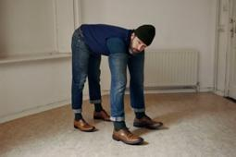

Date (s): **26th April 2014 – June 8th, 2014**

Open Daily, **10am – 5.30pm**

The Butler Gallery is delighted to present if and then… a multi-media exhibition by Dublin based artist Liam O’Callaghan.

O’Callaghan is one of Ireland’s most interesting younger artists at work today. His art expresses a willingness to engage with the absurdity of life and encourages us to look anew at ourselves and the world in which we live.

Read more at <http://www.butlergallery.com/>

Catch The He(art) – A Travelling Residency

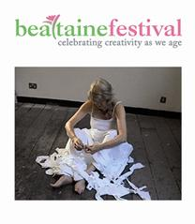

|  |  |
| --- | --- |
|  |  |
|  |  |

**Curated by Michelle Browne  
Hosted by Butler Gallery, The Parade Tower, Kilkenny Castle – 9th May, 2-4 pm**

**Catch the He(art)** is a travelling residency that invites four artists, **Patricia Hurl, Mary Kelly, James King** and **Therry Rudin**, to come together over the month of May to explore their motivation to continue making work in later life.For more information go to [www.bealtaine.com](http://mymail.spotonmail.com/t/r-l-xjdurlk-jiitttiukl-q/) or [www.butlergallery.com](http://mymail.spotonmail.com/t/r-l-xjdurlk-jiitttiukl-a/)

**\_\_\_\_\_\_\_\_\_\_\_\_\_\_\_\_\_\_\_\_\_\_\_\_\_\_\_\_\_\_\_\_\_\_\_\_\_\_\_\_\_\_\_\_\_\_\_\_\_\_\_\_\_\_\_\_\_\_\_\_\_\_\_\_\_\_\_\_\_\_\_\_\_\_\_**

**What’s happening in the Watergate?**

The Webb Sisters



Date(s): **2nd May**   
Time: **8:00 PM - 10:00 PM**

**Tickets:** **€20**

The Webb Sisters were chosen to join Leonard Cohen’s live band on his first tour in fifteen years. The record – breaking tour has played over 300 concerts to date. Having just finished the latest tour with Leonard, The Webb Sisters found time to record a new (and just-released) EP entitled ‘When Will You Come Home?’ and to embark on a tour of their own. The “Sublime Webb Sisters” – Leonard Cohen

[Find on Facebook](https://www.facebook.com/thewebbsisters) | [Follow On Twitter](https://twitter.com/thewebbsisters) | [Official Website](http://www.thewebbsisters.com/home.html)

Jimmy MacCarthy – Kilkenny Roots Festival

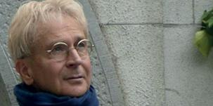

Date: **Saturday May 3rd**

Time: **8:00 PM - 10:00 PM**

Tickets: **€25**

One of Ireland’s foremost singer/songwriters returns to performing with his ‘Prophecy/Conspiracy?’ tour. The tour will pay homage to old favourites such as ‘Neidin’, while introducing more recent work such as ‘Andalucian Gray’ and ‘Children of Mile’.

[Find on Facebook](https://www.facebook.com/pages/Jimmy-MacCarthy/113462495372076) | Follow On Twitter | [Official Website](http://www.jimmymaccarthy.net/website/)

### Banff Mountain Film Festival

### Banff Mountain Film Festival

Date(s): **6th May 2014**   
Time:**7:30 PM - 9:30 PM**

**Tickets:** **€13.50/€11.50**

Attracting sold out audiences across the globe, the world’s most prestigious mountain film festival is coming to Kilkenny with a brand new selection of extraordinary short films from the world’s leading adventure film makers.

[Find on Facebook](https://www.facebook.com/UKBanffFilmFest) | [Follow On Twitter](https://twitter.com/UKBanffFilmFest) | [Official Website](http://www.banff-uk.com/)

Miss Saigon Auditions Round 2



Watergate Youth Productions will audition in the Watergate Theatre on **May 8th** for parts in their new production of Miss Saigon, taking place in the Watergate Theatre in November. Come with your friends and take part in something exciting for the summer time. The audition pieces can be found at [www.watergatetheatre.com](http://www.watergatetheatre.com) and further info can be found at the facebook link below. Hope to see you there!

Facebook: <http://tinyurl.com/p4fsdzr>

View more at <http://watergatetheatre.com/>

Want tickets? Call the box office now on 056-7761674 or click here to book online: [https://www.ctb.ie/tickets/watergate/?shows=%](https://www.ctb.ie/tickets/watergate/?shows=%25)

**\_\_\_\_\_\_\_\_\_\_\_\_\_\_\_\_\_\_\_\_\_\_\_\_\_\_\_\_\_\_\_\_\_\_\_\_\_\_\_\_\_\_\_\_\_\_\_\_\_\_\_\_\_\_\_\_\_\_\_\_\_\_\_\_\_\_\_\_\_\_\_\_\_\_\_**

**National craft gallery**

INTERLACE

[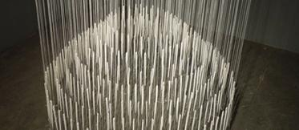](http://www.nationalcraftgallery.ie/exhibitions)

**28th March 2014 – 7th May 2014**

Castle Yard, Kilkenny

Interlace is an exhibition which focuses on contemporary interpretations of lace. The concept of the show developed by the National Craft Gallery is to explore how traditional material culture creates a resonant source for contemporary practice.

Beauty is the First Test



**16th May 2014 – 9th July 2014**

Mathematical concepts underpin many craft techniques, especially around textile construction, and can be key tools for artistic development. This exhibition’s intention is to unlock and demystify maths by showing unique and stimulating works of art, and also inviting in-depth consideration of contemporary artistic and craft practices in this wider context.

For more info of the above, please visit: <http://www.nationalcraftgallery.ie/exhibitions>

Gallery Tours

Crafternoon Tour at National Craft Gallery, Kilkenny, **Saturdays @ 3pm** - Booking Required  
[book now](http://www.nationalcraftgallery.ie/contact)

Read more about the above events at <http://miniurl.com/7P2D>

For more information: [events@nationalcraftgallery.ie](mailto:events@nationalcraftgallery.ie) / 056 7796151

**\_\_\_\_\_\_\_\_\_\_\_\_\_\_\_\_\_\_\_\_\_\_\_\_\_\_\_\_\_\_\_\_\_\_\_\_\_\_\_\_\_\_\_\_\_\_\_\_\_\_\_\_\_\_\_\_\_\_\_\_\_\_\_\_\_\_\_\_\_\_\_\_\_\_\_**

**Music in Kilkenny presents RIAM Symphony Orchestra**

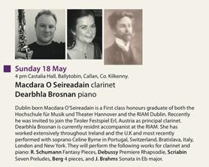

Tickets for all concerts: **€15.00** **(€10** concession)   
Season ticket: **€100.00**   
Further information:  
Susan Proud – 0861777017  
email: [mikilkenny@gmail.com](mailto:mikilkenny@gmail.com)

View more concerts at <http://www.musicinkilkenny.com/whats-on.html>

**\_\_\_\_\_\_\_\_\_\_\_\_\_\_\_\_\_\_\_\_\_\_\_\_\_\_\_\_\_\_\_\_\_\_\_\_\_\_\_\_\_\_\_\_\_\_\_\_\_\_\_\_\_\_\_\_\_\_\_\_\_\_\_\_\_\_\_\_\_\_\_\_\_\_\_**

**Set theatre - Mick Flannery (New album tour & Casey Black)**

[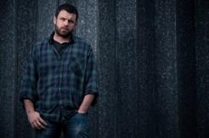](https://www.facebook.com/settheatrekilkenny/photos/gm.628056367284967/760567747289060/?type=1)

Date: **Thursday, 15th May, 20:00**

Venue:Set theatre, Kilkenny

Tickets: **€22**

[Concert: We Cut Corners [support: Lisa Flume]](http://www.set.ie/events-guide/events/we-cut-corners)

Venue: Set Theatre, Kilkenny

Date: **Saturday, 24th May,** **9.30pm**

Free admission

More info at <http://www.set.ie/>

**\_\_\_\_\_\_\_\_\_\_\_\_\_\_\_\_\_\_\_\_\_\_\_\_\_\_\_\_\_\_\_\_\_\_\_\_\_\_\_\_\_\_\_\_\_\_\_\_\_\_\_\_\_\_\_\_\_\_\_\_\_\_\_\_\_\_\_\_\_\_\_\_\_\_\_**

**Kats Theatre Group – ‘SPOILER ALERT’**

****

KATS return to their spiritual home of John Cleeres', for three nights of theatre with a difference. 'Spoiler Alert' will aim to bring some of the best loved and most Iconic movies scenes to the stage.

Spoiler Alert will **run from May 14th - 17th** in Cleere’s Theatre. Bookings can be made by calling Cleere’s on 056-776 2573, and are priced at just **€10** with some cinema treats included. [See more](https://www.facebook.com/katstheatregroup?fref=photo)

**\_\_\_\_\_\_\_\_\_\_\_\_\_\_\_\_\_\_\_\_\_\_\_\_\_\_\_\_\_\_\_\_\_\_\_\_\_\_\_\_\_\_\_\_\_\_\_\_\_\_\_\_\_\_\_\_\_\_\_\_\_\_\_\_\_\_\_\_\_\_\_\_\_\_\_**

**Hole in the Wall – Singspiel**

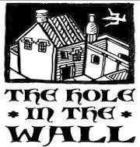

Singspiel - MANY YOUNG MEN: On Beal strand (MYM)

Date: **May 3rd, 9:00pm,**

Venue:Archer room, Hole in the wall

Tickets: **€15** on door or from Hole in the Wall on weekends.

This is a story about John B. Keane and the topics that influenced his plays. It will feature readings, poetry and original visuals of Beal strand on the Shannon estuary where many of JBK’s ideas were formulated on his weekly walks.

Singspiel - Dawn Choral

Date: **Thursday, May 8th**, **7.00am**

Venue: Hole in the wall

Tickets: **€15** on door or from Hole in the Wall on weekends.

Kilkenny College Chamber Choir, director David Milne, with guests perform the 10th annual Dawn Choral (not to be confused by the dawn chorus of the birds) sing madrigals and selected summertime pieces from 5.55 am. This reflects the annual May Day performance from the tower of Magdalen College, Oxford which has been occurring annually since the 1600s! Set your alarm clocks and join us for a hearty breakfast at **7.00 am.**

Ballad Session every Friday and most Saturdays **from 10.00pm**.

Call: 087 8075650

Facebook: <http://miniurl.com/7ilP>

W: <http://www.holeinthewall.ie/>

**\_\_\_\_\_\_\_\_\_\_\_\_\_\_\_\_\_\_\_\_\_\_\_\_\_\_\_\_\_\_\_\_\_\_\_\_\_\_\_\_\_\_\_\_\_\_\_\_\_\_\_\_\_\_\_\_\_\_\_\_\_\_\_\_\_\_\_\_\_\_\_\_\_\_\_**

**Upcoming Classes at Blackstack Studio**



Blackstack Studio, 42 Parliament St., Kilkenny

SATURDAY WORKSHOPS

* Bookbinding II – Continuation (**Saturday 24th May. 10am-4pm,** €80)
* Printmaking for Teachers (**Saturday 10th May & Saturday 17th May,** €160)

Bookings can be made on the website [www.blackstackstudio.com](http://www.blackstackstudio.com) or by emailing [sylvia@blackstackstudio.com](http://kk-moss/Sites/arts_office/Shared%20Documents/Julianne%20Morgan/E-bulletin/21st%20March/sylvia@blackstackstudio.com) . If you have a group of 3 or 4 people we can also arrange a special workshop to suit you - email Sylvia at the above address.

More info about the above workshops at <http://miniurl.com/7vXo>

**\_\_\_\_\_\_\_\_\_\_\_\_\_\_\_\_\_\_\_\_\_\_\_\_\_\_\_\_\_\_\_\_\_\_\_\_\_\_\_\_\_\_\_\_\_\_\_\_\_\_\_\_\_\_\_\_\_\_\_\_\_\_\_\_\_\_\_\_\_\_\_\_\_\_\_**

**Creative Writing – Kilmanagh**

[](http://usfcreativewriters.files.wordpress.com/2012/04/creative-writing.jpg)

A creative writing group takes place in Droicheád FRC **every Friday at 10.30am**. A talented writer will facilitate the group. **€2 per session.**

**\_\_\_\_\_\_\_\_\_\_\_\_\_\_\_\_\_\_\_\_\_\_\_\_\_\_\_\_\_\_\_\_\_\_\_\_\_\_\_\_\_\_\_\_\_\_\_\_\_\_\_\_\_\_\_\_\_\_\_\_\_\_\_\_\_\_\_\_\_\_\_\_\_\_\_**

**Arts & Crafts – Durrow**

[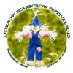](http://www.durrowscarecrowfestival.com/)

As part of Durrow Scarecrow Festival, which will be held from **Sunday 27th July to Monday 4th August**, we are reminding all local artists and crafts people that this year’s exhibition and sale takes place during the Scarecrow Festival. Now is the time to put on your thinking caps and prepare. For information, please contact Kathleen Flynn on (086) 8263368 or Mary Dowling on (087) 2200199. Many thanks.

**\_\_\_\_\_\_\_\_\_\_\_\_\_\_\_\_\_\_\_\_\_\_\_\_\_\_\_\_\_\_\_\_\_\_\_\_\_\_\_\_\_\_\_\_\_\_\_\_\_\_\_\_\_\_\_\_\_\_\_\_\_\_\_\_\_\_\_\_\_\_\_\_\_\_\_**

**Kilkenny Rock Music School**

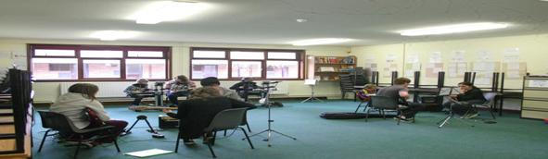

Lessons for guitar, keys, drums & playing in a rock band. Lessons cost €25 per hour lesson or €15 per half an hour lesson.

Call 087 9092700 or visit [www.kilkennyrock.com](http://www.kilkennyrock.com) (private lessons also available).

**\_\_\_\_\_\_\_\_\_\_\_\_\_\_\_\_\_\_\_\_\_\_\_\_\_\_\_\_\_\_\_\_\_\_\_\_\_\_\_\_\_\_\_\_\_\_\_\_\_\_\_\_\_\_\_\_\_\_\_\_\_\_\_\_\_\_\_\_\_\_\_\_\_\_\_**

**Ballyragget Book Club**

[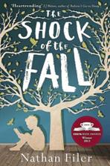](http://1.bp.blogspot.com/-w4sgoFrf0bw/UwDLY_fqIaI/AAAAAAAAC_I/CUnPPVkSgP8/s1600/the+shock+of+the+fall.JPG)

The book for next month’s Hogan Stand Book Club is *The Shock of the Fall* by Nathan Filer. The book club will meet on **Tuesday 6th May at 8:30** in the Hogan Stand and new members are always welcome.

**\_\_\_\_\_\_\_\_\_\_\_\_\_\_\_\_\_\_\_\_\_\_\_\_\_\_\_\_\_\_\_\_\_\_\_\_\_\_\_\_\_\_\_\_\_\_\_\_\_\_\_\_\_\_\_\_\_\_\_\_\_\_\_\_\_\_\_\_\_\_\_\_\_\_\_**

**Radio Summer school - KCLR**

**[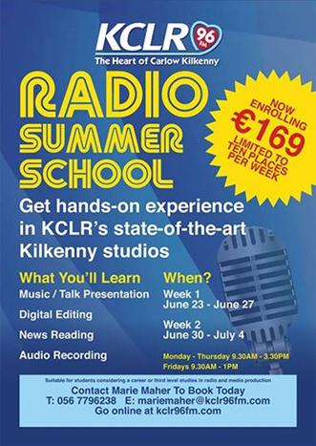](https://www.facebook.com/kclr96fm/photos/a.10150920723718438.523378.146296768437/10152845583178438/?type=1&relevant_count=1)**

Places are now booking on our Radio Summer School. This year we've a total of 20 places over 2 weeks available at our Kilkenny studios where you'll spend a week learning about music and talk presentation, digital editing, audio recording, news reading and preparation and more besides.

For more details or to book, contact Marie Maher at

T: 056 7796238

E: [mariemaher@kclr96fm.com](mailto:mariemaher@kclr96fm.com)

W: [www.kclr96fm.com](http://www.kclr96fm.com)ews reading and preparation and more besides.   
  
This is ideal for students considering a career or third level studies in radio and media presentation. For more details or to book, contact Marie Maher on 056 7796238 or email [mariemaher@kclr96fm.comews](mailto:mariemaher@kclr96fm.comews) reading and preparation and more besides.

**\_\_\_\_\_\_\_\_\_\_\_\_\_\_\_\_\_\_\_\_\_\_\_\_\_\_\_\_\_\_\_\_\_\_\_\_\_\_\_\_\_\_\_\_\_\_\_\_\_\_\_\_\_\_\_\_\_\_\_\_\_\_\_\_\_\_\_\_\_\_\_\_\_\_\_**

**Grennan Mill Craft School - Summer Courses 2014**

**[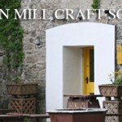](http://www.thomastownparish.ie/wp-content/uploads/2013/04/Grennan-Mill-Craft-School.jpg)**

* Tapestry Weaving suitable for Beginners & Improvers

**Mon 23rd – Fri 27th June / 10am- 4pm**

Minimum 8 - Maximum 10 persons

Following a morning of designing, students will weave a Tapestry on a wooden frame using a variety of textured and coloured yarns. All materials will be provided.

Course Fee: **€180**

Materials fee: **€10**

* Weekend Pottery Wheel Course suitable for Beginners & Improvers

**Sat 5th & Sun 6th July / 10am- 5pm**

Minimum 5 - Maximum 6 persons

Learn the art of throwing on the Potter’s wheel to create your own tableware and decorate with coloured slips.

Course Fee: **€140**

Materials fee: **€25** - includes firing fee

* Weekend Pottery Wheel Course suitable for Beginners & Improvers

**Sat 19th & Sun 20th July / 10am- 5pm**

Maximum 6 persons

Learn the art of throwing on the Potter’s wheel to create your own tableware and decorate with coloured slips.

Course Fee**: €140**

Materials fee**: €25** - includes firing fee

**For all summer courses:**

Application Forms available from Grennan Mill Craft School, Mill Street, Thomastown, Co Kilkenny

**Completed application form and non-refundable deposit of €50.00 are required by:**  
**Friday 30th May for ALL courses**  
• Cheques made payable to ‘Grennan Mill Craft School’  
• Class formation is dependent on an adequate number of applicants – usually 10 participants necessary  
• Should Grennan Mill cancel the course, your monies will be refunded in full

**For further details: Tel: (056) 7724557** [grennanmill@eircom.net](mailto:grennanmill@eircom.net)

**\_\_\_\_\_\_\_\_\_\_\_\_\_\_\_\_\_\_\_\_\_\_\_\_\_\_\_\_\_\_\_\_\_\_\_\_\_\_\_\_\_\_\_\_\_\_\_\_\_\_\_\_\_\_\_\_\_\_\_\_\_\_\_\_\_\_\_\_\_\_\_\_\_\_\_**

**The Abhainn RíFestival**

The Abhainn RíFestival is seeking proposals for our 2014 programme. This year we are inviting proposals to contribute to an exciting programme of events that will shape Abhainn Rí2014 and help make the festival a success. If you have an idea for an event please submit your proposal by the **25th April. Full details on how to submit an idea to our festival** [here](http://abhainnrifestival.com/assets/ARF-2014-Call-for-Ideas2.pdf)

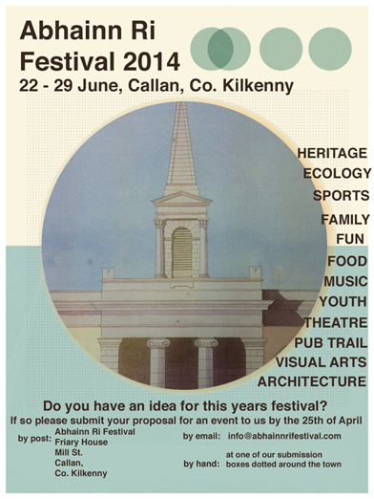

Submissions can be made by post, email or by hand.

by post:      Abhainn Ri Festival, Friary House, Mill Street, Callan, Co. Kilkenny

by email:   [info@abhainnrifestival.com](http://kk-moss/Sites/arts_office/Shared%20Documents/Julianne%20Morgan/E-bulletin/16th%20May/info@abhainnrifestival.com)

**\_\_\_\_\_\_\_\_\_\_\_\_\_\_\_\_\_\_\_\_\_\_\_\_\_\_\_\_\_\_\_\_\_\_\_\_\_\_\_\_\_\_\_\_\_\_\_\_\_\_\_\_\_\_\_\_\_\_\_\_\_\_\_\_\_\_\_\_\_\_\_\_\_\_\_**

**Personal Effects: Fund-it campaign**

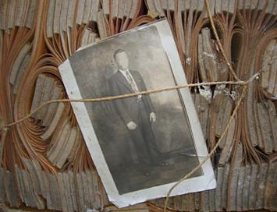

Venue: The Long Stores, Old St Brendan’s Hospital, (North of the Clocktower), Lower Grangegorman, Dublin 7.

Date: **Thurs, 1st May to Sat 10th May, 11.00am-4.00**

*PERSONAL EFFECTS: a history of possession* is a site-specific installationby Kilkenny artist and writer Alan Counihan based on the personal effects of dead or discharged patients of Grangegorman Mental Hospital.

Following its run in Grangegorman during Phizzfest, the work will next be shown in early June at Culture Box in Temple Bar, Dublin, a non-profit gallery space offered to the project by Dublin City Arts Office. The Culture Box installation will require that the work be newly adapted to the environment of a traditional white cube gallery space and support is being sought for these costs through a Fund-it campaign. I simply am unable to meet them on the Emergency Community Welfare Benefit of which I am now in receipt.

I will be grateful if you can share this message and the relevant link through your networks so that the Fund-it campaign can gain a wider audience.

<http://fundit.ie/project/personal-effects-a-history-of-possession-1>

W: [http://personaleffects.alancounihan.net](http://personaleffects.alancounihan.net/)

F: [facebook](https://www.facebook.com/personaleffectsahistoryofpossessionproject)

**\_\_\_\_\_\_\_\_\_\_\_\_\_\_\_\_\_\_\_\_\_\_\_\_\_\_\_\_\_\_\_\_\_\_\_\_\_\_\_\_\_\_\_\_\_\_\_\_\_\_\_\_\_\_\_\_\_\_\_\_\_\_\_\_\_\_\_\_\_\_\_\_\_\_\_**

**Courses / Training / Jobs**

**\_\_\_\_\_\_\_\_\_\_\_\_\_\_\_\_\_\_\_\_\_\_\_\_\_\_\_\_\_\_\_\_\_\_\_\_\_\_\_\_\_\_\_\_\_\_\_\_\_\_\_\_\_\_\_\_\_\_\_\_\_\_\_\_\_\_\_\_\_\_\_\_\_\_\_**

**GALWAY FRINGE FESTIVAL-Production Manager**

# [cid:image221.png@01CF661A.FBD84030](http://www.theatreforum.ie/)

The Galway Fringe Festival 12th-28th July 2014 will host a programme of over 30 shows including theatre, dance, cabaret and music. The Production Manager will oversee the build, technical rehearsals and running of the relevant venues. The role is a management position and responsibilities include representing the Galway Fringe Festival with incoming companies and our host venues.

**Deadline:** To apply, please send a cover letter and your up-to-date CV to [info(at)galwayfringe.ie](javascript:linkTo_UnCryptMailto('nbjmup+jogpAhbmxbzgsjohf/jf');) **by the 10th May 2014**

W: <http://tinyurl.com/lb3qknq>

**\_\_\_\_\_\_\_\_\_\_\_\_\_\_\_\_\_\_\_\_\_\_\_\_\_\_\_\_\_\_\_\_\_\_\_\_\_\_\_\_\_\_\_\_\_\_\_\_\_\_\_\_\_\_\_\_\_\_\_\_\_\_\_\_\_\_\_\_\_\_\_\_\_\_\_**

## [Marketplace Autumn 2014 – Invitation to Tender for project management](http://artsaudiences.ie/2014/04/marketplace-autumn-2014-invitation-to-tender-for-project-management/)

## [cid:image222.jpg@01CF661A.FBD84030](http://artsaudiences.ie/)

Arts Audiences is seeking tenders from suitably qualified consultants to undertake the project management of Marketplace, an initiative which seeks to facilitate communication between venues around Ireland and promoters of work. If you are an experienced project manager, familiar with the performing arts landscape and interested in applying for this exciting role, the invitation to tender document is here.[MARKETPLACE autumn 2014 invitation to tender](http://artsaudiences.ie/wp-content/uploads/2014/04/MARKETPLACE-autumn-2014-invitation-to-tender.pdf).

**The closing date is May 12th**

**\_\_\_\_\_\_\_\_\_\_\_\_\_\_\_\_\_\_\_\_\_\_\_\_\_\_\_\_\_\_\_\_\_\_\_\_\_\_\_\_\_\_\_\_\_\_\_\_\_\_\_\_\_\_\_\_\_\_\_\_\_\_\_\_\_\_\_\_\_\_\_\_\_\_\_**

# Camphill Community Clanabogan – Weaver/Craft Worker (Day Opportunities Workshop Coordinator) – closing 06/05/14

[](http://www.camphillclanabogan.com/index.php)

[News & Events](http://camphillclanabogan.com/news.php) | [Our Magazine](http://www.camphillclanabogan.com/page.php?19) | [Photo Gallery](http://www.camphillclanabogan.com/gallery.php) | [Contact Us](http://www.camphillclanabogan.com/contact.php) | [Sitemap](http://www.camphillclanabogan.com/sitemap.php)   [aaa](http://www.camphillclanabogan.com/index.php)

[**Camphill NI**](http://www.camphillni.org) [**Glencraig**](http://www.glencraig.org.uk) [**Holywood**](http://www.camphillholywood.co.uk) [**Mourne Grange**](http://www.mournegrange.org)

**A therapeutic, life-sharing community and home to 70 people, including adults with a learning disability.**

We are seeking applications for:  
Weaver/Craft Worker – Day Opportunities Workshop Coordinator – Adults with a Learning Disability

**Please request a job description and application form from:**[office@camphillclanabogan.com](http://kk-moss/Sites/arts_office/Shared%20Documents/Julianne%20Morgan/E-bulletin/16th%20May/office@camphillclanabogan.com)

**The Office, Camphill Community Clanabogan, 15, Drudgeon Rd., Omagh, Co. Tyrone BT78 1TJ**

**Tel. 028 82256100**

**Closing date for applications: 6th May 2014, 12:00**

Our website:[www.camphillclanabogan.com](http://www.camphillclanabogan.com)

Full Job Description can be found here –[*CCC Weavery full job description*](http://comartspartner.org/wp-content/uploads/2014/04/CCC-Weavery-full-job-description.doc)

**\_\_\_\_\_\_\_\_\_\_\_\_\_\_\_\_\_\_\_\_\_\_\_\_\_\_\_\_\_\_\_\_\_\_\_\_\_\_\_\_\_\_\_\_\_\_\_\_\_\_\_\_\_\_\_\_\_\_\_\_\_\_\_\_\_\_\_\_\_\_\_\_\_\_\_**

**University Hospital Limerick: Per Cent for Art Scheme – Invitation to Tender**



University Hospital Limerick, Dooradoyle is being transformed into a major university hospital and the major acute centre for the mid-west region with significant capital developments being progressed at the site.

The HSE is now inviting Artists to tender for the provision of original art work(s) for public display at the main entrance internal roundabout at the Hospital, under the terms of the Government ”Per Cent for Art Scheme”.

**The available funding is €51,000.**

**The deadline for receipt of proposals is by 3pm on Friday 16th May 2014.**

The detailed Invitation to Tender document is available here: [UHL\_tender\_brief](http://visualartists.ie/wp-content/uploads/2014/04/UHL_tender_brief.pdf) and drawings here: [Appendix\_drawings\_UHL](http://visualartists.ie/wp-content/uploads/2014/04/Appendix_drawings_UHL.pdf)

**\_\_\_\_\_\_\_\_\_\_\_\_\_\_\_\_\_\_\_\_\_\_\_\_\_\_\_\_\_\_\_\_\_\_\_\_\_\_\_\_\_\_\_\_\_\_\_\_\_\_\_\_\_\_\_\_\_\_\_\_\_\_\_\_\_\_\_\_\_\_\_\_\_\_\_**

# Island Arts Centre (LISBURN) – Arts Attendant (Part-Time) – closing 06/05/14



The post holder acts as a point of contact for the public at ISLAND Arts Centre’s Arts Reception and assists with the day-to-day programming and running of the Arts Centre, as required.

See link for more information and for application forms: <http://tinyurl.com/ojch93e>

**\_\_\_\_\_\_\_\_\_\_\_\_\_\_\_\_\_\_\_\_\_\_\_\_\_\_\_\_\_\_\_\_\_\_\_\_\_\_\_\_\_\_\_\_\_\_\_\_\_\_\_\_\_\_\_\_\_\_\_\_\_\_\_\_\_\_\_\_\_\_\_\_\_\_\_**

**MISCELLANEOUS: HETAC COURSE Creativity & Exchange, CIT Crawford College of Art and Design**

cid:image090.gif@01CF6612.C2AE48C0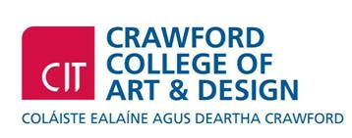  
  
<http://www.creativityandchange.info>  
This is a CIT approved Special Purpose Award at Level 8 (10 credits) certificate supported by Irish Aid.  
  
WHO IS IT FOR?  
Artists, community workers, youth workers, activists, educators, volunteers and anyone who is interested in exploring the connection between creativity, learning and change in the world and in nurturing possibilities to grow as connected global citizens.  
DURATION  
Seven 2/3 day blocks, **Oct 2014 to May 2015**  
APPLY  
Applications accepted by email. Go to website, <http://www.creativityandchange.info> and 'get involved' page to download application form.  
FEE

The course fee is subsidised through Irish Aid funding so it can be offered at reduced rate of **€680**  
  
ENQUIRIES  
Enquiries to [creativityandchangecit@gmail.com](mailto:creativityandchangecit@gmail.com)**\_\_\_\_\_\_\_\_\_\_\_\_\_\_\_\_\_\_\_\_\_\_\_\_\_\_\_\_\_\_\_\_\_\_\_\_\_\_\_\_\_\_\_\_\_\_\_\_\_\_\_\_\_\_\_\_\_\_\_\_\_\_\_\_\_\_\_\_\_\_\_\_\_\_\_**

**Shadowbox Theatre Company**

[admin@shadowboxireland.com](mailto:admin@shadowboxireland.com)

Tel: 086 3451457

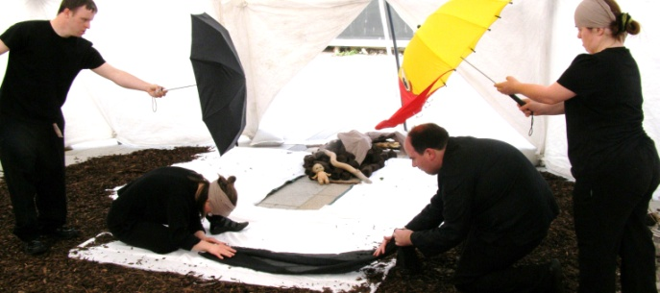

Shadowbox Theatre are continuing their workshop programme for actors with Intellectual disabilities this spring. We are providing workshops on a once a week basis in Bray, Co. Wicklow and week long summer workshops in Ireland and England.

**Dates: May 1st, 8th, 15th, 22nd, 29th**

The workshops will run for 1 day a week for 5 weeks

**Thurs 11.30-12.30** session 1 (Introduction to making theatre) €10 per session   (book all 5 for €45)

**Thurs 2 -4.00** session 2 (Advanced -Making Theatre) €15 per session  (book all 5 for €65)

Full day €25 (book 5 for €110)

Beginners may prefer to come to morning sessions

**Bookings: contact:** [admin@shadowboxireland.com](mailto:admin@shadowboxireland.com)or 086 3451457

W: [www.shadowboxireland.com](http://www.shadowboxireland.com)

**\_\_\_\_\_\_\_\_\_\_\_\_\_\_\_\_\_\_\_\_\_\_\_\_\_\_\_\_\_\_\_\_\_\_\_\_\_\_\_\_\_\_\_\_\_\_\_\_\_\_\_\_\_\_\_\_\_\_\_\_\_\_\_\_\_\_\_\_\_\_\_\_\_\_\_**

# Irish Ballet Forum: Summer Intensive Now Enrolling

* [Performances](http://www.danceireland.ie/board/category/performances/)
* [Events](http://www.danceireland.ie/board/category/events/)
* [Jobs & Opportunities](http://www.danceireland.ie/board/category/opportunities/)
* [Services](http://www.danceireland.ie/board/category/services/)
* [Dance Classes & Workshops](http://www.danceireland.ie/board/category/dance-classes-workshops/)

[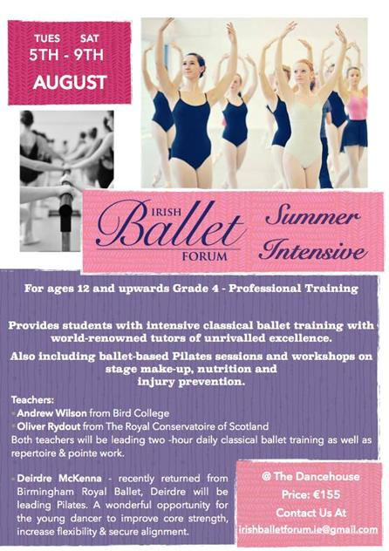](http://www.danceireland.ie/board/wp-content/uploads/2014/04/Irish-Ballet-Forum.jpg)

# Date: 5th – 9th August

# Venue: The Dancehouse

# E: [irishballetforum.ie@gmail.com](mailto:irishballetforum.ie@gmail.com)

W: <http://tinyurl.com/lp6cj2d>

**\_\_\_\_\_\_\_\_\_\_\_\_\_\_\_\_\_\_\_\_\_\_\_\_\_\_\_\_\_\_\_\_\_\_\_\_\_\_\_\_\_\_\_\_\_\_\_\_\_\_\_\_\_\_\_\_\_\_\_\_\_\_\_\_\_\_\_\_\_\_\_\_\_\_\_**

**Dance Ireland – Evening classes**

[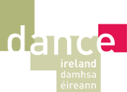](http://www.danceireland.ie/index.php)

# Contemporary Dance

Date: **Every Monday from** **28th April 2014 – 23rd June 2014**

Time: **19:00 -20:30**

Venue: DanceHouse

Level: Advanced beginners

Teacher: Mariam Ribon

The second part of the class consists of developing a sense for fluid movement, musicality, rhythm and technical aspects of movement that aims to be free and natural. The technique is revealed in a comprehensive and simple way.

## For further information:

* **Telephone:** 086 8639702
* **Email:** [mariamribon@gmail.com](mailto:mariamribon@gmail.com)
* **W:** <http://www.danceireland.ie/events/event.php?id=1699>

# Tap Dance

Date: **Every Tuesday from 29 April 2014 - 17 June 2014**

Time: **18:30 - 19:30**

Venue:DanceHouse

Admission: **€80 for a 8-week course / €12 Drop-in**

Level: Beginners

Teacher:Dance Ireland / Jessica Peel-Yates

Feeling inspired by the tap sequences in the film The Artist? Discover the difference between a shuffle and a flap. Explore time steps.

## For further information:

* **Telephone:** 01 855 8800
* **Email:** [info@danceireland.ie](mailto:info@danceireland.ie)
* **W:** <http://www.danceireland.ie/events/event.php?id=1657>

**\_\_\_\_\_\_\_\_\_\_\_\_\_\_\_\_\_\_\_\_\_\_\_\_\_\_\_\_\_\_\_\_\_\_\_\_\_\_\_\_\_\_\_\_\_\_\_\_\_\_\_\_\_\_\_\_\_\_\_\_\_\_\_\_\_\_\_\_\_\_\_\_\_\_\_**

**MA Festive Arts programme**

[](http://www.irishworldacademy.ie/)

Applications are now being accepted for the MA Festive Arts programme at the Irish World Academy of Music and Dance, University of Limerick.

The MA Festive Arts Programme at the Irish World Academy of Music and Dance offers students the opportunity to develop skills in arts management, curating, production, performance and research with an emphasis on festivity and the role of festival in society. Bringing together artists, performers, curators, producers and researchers, the MA Festive Arts Programme provides a unique context for the acquisition and development of skills in this field.

For more information on this programme, please visit <http://tinyurl.com/qfr8hlg> or contact [niamh.nicghabhann@ul.ie](mailto:niamh.nicghabhann@ul.ie)

**Dublin Writers’ Festival**

[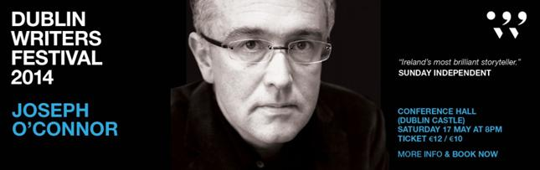](http://www.dublinwritersfestival.com/event/joseph-oconnor-in-conversation/)

Aidan Courtney: Comics Workshop

**Part of Dublin Writers Festival**

**Venue: The Ark  
Date: Tues 20th May @ 10.30am & 12pm**  **Age range: 2nd-6th Class**

Tickets**:** Schools **€5 or €4.50**

A fantastic comic book & storytelling workshop available in Irish or Irish/English  
In this engaging workshop, Aidan will show participants how to script and draw comics, with a focus on storytelling. The workshop can be conducted totally through Irish or bi-lingually.

What's Your Story? Making Friends for the Nest

**Part of Dublin Writers Festival**

Venue:Meeting House Square **Date: Wed 21st May @ 10am – 12pm  
Age range: 2nd- 4th class**

**Tickets: €5 / €4.50**

Join author/ illustrator Chris Judge and a great team of illustrators to add new stories to the Dublin Story Bird’s nest. Chris Judge and his team will help you create new story ideas, and make your story eggs to add to Story Bird’s nest.  Can you help create some friends for our extremely tall bird? This workshop will take place on Meeting House Square (behind The Ark) or inside The Ark in the event of wet weather.

W: <http://www.dublinwritersfestival.com/>

**\_\_\_\_\_\_\_\_\_\_\_\_\_\_\_\_\_\_\_\_\_\_\_\_\_\_\_\_\_\_\_\_\_\_\_\_\_\_\_\_\_\_\_\_\_\_\_\_\_\_\_\_\_\_\_\_\_\_\_\_\_\_\_\_\_\_\_\_\_\_\_\_\_\_\_**

## The Ark - Teachers Summer Course: A Visual Arts Approach

## cid:image230.jpg@01CF661A.FBD84030

## **Venue: The Ark**

## **Date: **Mon 18-Fri 22nd August @ 9.30am-2.30pm**** The Ark and the Dublin West Education Centre presents a highly creative summer course for primary school teachers focusing on a Visual Arts approach to exploring narrative, literacy & other subjects. This is a five day Department of Education and Skills and EPV-approved summer course for teachers.

More info and booking details at <http://tinyurl.com/ocqxnsh>

# Join the Limerick National City of Culture Volunteer Team!

[](http://www.limerickcityofculture.ie/)

Limerick National City of Culture has begun taking applications for volunteers who wish to get involved in this year's exciting programme of events. This year Limerick will be the national stage for a host of acts, arts and events from the best in local talent to internationally renowned artists performing in Ireland for the first time.

Deadline: **23/06/14**

For further information on the Limerick City of Culture Volunteer Programme please contact Kate McDonagh, Volunteer Programme Manager 087 9127956 or email  [volunteer@limerickcityofculture.ie](mailto:volunteer@limerickcityofculture.ie)

For more info see <http://tinyurl.com/osxkmqa> or <http://www.limerickcityofculture.ie/>

**\_\_\_\_\_\_\_\_\_\_\_\_\_\_\_\_\_\_\_\_\_\_\_\_\_\_\_\_\_\_\_\_\_\_\_\_\_\_\_\_\_\_\_\_\_\_\_\_\_\_\_\_\_\_\_\_\_\_\_\_\_\_\_\_\_\_\_\_\_\_\_\_\_\_\_**

# ****Internship Recruitment****

# cid:image231.png@01CF661A.FBD84030

Cavan Theatre Festival wishes to recruit a social media intern to be part of our core marketing and PR management for the festival to start **Mid May – July 20th 2014.** This internship is unpaid, however to be part of this new, ambitious theatre festival in Cavan is something that will stand to the intern’s future role with the festival and beyond.

All inquires to be made by email to [cavantheatrefestival@outlook.com](mailto:cavantheatrefestival@outlook.com).Interested candidates should send a C.V, letter of Interest in why you want the role. (No more that 500 words max) to the above email address, with Internship as your Heading.

**Deadline is May 7th 2014, 5.00pm.  Interviews on Friday May 9th 2014.**

Read more at <http://www.cavanarts.ie/Default.aspx?StructureID_str=35&guid=647>

**\_\_\_\_\_\_\_\_\_\_\_\_\_\_\_\_\_\_\_\_\_\_\_\_\_\_\_\_\_\_\_\_\_\_\_\_\_\_\_\_\_\_\_\_\_\_\_\_\_\_\_\_\_\_\_\_\_\_\_\_\_\_\_\_\_\_\_\_\_\_\_\_\_\_\_**

# Diversity Challenges: Invitation to Tender



#### Aim:

To develop a storytelling project, reflecting the cooperation and interaction between former members of the Royal Ulster Constabulary and former members of An Garda Siochána in the border region from the establishment of both Police Forces in 1922 to 2001.  
‘A project supported by PEACE III Programme managed for the Special EU Programmes Body by the Community Relations Council/Pobal Consortium’.

The budget for the commission is a **maximum of £5, 000** inclusive of VAT

# Tenders to be received by Will Glendinning Coordinator ****by 4.00pm Friday 9th May 2014.****

# More info at <http://www.activelink.ie/content/vacancies/tenders/15826>

**\_\_\_\_\_\_\_\_\_\_\_\_\_\_\_\_\_\_\_\_\_\_\_\_\_\_\_\_\_\_\_\_\_\_\_\_\_\_\_\_\_\_\_\_\_\_\_\_\_\_\_\_\_\_\_\_\_\_\_\_\_\_\_\_\_\_\_\_\_\_\_\_\_\_\_**

**CALM: Workshop "Music and Health"**   
  
[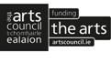](http://www.artscouncil.ie/)[](http://www.waterfordhealingarts.com/)[](http://www.create-ireland.ie/)

Date:  **25th - 27th June**  
Venue: Solstice Arts Centre, Navan, Co. Meath.  
  
 (Ceol Agus Lán Maitheas), with the support of Meath County Council Arts Office FEACH Programme, is offering a 3 day intensive introductory  training workshop for musicians in "Music and Health" with  an emphasis on geriatric care, to take place at the Solstice Arts Centre, Navan, Co. Meath.  
   
Read more at <http://tinyurl.com/k9xvbn4>

**\_\_\_\_\_\_\_\_\_\_\_\_\_\_\_\_\_\_\_\_\_\_\_\_\_\_\_\_\_\_\_\_\_\_\_\_\_\_\_\_\_\_\_\_\_\_\_\_\_\_\_\_\_\_\_\_\_\_\_\_\_\_\_\_\_\_\_\_\_\_\_\_\_\_\_**

|  |
| --- |
| **Irish Writers' Centre at Phizzfest**  **[cid:image114.png@01CF6612.C2AE48C0](http://www.phizzfest.ie/)** |

|  |
| --- |
| As part of Phizzfest we are pleased to announce an exciting **writing workshop**.   CREATIVE WRITING WITH THE IRISH WRITERS’ CENTRE INKSLINGERS GROUPVenue: The HutDate: Fri 2nd May﻿﻿ Time: 6.30pm - 8.00pm      Admission: Free (Numbers limited - places offered on first-come basis) **Inkslingers** is an informal creative writing group that has been set up by the Irish Writers' Centre to encourage people from all backgrounds and of all ages to pick up the pen, engage their imagination and write!  **This event is part of Phizzfest and will take place at The Hut and NOT the Writers' Centre.**  **Click** [here](http://r20.rs6.net/tn.jsp?f=001M2UvA9yXTw87VOmC9QEZZG2txi6o_ZbsW_JypvjtF4yqjfB9xga7-rhEYaIq9t1W5lnwakgdO7rTmkBuFddxZRQ5K7EB21luW_DJ_WxzMCEDZAXp2xBJsYK4M831fPj_IEfkPs8FiB7Y3LOCSPYAlaMHYyizgAtgErvfJxXEU-I=&c=tNkglR-0w8LR8mEOmSo1MClOB4b_xHQ1PDcN0Sap1CGmLRSMm2dGdA==&ch=lFLsZiSy_bMpugcdEnMCHhJU4J_Hqs7EAv5befqE0OeYWhLJIdcaZg==)**for full details.**    **Introduction to Screenwriting Workshop with Ferdia MacAnna**  Venue: McGeoughs Bohemian Lounge  Date: **Sat 3rd May** Time: **12.00noon - 2.00pm.**   Admission: Free   (Numbers limited - Places offered on a first-come basis  Have you ever wanted to draft a script but didn't know where to start?  **This event is part of the Phizzfest and will take place at McGeough's Bohemian Lounge and NOT the Writers' Centre.**  **Click** [here](http://r20.rs6.net/tn.jsp?f=001M2UvA9yXTw87VOmC9QEZZG2txi6o_ZbsW_JypvjtF4yqjfB9xga7-rhEYaIq9t1W5lnwakgdO7rTmkBuFddxZRQ5K7EB21luW_DJ_WxzMCEDZAXp2xBJsYK4M831fPj_IEfkPs8FiB7Y3LOCSPYAlaMHYyizgAtgErvfJxXEU-I=&c=tNkglR-0w8LR8mEOmSo1MClOB4b_xHQ1PDcN0Sap1CGmLRSMm2dGdA==&ch=lFLsZiSy_bMpugcdEnMCHhJU4J_Hqs7EAv5befqE0OeYWhLJIdcaZg==) **for more details.** |

**\_\_\_\_\_\_\_\_\_\_\_\_\_\_\_\_\_\_\_\_\_\_\_\_\_\_\_\_\_\_\_\_\_\_\_\_\_\_\_\_\_\_\_\_\_\_\_\_\_\_\_\_\_\_\_\_\_\_\_\_\_\_\_\_\_\_\_\_\_\_\_\_\_\_\_**

**Gilding Workshop with Sue White at VISUAL**

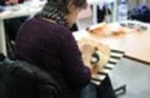

Facilitated by Sue White  
Date: **Saturday May 3rd**  
Time: **11am-5pm**  
Price: **€85** (Gold/ Metal Leaf included)  
VISUAL, Old Dublin Rd, Carlow

A day-long introduction to the use of metal leaf as a medium for art works. Reflecting on techniques involved in Patrick Scott: Image Space Light, VISUAL are offering a one-day gilding workshop for creatives, artists and makers. Facilitator and artist Sue White will introduce participants to the techniques involved in gilding onto canvas.

W: [www.visualcarlow.ie/events/info/gilding-workshop-sue-white](http://lists.visualartists.ie/lt.php?c=1132&m=4172&nl=1&s=e784eec6bf8bb9680747b324b9c9eee1&lid=85401&l=-http--www.visualcarlow.ie/events/info/gilding-workshop-sue-white)

**\_\_\_\_\_\_\_\_\_\_\_\_\_\_\_\_\_\_\_\_\_\_\_\_\_\_\_\_\_\_\_\_\_\_\_\_\_\_\_\_\_\_\_\_\_\_\_\_\_\_\_\_\_\_\_\_\_\_\_\_\_\_\_\_\_\_\_\_\_\_\_\_\_\_\_**

**NYCI Summer School 2014, Early Bird extended until Wed 8th May 2014!**

**[](http://nycitraining.org/)**

**When: Wed 11th - Fri 13th June 2014**

**Where: NUI Galway**

**Cost: €250** for members of NYCI and **€300** for non-members.This covers your accommodation, meals, all workshops and materials.

Early bird promotion – if you book and pay before **Friday, 9th May 2014**, there will be a **€50.00 discount**. This brings the cost to **€200.00** for members and **€250.00** for non members.

3-day residential youth arts practice summer school in NUI Galway, running from **11th-13th June 2014**. It will offer workshops, evening events and lots more to stimulate your imagination and send you home with a wealth of ideas and techniques for developing creative approaches for your work with young people.

Download the brochure here: <http://www.youtharts.ie/yass2014>

Book here: <http://nycitraining.org/yass2014>

**\_\_\_\_\_\_\_\_\_\_\_\_\_\_\_\_\_\_\_\_\_\_\_\_\_\_\_\_\_\_\_\_\_\_\_\_\_\_\_\_\_\_\_\_\_\_\_\_\_\_\_\_\_\_\_\_\_\_\_\_\_\_\_\_\_\_\_\_\_\_\_\_\_\_\_**

**Summer Workshops 2014 at Cló & The Living Archive Donegal**

[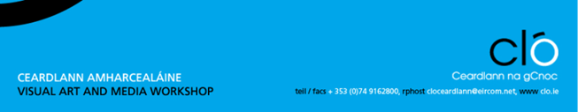](http://www.clo.ie/)

Venue: Cló & The Living Archive, Mín a Leá, Gortahork, Co. Donegal  
Cost: **€100** (payable in advance)  
Book early as limited places available

The workshops are suitable for beginners & professional artists  
Workshops run from 10 – 4 (except photography)

A Donegal artists’ creative encounter at the foot of mount Errigal lead by Ian Joyce & Oona Hyland

“Monotype”: a Painterly approach to Printmaking, **12th  & 13th July**  
Monotype, or ‘one print’, a direct, exciting and spontaneous printmaking practice.

“Grianghraf” – Cyanotype, **14th July**

Papermaking, **15th July**

Stone Lithography, **19th – 20th July**

Photo etching, **26th – 27th July**

Introduction to Landscape photography, techniques and skills, **19th – 20th July**

More info at [www.clo.ie](http://www.clo.ie)

**\_\_\_\_\_\_\_\_\_\_\_\_\_\_\_\_\_\_\_\_\_\_\_\_\_\_\_\_\_\_\_\_\_\_\_\_\_\_\_\_\_\_\_\_\_\_\_\_\_\_\_\_\_\_\_\_\_\_\_\_\_\_\_\_\_\_\_\_\_\_\_\_\_\_\_**

**Call for Submissions / Residencies**

**\_\_\_\_\_\_\_\_\_\_\_\_\_\_\_\_\_\_\_\_\_\_\_\_\_\_\_\_\_\_\_\_\_\_\_\_\_\_\_\_\_\_\_\_\_\_\_\_\_\_\_\_\_\_\_\_\_\_\_\_\_\_\_\_\_\_\_\_\_\_\_\_\_\_\_**

**IMMA Residency News**

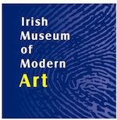

In 2014 IMMA’s onsite residency is expanding its actvities to complement the many ways that art practitioners develop and research their practices.

IMMA Open Call:  
IMMA will be accepting applications during the **month of June** for the yearly open call from national and international arts practitioners , **the closing date is 30th June 2014**. This year IMMA will also introduce a 12 month studio award for one selected artist / project. Please check our website for further details on both of these opportunities and for exact opening and closing dates for the open call.

IMMA Fellowship Residency:  
In collaboration with the National College of Art and Design IMMA is delighted to support a visiting Research Fellow. Applications are welcome from writers, artists, curators and other practitioners who have published writings in the field of contemporary art theory. Further information can be found at [www.ncad.ie](http://www.ncad.ie)

W: [www.imma.ie](http://lists.visualartists.ie/lt.php?c=1132&m=4172&nl=1&s=e784eec6bf8bb9680747b324b9c9eee1&lid=85346&l=-http--www.imma.ie)

**\_\_\_\_\_\_\_\_\_\_\_\_\_\_\_\_\_\_\_\_\_\_\_\_\_\_\_\_\_\_\_\_\_\_\_\_\_\_\_\_\_\_\_\_\_\_\_\_\_\_\_\_\_\_\_\_\_\_\_\_\_\_\_\_\_\_\_\_\_\_\_\_\_\_\_**

**Hotel Maria Kapel Residence Program, Hoorn (The Netherlands)**



Hotel Maria Kapel is an artist-run residency and project space located in a 15th century chapel in Hoorn, the Netherlands, a small historic town 40 kilometres north of Amsterdam. The programme invites artists (individually or as a group, max. 4), curators, and researchers working in a wide range of media, but mainly focusing on installation and context based work and video.

**Deadline for applications: 5th May 2014**

Read more at <http://tinyurl.com/k5jdtwc>

**\_\_\_\_\_\_\_\_\_\_\_\_\_\_\_\_\_\_\_\_\_\_\_\_\_\_\_\_\_\_\_\_\_\_\_\_\_\_\_\_\_\_\_\_\_\_\_\_\_\_\_\_\_\_\_\_\_\_\_\_\_\_\_\_\_\_\_\_\_\_\_\_\_\_\_**

# Have you ever created on a tram? Residence program for visual artists (Torino, Italy)

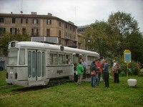

**The call is open to all national and international artists, working in the specific field of visual arts, without restriction of gender, age and technique.** Candidates must have a good knowledge of English and / or Italian (spoken and written).

To support the artistic work in the six-month relationship with Diogene and **travel expenses**, the research grant amount is **€ 6,000** (net of tax). It will be managed freely by the selected artist and will be paid in three parts: 50% at the beginning of the research period, 25% during the intermediary step of work and the remaining 25% at the final delivery.

**Deadline: 15th May 2014**

Find all the details [online](http://www.progettodiogene.eu/?lang=en%20%20%20%20%20%20%20%20%20%20)

**\_\_\_\_\_\_\_\_\_\_\_\_\_\_\_\_\_\_\_\_\_\_\_\_\_\_\_\_\_\_\_\_\_\_\_\_\_\_\_\_\_\_\_\_\_\_\_\_\_\_\_\_\_\_\_\_\_\_\_\_\_\_\_\_\_\_\_\_\_\_\_\_\_\_\_**

**Athlone Art & Heritage: Long and Short Term Studio Residencies at Abbey Road Artists’ Studios**

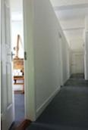

Athlone Art and Heritage Ltd are now accepting short and long term studio residency applications for the facility at Abbey Road Artists’ Studios. The studios are located on Abbey Road near the Radisson Hotel, in the heart of Athlone and welcome applications from artists working in all mediums both individual artists and collectives.

Studios are priced from **€100 per month**, including all utilities.

Submissions guidelines for applicants: Applications should be sent to: Luan Gallery, Grace Road, Athlone, Co. Westmeath FAO Emilia Krysztofiak  
Tel 00 353 (0) 90 6442173 / Email: [gallery@athloneartandheritage.ie](mailto:gallery@athloneartandheritage.ie)

Application procedures at <http://tinyurl.com/mshdkbj>

**\_\_\_\_\_\_\_\_\_\_\_\_\_\_\_\_\_\_\_\_\_\_\_\_\_\_\_\_\_\_\_\_\_\_\_\_\_\_\_\_\_\_\_\_\_\_\_\_\_\_\_\_\_\_\_\_\_\_\_\_\_\_\_\_\_\_\_\_\_\_\_\_\_\_\_**

**Deadline Extended: Sky Arts – Portrait Artist of the Year 2014 | Call for Entries**

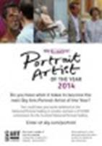

We’re excited to announce that the Sky Arts TV series Portrait Artist of the Year 2014 competition is now open!

**The new closing date is 9am, 6th May, so don’t delay!**

This televised programme is made in association with the National Portrait Gallery and this year artists will compete to win a **£10,000 commission** which will hang in the Scottish National Gallery’s permanent collection, as well as a year’s supply of Cass Art materials.

The application form, the terms and conditions and the frequently asked questions can be found at [www.sky.com/portrait](http://www.sky.com/portrait).

**\_\_\_\_\_\_\_\_\_\_\_\_\_\_\_\_\_\_\_\_\_\_\_\_\_\_\_\_\_\_\_\_\_\_\_\_\_\_\_\_\_\_\_\_\_\_\_\_\_\_\_\_\_\_\_\_\_\_\_\_\_\_\_\_\_\_\_\_\_\_\_\_\_\_\_**

**Kerry Film Festival | Call for Submissions**

**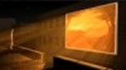**

Kerry Film Festival, which takes place from 4th to 11th October 2014, is inviting entries for short films in categories such as Best Irish Narrative, Best International Narrative, Best Documentary, Best Animated Film, and for the first time, Best Score.

The deadline for submissions is **July 14th**.

W: [www.kerryfilmfestival.com](http://lists.visualartists.ie/lt.php?c=1138&m=4178&nl=1&s=e97e60e0a85e4e4156f0ad241cfbea58&lid=85802&l=-http--www.kerryfilmfestival.com/)

**\_\_\_\_\_\_\_\_\_\_\_\_\_\_\_\_\_\_\_\_\_\_\_\_\_\_\_\_\_\_\_\_\_\_\_\_\_\_\_\_\_\_\_\_\_\_\_\_\_\_\_\_\_\_\_\_\_\_\_\_\_\_\_\_\_\_\_\_\_\_\_\_\_\_\_**

**2014 Over The Edge New Writer of The Year competition OPEN TO POETS & FICTION WRITERS WORLDWIDE**

**Closing date:** **Wednesday**, **August 6th, 2014**

In 2014 Over The Edge is continuing its exciting annual international creative writing competition. The competition is open to both poets and fiction writers worldwide. The total prize money is **€1,000**. The best fiction entry will win **€300**. The best poetry entry will win **€300**. One of these will then be chosen as **the overall winner** and will receive an additional **€400**, giving the overall winner total prize money of **€700** and the title *Over The Edge New Writer of The Year 2014*.

[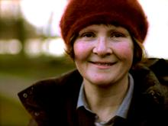](http://1.bp.blogspot.com/-awgfmgAe9mg/UhKhiBECecI/AAAAAAAADPk/WV6TZ7exZfU/s1600/Eleanor+Hooker+-+Photograph+by+George+Hooker-1.JPG)

Competition judge: Eleanor Hooker

The winners will be announced at the October Over The Edge: Open Reading in Galway City Library on **Thursday, October 30th, 2014** (6.30-8pm).

For further details contact Over The Edge on 087-6431748,

E-mail [over-the-edge-openreadings@hotmail.com](mailto:over-the-edge-openreadings@hotmail.com) or to make an online payment see [http://overtheedgeliteraryevents.blogspot.com](http://overtheedgeliteraryevents.blogspot.com/)

**\_\_\_\_\_\_\_\_\_\_\_\_\_\_\_\_\_\_\_\_\_\_\_\_\_\_\_\_\_\_\_\_\_\_\_\_\_\_\_\_\_\_\_\_\_\_\_\_\_\_\_\_\_\_\_\_\_\_\_\_\_\_\_\_\_\_\_\_\_\_\_\_\_\_\_**

**The Moth Short Story Prize**

**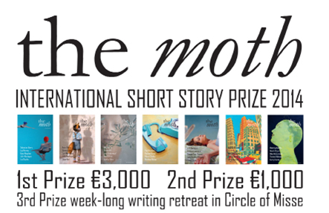**

The Moth Short Story Prize is sponsored by the arts & literature magazine *The Moth*, recently described by the novelist David Mitchell as ‘a beautiful creature’.

The prize is open to everyone, as long as the work is original and previously unpublished. There is a **6,000 word limit**. The entry fee is **€9 ($12.50)** and you can enter as many stories as you like.

For details of how to enter the competition go to [www.themothmagazine.com](http://kk-moss/Sites/arts_office/Shared%20Documents/Julianne%20Morgan/E-bulletin/16th%20May/www.themothmagazine.com), email [enquiries@themothmagazine.com](http://kk-moss/Sites/arts_office/Shared%20Documents/Julianne%20Morgan/E-bulletin/16th%20May/enquiries@themothmagazine.com) or call 00 353 49 4362677.

**\_\_\_\_\_\_\_\_\_\_\_\_\_\_\_\_\_\_\_\_\_\_\_\_\_\_\_\_\_\_\_\_\_\_\_\_\_\_\_\_\_\_\_\_\_\_\_\_\_\_\_\_\_\_\_\_\_\_\_\_\_\_\_\_\_\_\_\_\_\_\_\_\_\_\_**

**Mobile Pop Up Printmaking – Call for submissions**



For more information contact: [Stephanie.reilly@lit.ie](mailto:Stephanie.reilly@lit.ie) or see contact details below.  
061 311806  
[limerickprintmakers@gmail.com](mailto:limerickprintmakers@gmail.com)  
[www.limerickprintmakers.com](http://www.limerickprintmakers.com/)

**\_\_\_\_\_\_\_\_\_\_\_\_\_\_\_\_\_\_\_\_\_\_\_\_\_\_\_\_\_\_\_\_\_\_\_\_\_\_\_\_\_\_\_\_\_\_\_\_\_\_\_\_\_\_\_\_\_\_\_\_\_\_\_\_\_\_\_\_\_\_\_\_\_\_\_**

**Hive Emerging – May Group Exhibition | Call for Submissions**



This May, Hive is due to launch the first events of its summer programme. We are staging an open call for artworks from across the broad spectrum of mediums to compile a group show which will exemplify the current practice of emerging artists.

With regards to video and performance art, we would require exemplary video as part of submissions. Hive accepts links to both Youtube & Vimeo.

**Deadline May 6th, 5.30pm**

Email: [submissions@hiveemerging.com](mailto:submissions@hiveemerging.com) / [hiveemerging@gmail.com](mailto:hiveemerging@gmail.com)

Read more at <http://tinyurl.com/oxmnkpg>

**\_\_\_\_\_\_\_\_\_\_\_\_\_\_\_\_\_\_\_\_\_\_\_\_\_\_\_\_\_\_\_\_\_\_\_\_\_\_\_\_\_\_\_\_\_\_\_\_\_\_\_\_\_\_\_\_\_\_\_\_\_\_\_\_\_\_\_\_\_\_\_\_\_\_\_**

**Cavan Town Council Public Art – Call for submissions**

****

Cavan Town Council requests submissions for a work of public art celebrating the history of Cavan Town Council.

Site

The site is photographed here and is adjacent to Cavan Town Hall, Townhall St, Cavan. Google St View: <http://goo.gl/maps/eRYjV>

Budget

The overall value of the commission is **€12,000** excluding site works which the Council will provide but the artist is expected to identify likely cost/value for this input.

Site visits can be arranged by appointment with Cavan Town Clerk, email [bhora@cavantc.ie](http://kk-moss/Sites/arts_office/Shared%20Documents/Julianne%20Morgan/E-bulletin/16th%20May/bhora@cavantc.ie)

Date for Receipt of Submissions: **Friday 30th May by 4pm**

Submissions should include detail on the estimated time to complete the project if successful.

Submission to Cavan Town Hall, Townhall St, Cavan Or via email to [bhora@cavantc.ie](http://kk-moss/Sites/arts_office/Shared%20Documents/Julianne%20Morgan/E-bulletin/16th%20May/bhora@cavantc.ie)

For full brief see: [small\_Cavan\_Town\_Council\_Public\_Art\_Request\_for\_Submissions](http://visualartists.ie/wp-content/uploads/2014/04/small_Cavan_Town_Council_Public_Art_Request_for_Submissions.pdf)

**\_\_\_\_\_\_\_\_\_\_\_\_\_\_\_\_\_\_\_\_\_\_\_\_\_\_\_\_\_\_\_\_\_\_\_\_\_\_\_\_\_\_\_\_\_\_\_\_\_\_\_\_\_\_\_\_\_\_\_\_\_\_\_\_\_\_\_\_\_\_\_\_\_\_\_**

# Call for Proposals from Performing Arts Practitioners: Arts and Disability Public Art Commission

[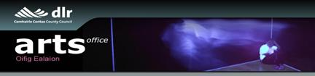](http://www.dlrcoco.ie/arts/index.html)

Dún Laoghaire-Rathdown County Council invites proposals for a performing arts commission focusing on the exploration of sensory disabilities . The commission is open to either individuals or companies/collaborators to apply. It is anticipated that the successful applicant will work collaboratively with groups(s) of people with sensory disabilities in the Stillorgan electoral area of the county.

**The budget for the commission is €14,000 inclusive. Deadline for submissions: Tuesday 24th June @ 12 noon**

**Read more at** <http://tinyurl.com/qx4gxc8>

**\_\_\_\_\_\_\_\_\_\_\_\_\_\_\_\_\_\_\_\_\_\_\_\_\_\_\_\_\_\_\_\_\_\_\_\_\_\_\_\_\_\_\_\_\_\_\_\_\_\_\_\_\_\_\_\_\_\_\_\_\_\_\_\_\_\_\_\_\_\_\_\_\_\_\_**

**Artists & Lecturers for Dun Laoghaire-Rathdown Libraries Panels**

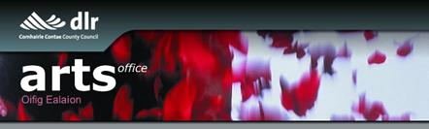  
  
DLR Libraries are delighted to announce this call for creative practitioners and facilitators to work with children, young people and adults throughout its public libraries. Artforms which will be considered include Architecture, Circus, Dance, Film, Literature, Music, Opera, Theatre, Traditional Arts, Visual Arts and Crafts

Creative practitioners and facilitators will be selected for a panel and for events programmed from Autumn 2014 through to early 2016.   
  
All queries to: Maeve McElligott at email above or call (01) 214 7970

Deadline:  **9th May, 12 noon**   
Web: <http://www.dlrcoco.ie/arts/>  
Email: [mmcelligott@dlrcoco.ie](mailto:mmcelligott@dlrcoco.ie)

**\_\_\_\_\_\_\_\_\_\_\_\_\_\_\_\_\_\_\_\_\_\_\_\_\_\_\_\_\_\_\_\_\_\_\_\_\_\_\_\_\_\_\_\_\_\_\_\_\_\_\_\_\_\_\_\_\_\_\_\_\_\_\_\_\_\_\_\_\_\_\_\_\_\_\_**

**6th Brandenburg Biennial**

[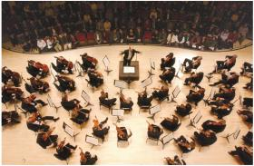](http://mediad.publicbroadcasting.net/p/wabe/files/201209/Orchestra_overhead.jpg)

Deadline: **24th May, 2014**

The Association of Friends of the Brandenburg Symphony Orchestra (FBS e.V.) announces the sixth edition of its competition for composers of symphonic music. The competition is international and open to all age groups.  
  
Web: [fbsym.de/index.php?id=74](http://fbsym.de/index.php?id=74) cid:image246.png@01CF661A.FBD84030

**\_\_\_\_\_\_\_\_\_\_\_\_\_\_\_\_\_\_\_\_\_\_\_\_\_\_\_\_\_\_\_\_\_\_\_\_\_\_\_\_\_\_\_\_\_\_\_\_\_\_\_\_\_\_\_\_\_\_\_\_\_\_\_\_\_\_\_\_\_\_\_\_\_\_\_**

**Nordic Music Days registration open**

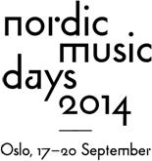

No Deadline

Are you interested in the current movements in the Nordic contemporary music scene? Do you want to meet and greet representatives of the Nordic contemporary music scene, and hear new works by up-and-coming Nordic composers?  
We welcome composers, artistic directors, musicians, journalists, managers and all other interested parties to register as delegates and join us in Oslo. As a registered Nordic Music Days delegate, you will get access to all NMD concerts, showcases and networking events.  
  
Web: [ultima.no/nordicmusicdays/](http://ultima.no/nordicmusicdays/) cid:image246.png@01CF661A.FBD84030

**\_\_\_\_\_\_\_\_\_\_\_\_\_\_\_\_\_\_\_\_\_\_\_\_\_\_\_\_\_\_\_\_\_\_\_\_\_\_\_\_\_\_\_\_\_\_\_\_\_\_\_\_\_\_\_\_\_\_\_\_\_\_\_\_\_\_\_\_\_\_\_\_\_\_\_**

# Typecast commission

# [cid:image147.png@01CF6612.C2AE48C0](http://www.create-ireland.ie/)

[Create](http://www.create-ireland.ie), in partnership with the Design & Crafts Council of Ireland (DCCoI) and Coolmine Therapeutic Community is seeking expressions of interest from artists and craftspeople with experience of working within the context of substance misuse and recovery, to create a new contemporary collaborative artwork utilising clay as a key material.

**Deadline for submissions is 19th May 2014.**

The brief is available from:  <http://tinyurl.com/mkvw6ns>

**\_\_\_\_\_\_\_\_\_\_\_\_\_\_\_\_\_\_\_\_\_\_\_\_\_\_\_\_\_\_\_\_\_\_\_\_\_\_\_\_\_\_\_\_\_\_\_\_\_\_\_\_\_\_\_\_\_\_\_\_\_\_\_\_\_\_\_\_\_\_\_\_\_\_\_**

### Open Call: Friday New Works Series

[](http://www.danceireland.ie/index.php)

Application deadline: **16th May @ 12noon**  
  
Dance Ireland announces an open call for submissions for a new presentation initiative, Friday New Works Series, open to Dance Ireland members.

Friday New Works Series will offer a platform and will showcase some of the dance/performance work currently being made by members today.  
  
[READ MORE](http://danceireland.us5.list-manage2.com/track/click?u=5121d0fedd423c64bdbf0d66b&id=31c9685df1&e=1505fd3a45)

**\_\_\_\_\_\_\_\_\_\_\_\_\_\_\_\_\_\_\_\_\_\_\_\_\_\_\_\_\_\_\_\_\_\_\_\_\_\_\_\_\_\_\_\_\_\_\_\_\_\_\_\_\_\_\_\_\_\_\_\_\_\_\_\_\_\_\_\_\_\_\_\_\_\_\_**

**Awards / Bursaries / Schemes**

**\_\_\_\_\_\_\_\_\_\_\_\_\_\_\_\_\_\_\_\_\_\_\_\_\_\_\_\_\_\_\_\_\_\_\_\_\_\_\_\_\_\_\_\_\_\_\_\_\_\_\_\_\_\_\_\_\_\_\_\_\_\_\_\_\_\_\_\_\_\_\_\_\_\_\_**

**Emerging Visual Artist Award 2014 - Call for Submissions**

[](http://www.wexfordartscentre.ie/)

Wexford Arts Centre and Wexford County Council are pleased to announce a call for submissions for their annual Emerging Visual Artist Award.   
   
The Emerging Visual Artist Award is a partnership initiative between Wexford Arts Centre, Wexford County Council and the Arts Council. The initiative supports promising visual artists in Ireland with **an award of €5,000** and a solo exhibition at Wexford Arts Centre.

The deadline for receipt of email submissions is **4.00p.m. Thursday 15th May 2014**.

For more info, please log on to <http://www.wexfordartscentre.ie/application-process-2014.html>.

**\_\_\_\_\_\_\_\_\_\_\_\_\_\_\_\_\_\_\_\_\_\_\_\_\_\_\_\_\_\_\_\_\_\_\_\_\_\_\_\_\_\_\_\_\_\_\_\_\_\_\_\_\_\_\_\_\_\_\_\_\_\_\_\_\_\_\_\_\_\_\_\_\_\_\_**

**Business to Arts Awards - One Week Left! Awards deadline 6th May**



**Entries close at 5pm on Tuesday 6th May 2014**  
  
Remember, your application should:

* **Tell the story of your partnership.** How did it start? What were the objectives and how were they met? What were the fun and unexpected aspects of the project?
* **Include the required material.** Have you told your story in the 3 page presentation? Have you got 8 copies of everything? Has it been proofread? Have you added the extra 800 word artists’ statement for the **Jim McNaughton / TileStyle €10,000 Artist’s Bursary, if that's relevant?**

If you have done all of the above, you’re ready to submit your application! Good luck!   
   
Click [here](http://cts.vresp.com/c/?BusinesstoArts/41f3c03e50/608128ad7e/68f16ecbc2) for information on the application process, the alumni of past winners, and to download the application form.  
**\_\_\_\_\_\_\_\_\_\_\_\_\_\_\_\_\_\_\_\_\_\_\_\_\_\_\_\_\_\_\_\_\_\_\_\_\_\_\_\_\_\_\_\_\_\_\_\_\_\_\_\_\_\_\_\_\_\_\_\_\_\_\_\_\_\_\_\_\_\_\_\_\_\_\_**

**The Arts Council – Funding**

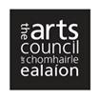

**Touring and Dissemination of Work Scheme – January to June 2015**

Applications are welcome for tours with performances / exhibitions on both sides of the border.

All administration for this scheme will be done by the Arts Council / An Chomhairle Ealaíon and general inquiries can be directed to [val.ballance@artscouncil.ie](mailto:val.ballance@artscouncil.ie)

**Closing date: 5.30pm, Thursday 8th May, 2014.**

Contact: Regina O’Shea

**Email:** [regina.oshea@artscouncil.ie](mailto:regina.oshea@artscouncil.ie)

# Splanc! Arts Documentary Scheme

# http://www.tg4.ie/assets/images/Production/Splanc.jpg[Voluntary ArtsVoluntary ArtsVoluntary Arts](http://www.voluntaryarts.org/)

**The Arts Council and TG4 invite submissions for the 8th season of Splanc!**

This year the scheme aims to support ambitious landmark factual films on a contemporary artistic theme that are notably creative in their execution. **A total fund of €120,000** is available and will support two hour-long films or one feature length film.

Submissions should be sent to TG4, Baile na hAbhann, Co na Gaillimhe.

**Deadline for receipt of submissions is 1 pm, Friday, 30th May, 2014.**

Read more at: [http://tinyurl.com/nczfyk3](http://tinyurl.com/nczfyk3%20)

Artist in the community scheme

Twice yearly, the Arts Council offers grants to enable artists and communities of place/or interest to work together on projects.

There are two phases to the scheme.

**Phase One**

[Research & Development](http://newsletter.artscouncil.ie/1rlddxfaj7v14rbsgtdsq9?a=6&p=47027345&t=17684704)  
[Research & Development/Mentoring](http://newsletter.artscouncil.ie/2x9bljt4rjn14rbsgtdsq9?a=6&p=47027345&t=17684704)

**Phase Two**

[Project Realisation](http://newsletter.artscouncil.ie/1my9i3o2ve114rbsgtdsq9?a=6&p=47027345&t=17684704),

Deadline: **June 23rd**

Full details on the application criteria on the Create website: <http://tinyurl.com/ms68f5e>

Engaging with Architecture Scheme closing date

The Arts Council announces the *Engaging with Architecture Scheme 2014*, with the purpose of engaging the public with architecture.

**The closing date for applications is Thursday, 12th June, 2014 at 5.30pm and projects must take place before 24th April, 2015.**

Guidelines will be available shortly on the 'available funding' section of the Arts Council website.

More info about the above funding at <http://www.artscouncil.ie/en/funding_deadlines.aspx>

**\_\_\_\_\_\_\_\_\_\_\_\_\_\_\_\_\_\_\_\_\_\_\_\_\_\_\_\_\_\_\_\_\_\_\_\_\_\_\_\_\_\_\_\_\_\_\_\_\_\_\_\_\_\_\_\_\_\_\_\_\_\_\_\_\_\_\_\_\_\_\_\_\_\_\_**

**The Arts Council - Awards**

**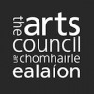**

Bursary Awards

The deadline for the next round of the Arts Council’s Bursary Awards is **Thursday, 17th July 2014 at 5.30pm.** The window for making an application opens on **Tuesday, 17th June 2014.**

The following awards are available:

• YPCE Bursary Award

• Traditional Arts Bursary Award

• Literature Bursary Award (English Language)

• Visual Arts Bursary Award

The Arts Council provides Bursary Awards in order to assist individual artists in the development of their art practice.

Deis Award

The deadline for the next round of the Arts Council's Deis Award is **Thursday 5 June, 2014 at 5.30pm.**

Deis is aimed at encouraging and facilitating the traditional arts community to seek funding from the Arts Council for a range of projects.

You can download the guidelines by clicking on the link below:

* [Guidelines Deis R2 2014](http://www.artscouncil.ie/GetAttachment.aspx?id=3c0b8670-df52-413d-b647-f9afce0f6790)(0.09 MB, MS Word)

Read more at <http://www.artscouncil.ie/en/funding_deadlines.aspx>

**\_\_\_\_\_\_\_\_\_\_\_\_\_\_\_\_\_\_\_\_\_\_\_\_\_\_\_\_\_\_\_\_\_\_\_\_\_\_\_\_\_\_\_\_\_\_\_\_\_\_\_\_\_\_\_\_\_\_\_\_\_\_\_\_\_\_\_\_\_\_\_\_\_\_\_**

**Galway Film Centre and RTÉ -2014 Short Film Awards**

**[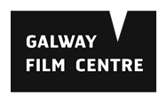](http://www.galwayfilmcentre.ie/)**

Galway Film Centre, in association with RTÉ, has announced two cash awards of **€9,500 each** under its 2014 Short Film Awards. The awards will be given to the two best scripts submitted to the Galway Film Centre, **with the deadline for submissions announced as 12 noon on Friday May 9th.**

Application forms for submission are available on request from [info@galwayfilmcentre.ie](mailto:info@galwayfilmcentre.ie). Full details at [www.galwayfilmcentre.ie](http://r20.rs6.net/tn.jsp?f=001M2UvA9yXTw87VOmC9QEZZG2txi6o_ZbsW_JypvjtF4yqjfB9xga7-qNCf71Qr1ZcPGEDZGSBH6QL6FElnqdPseX-HIK2cFaUgL5qoSpM2UuyLyI9asTnXt2PuXXB7qFjCnSBKGLuzjxP2ddMyS3JSdypS2RkGhDG-SqZTPYs28jcBta92eYfAQ==&c=tNkglR-0w8LR8mEOmSo1MClOB4b_xHQ1PDcN0Sap1CGmLRSMm2dGdA==&ch=lFLsZiSy_bMpugcdEnMCHhJU4J_Hqs7EAv5befqE0OeYWhLJIdcaZg==).

**\_\_\_\_\_\_\_\_\_\_\_\_\_\_\_\_\_\_\_\_\_\_\_\_\_\_\_\_\_\_\_\_\_\_\_\_\_\_\_\_\_\_\_\_\_\_\_\_\_\_\_\_\_\_\_\_\_\_\_\_\_\_\_\_\_\_\_\_\_\_\_\_\_\_\_**

**The Éigse Award**

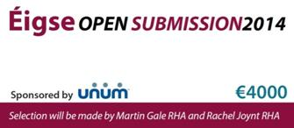

The Éigse Award of **€4000** for Visual Arts will be presented for the ‘most outstanding work in any medium’ at the Opening of the Carlow Arts Festival on Friday 6 June 2014.

**The deadline for postal applications is 16th May 2014.**

Please note that this year **NO E-MAIL SUBMISSIONS** will be accepted, it must be the actual artwork.

**€10 per entry**, limited to 3 per artist. Works must be new or recent, and not yet exhibited in public.

 For more information contact [Lisa Williamson](mailto:lwilliamson@carlowartsfestival.com)

**Application form terms & conditions available for download on link below**

[*Open Submission 2014 Application – Download*](http://carlowartsfestival.com/wp-content/uploads/2014/01/Open-Submission-2014-Application-Download.doc)

More info at <http://carlowartsfestival.com/open-submission/>

**\_\_\_\_\_\_\_\_\_\_\_\_\_\_\_\_\_\_\_\_\_\_\_\_\_\_\_\_\_\_\_\_\_\_\_\_\_\_\_\_\_\_\_\_\_\_\_\_\_\_\_\_\_\_\_\_\_\_\_\_\_\_\_\_\_\_\_\_\_\_\_\_\_\_\_**

**Bursary Award Opportunity with Lorg Printmakers**

**cid:image161.png@01CF6612.C2AE48C0**

Lorg Fine Art Printmakers Ltd., Unit 8, Ballybane Enterprise Centre, Ballybane, Galway

Each year, Lorg Fine Art Printmakers offer a 1 year bursary to one Honours Degree graduate.

The successful applicant receives 12 months free membership which includes use of the workshop facilities and an invitation to exhibit in group shows. The successful applicant will also have a solo exhibition at the end of the exhibition.

Please forward proposals to [lorgprintmakers@gmail.com](mailto:lorgprintmakers@gmail.com) **before 4pm June 5th 2014**.

W: [www.lorgprintmakers.com](http://lists.visualartists.ie/lt.php?c=1138&m=4178&nl=1&s=e97e60e0a85e4e4156f0ad241cfbea58&lid=85796&l=-http--www.lorgprintmakers.com/)

**\_\_\_\_\_\_\_\_\_\_\_\_\_\_\_\_\_\_\_\_\_\_\_\_\_\_\_\_\_\_\_\_\_\_\_\_\_\_\_\_\_\_\_\_\_\_\_\_\_\_\_\_\_\_\_\_\_\_\_\_\_\_\_\_\_\_\_\_\_\_\_\_\_\_\_**

**RDS National Craft Awards and RDS Student Art Awards | Call for Entries**



The Royal Dublin Society (RDS) is calling for entries for its 2014 RDS National Craft Awards (formerly RDS Crafts Competition) and its RDS Student Art Awards. Enter online at [www.rds.ie/arts](http://lists.visualartists.ie/lt.php?c=1132&m=4172&nl=1&s=e784eec6bf8bb9680747b324b9c9eee1&lid=85353&l=-http--www.rds.ie/arts)

Open to craftspeople living in Ireland and Irish makers abroad, the competition has a **prize fund of €24,000** and sets the standard for craft on the island of Ireland to the highest possible level of skill and design excellence. The RDS Student Art Awards has a prize fund in **excess of €17,600 and includes the €5,000 Taylor Art Award**, which has been awarded since 1860.

There are two new awards this year; the RDS **Lens-Based Art Award of €2,200**, open to film and photography based entries and the RDS Monster Truck 1 Year Studio Award (**non-cash prize worth €2,500**) open to graduate and post graduate students completing their studies in 2014. For more information, visit [www.rds.ie/arts](http://www.rds.ie/arts%20)

Application forms are accessible online at [www.rds.ie./arts](http://lists.visualartists.ie/lt.php?c=1132&m=4172&nl=1&s=e784eec6bf8bb9680747b324b9c9eee1&lid=85354&l=-http--www.rds.ie./arts) until the **closing date deadlines of May 12th, (Craft)** **and June 18th, (Student Art)**

**\_\_\_\_\_\_\_\_\_\_\_\_\_\_\_\_\_\_\_\_\_\_\_\_\_\_\_\_\_\_\_\_\_\_\_\_\_\_\_\_\_\_\_\_\_\_\_\_\_\_\_\_\_\_\_\_\_\_\_\_\_\_\_\_\_\_\_\_\_\_\_\_\_\_\_**

# Rehab Group Visual and Performing Arts Fund

# cid:image164.gif@01CF6612.C2AE48C0

Applications for the 2014 round of funding are now being sought from individuals with disabilities and individuals with mental health difficulties working or studying in the arts who require financial support for the forthcoming year and is open to people interested in a wide range of visual and performing arts – from painting, sculpture and graphic art to film, drama, music and dance.

Applicants can seek funding of between **€1,000 and €10,000** per project or individual.

To apply for the funding, please fill out the application form which is available to download online at: <http://rehab.ie/about/VisualAndPerformingArtsFund.aspx>

For further information email: [artsfund@rehab.ie](mailto:artsfund@rehab.ie) or call 01 2057 397.

**The closing date for receipt of applications has been extended to 5pm on Friday, 16th May 2014.**

# \_\_\_\_\_\_\_\_\_\_\_\_\_\_\_\_\_\_\_\_\_\_\_\_\_\_\_\_\_\_\_\_\_\_\_\_\_\_\_\_\_\_\_\_\_\_\_\_\_\_\_\_\_\_\_\_\_\_\_\_\_\_\_\_\_\_\_\_\_\_\_\_\_\_\_

# Small Grants Programme

# [cid:image165.jpg@01CF6612.C2AE48C0](https://www.google.ie/url?q=http://journalofmusic.com/radar/arts-council-northern-ireland-seeks-board-members&sa=U&ei=g05iU87XCOuv7Aao84DwBg&ved=0CC4Q9QEwAQ&usg=AFQjCNGpR_BOQzfebfSsz-QQtkzSpxvHzQ)

# The Arts Council has designed this programme to encourage organisations to develop and deliver ideas linked to artistic needs and to their future plans.

Applications for this scheme can be made using our online form or by downloading a hard copy. We aim to inform you of our final decision within three months of the closing date.

Read more at <http://tinyurl.com/qfzcf66>

# \_\_\_\_\_\_\_\_\_\_\_\_\_\_\_\_\_\_\_\_\_\_\_\_\_\_\_\_\_\_\_\_\_\_\_\_\_\_\_\_\_\_\_\_\_\_\_\_\_\_\_\_\_\_\_\_\_\_\_\_\_\_\_\_\_\_\_\_\_\_\_\_\_\_\_

## Arts and Disability Connect scheme 2014

## [cid:image166.png@01CF6612.C2AE48C0](http://www.adiarts.ie/)

# **Arts & Disability Ireland and Arts Council announce Arts and Disability Connect (ADC) a new scheme open to artists with disabilities working in any artform.**This scheme is designed to support artists with disabilities to make new and ambitious work.

**Arts and Disability Connect New Work**  
2 awards of up to **€8,000 each**

**Arts and Disability Connect Mentoring**                                             
3 awards of up to **€2,000 each**

**Arts and Disability Connect Training**                                                     
3 awards of up to **€1,000 each**

All application forms, guidelines and information documents can be downloaded <http://tinyurl.com/oagpchq>

A completed application form along with all supporting material must be sent to [info@adiarts.ie](http://kk-moss/Sites/arts_office/Shared%20Documents/Julianne%20Morgan/E-bulletin/16th%20May/info@adiarts.ie%20) using WeTransfer by **5pm on** **12th June 2014.**

**Further information:**Contact Arts & Disability Ireland at 01 850 9002 or email [info@adiarts.ie](http://kk-moss/Sites/arts_office/Shared%20Documents/Julianne%20Morgan/E-bulletin/16th%20May/info@adiarts.ie )

# \_\_\_\_\_\_\_\_\_\_\_\_\_\_\_\_\_\_\_\_\_\_\_\_\_\_\_\_\_\_\_\_\_\_\_\_\_\_\_\_\_\_\_\_\_\_\_\_\_\_\_\_\_\_\_\_\_\_\_\_\_\_\_\_\_\_\_\_\_\_\_\_\_\_\_

# Call for applications: artsandhealth.ie documentation bursary

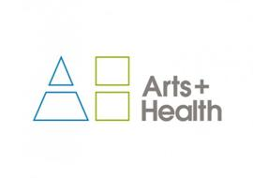

artsandhealth.ie

[artsandhealth.ie](http://www.artsandhealth.ie) invites applications from arts and health practitioners (artists working in healthcare settings, healthcare professionals, arts and health partnerships etc.) for a bursary to produce documentation of an arts and health project. The proposed documentation can take the form of a **short film / audio documentary and / or publication** which can be widely disseminated with a view to encouraging high quality, creative documentation of arts and health practice and creating a greater national understanding of the nature of this practice.

**Bursary**A bursary of **€4000** will be made available to the successful applicant for the production of film / audio documentary and / or publication about an arts and health project.

More info and application details at <http://tinyurl.com/lkuk6s5>

**Submissions should be sent by email to** [info@artsandhealth.ie](mailto:info@artsandhealth.ie) **by Friday, 30th May 2014 at 12 noon.**

**\_\_\_\_\_\_\_\_\_\_\_\_\_\_\_\_\_\_\_\_\_\_\_\_\_\_\_\_\_\_\_\_\_\_\_\_\_\_\_\_\_\_\_\_\_\_\_\_\_\_\_\_\_\_\_\_\_\_\_\_\_\_\_\_\_\_\_\_\_\_\_\_\_\_\_**

**Of Interest**

**\_\_\_\_\_\_\_\_\_\_\_\_\_\_\_\_\_\_\_\_\_\_\_\_\_\_\_\_\_\_\_\_\_\_\_\_\_\_\_\_\_\_\_\_\_\_\_\_\_\_\_\_\_\_\_\_\_\_\_\_\_\_\_\_\_\_\_\_\_\_\_\_\_\_\_**

**First highlights of Kilkenny Arts Festival 2014 announced!**

**A world of artistic magic in Ireland’s medieval city**



Initial Festival highlights were announced and tickets for went on sale on Monday 7 April at 10am.

**Beethoven Quest: The Complete String Quartets**

**The Heath Quartet**

Venue: St John’s Priory

Dates: **8-17 August**

Time: **1pm**

Tickets: from **€13**

**Beethoven Quest: The Complete Piano Concertos**

**Barry Douglas (piano/director) and Camerata Ireland**

Venue: St Canice’s Cathedral

Programme I

Date: **Friday 15 August**

Time: **8pm**

Piano Concerto No 2 in Bb

Piano Concerto No 1 in C

Piano Concerto No 4 in G

Tickets: from **€23.50**

Programme II

Date: **Saturday 16 August**

Time: **8pm**

Piano Concerto No 3 in C minor

Piano Concerto No 5 "Emperor" in Eb

Tickets: from **€23.50**

**The Gloaming with Special Guests**

Venue: St Canice’s Cathedral

Date: **13 August**

Time: **8pm**

Tickets: from **€26**

**Shakespeare’s Globe Theatre**

***Much Ado About Nothing* by William Shakespeare**

**Directed by Max Webster**

Venue: Castle Yard

Dates: 8–12, **14-17 August**

Time: **7.30pm**

Tickets: from **€22.50**

The full programme for the 2014 Kilkenny Arts Festival will be announced in the coming months.

**Booking details:** [www.kilkennyarts.ie](http://www.kilkennyarts.ie)

**Learn more about the festival** at:  <http://www.kilkennyarts.ie/blog/> <http://www.youtube.com/user/KilkennyArtsFestival>

**Get social** and let the festival know your own personal highlights and comments:

[facebook.com/kilkennyarts](http://www.facebook.com/kilkennyarts)   twitter.com/kilkennyarts

**Learn more about Kilkenny** at:<http://www.kilkennyarts.ie/visit/>

Special offers, family tickets and bundles available - see [www.kilkennyarts.ie](http://www.kilkennyarts.ie) for details.

No booking fee will apply for a limited time.

Read more of the above at <http://miniurl.com/8fI6>

**\_\_\_\_\_\_\_\_\_\_\_\_\_\_\_\_\_\_\_\_\_\_\_\_\_\_\_\_\_\_\_\_\_\_\_\_\_\_\_\_\_\_\_\_\_\_\_\_\_\_\_\_\_\_\_\_\_\_\_\_\_\_\_\_\_\_\_\_\_\_\_\_\_\_\_**

**Photographic Equipment for Sale**

****

Calumet Field 5X4 view camera, cherry wood with brass fittings, Caltar 11-N 1:5.6 150mm lens, cable release, black cloth, focus ring, neg. sleeves, hand crafted wood camera box, wooden contact printer, 12 double sided negative holders, changing bag, 2-5X4 complete development tanks. **€1,200**

￼Precision machinist made pin-hole view camera plate with four metal pinhole lens plates. **€150**

Nikkor lenes: 70-210mm 1:4, **€250 or best offer**  
Nikkor 35-70mm 1:3.3-4.5, **€200 or best offer**  
Nikon Telecoverter 1:6 **€15**

Contact: Gypsy Ray / email:[gypsyray@eircom.net](mailto:gypsyray@eircom.net)

**\_\_\_\_\_\_\_\_\_\_\_\_\_\_\_\_\_\_\_\_\_\_\_\_\_\_\_\_\_\_\_\_\_\_\_\_\_\_\_\_\_\_\_\_\_\_\_\_\_\_\_\_\_\_\_\_\_\_\_\_\_\_\_\_\_\_\_\_\_\_\_\_\_\_\_**

[**Daniel Seery**](http://feedproxy.google.com/~r/WordsADay/~3/hFIjXK5rF-o/author-interview-daniel-seery.html?utm_source=feedburner&utm_medium=email)**’s Top Tips for Writers**

[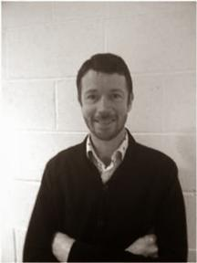](http://4.bp.blogspot.com/-duaGTCL8iOQ/U1p39OxisNI/AAAAAAAADKA/x1GZWN9ZBj0/s1600/dseery_1377697581_62.jpg)

**Novelist Daniel Seery**

At times, some of my personality traits can find their way into the characters I create. These traits can often become exaggerated, skewed even. Tom Stacey is an example of this, the central character in my novel ‘A Model Partner’. So in honour of Tom’s qualities and bearing in mind his love of lists, here are a number of tips which might be of some use to budding writers out there – <http://danielseery.com/2014/04/10/my-top-tips-for-writers/>

**\_\_\_\_\_\_\_\_\_\_\_\_\_\_\_\_\_\_\_\_\_\_\_\_\_\_\_\_\_\_\_\_\_\_\_\_\_\_\_\_\_\_\_\_\_\_\_\_\_\_\_\_\_\_\_\_\_\_\_\_\_\_\_\_\_\_\_\_\_\_\_\_\_\_\_**

**One City One Book - Northern Ireland, May 2014**

**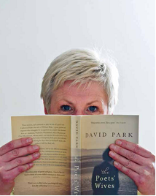**

The Poets' Wives by leading Co. Down author, David Park has been chosen as the novel for this year's One City One Book campaign. The critically-acclaimed novel tells the story of three women, born in different times, in different places, each destined to play the role of a poet's wife.

We are delighted to also announce that One City One Book will also be coming to Derry-Londonderry with a series of events planned at the Verbal Arts Centre during May.

[Download the Programme Now](https://s5.newzapp.co.uk/t/gtl_pg.aspx?LID=ODYxNzczNCw0OTk3MjczNjQsMTQ=)

[Download The Poets' Wives Chapter 1 now](http://www.artscouncil-ni.org/news/download-the-poets-wives-chapter-1)

**\_\_\_\_\_\_\_\_\_\_\_\_\_\_\_\_\_\_\_\_\_\_\_\_\_\_\_\_\_\_\_\_\_\_\_\_\_\_\_\_\_\_\_\_\_\_\_\_\_\_\_\_\_\_\_\_\_\_\_\_\_\_\_\_\_\_\_\_\_\_\_\_\_\_\_**

**10th Dublin Dance Festival, 20—31st May 2014**

****

In this landmark 10th Dublin Dance Festival, we celebrate dance and our achievements with an inspiring range of quality choices. Artistic treasures from home and abroad have been handpicked to make maximum impact in Dublin and beyond. Once again the Festival showcases world-class international choreography.

Read more at <http://tinyurl.com/n27w7yq>

**\_\_\_\_\_\_\_\_\_\_\_\_\_\_\_\_\_\_\_\_\_\_\_\_\_\_\_\_\_\_\_\_\_\_\_\_\_\_\_\_\_\_\_\_\_\_\_\_\_\_\_\_\_\_\_\_\_\_\_\_\_\_\_\_\_\_\_\_\_\_\_\_\_\_\_**

**Barrow River Arts Festival, 9 – 11th May 2014**

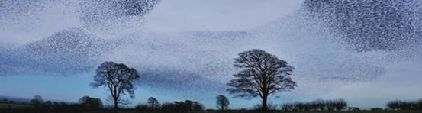

Now in its fourth edition the 2014 festival, which will take place from **9 – 11th May**, brings some of the world’s most exciting musicians and artists to the magnificent setting of Borris House, Borris, Co. Carlow.

Opening of Exhibition - **Alan Davie**

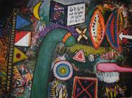

Venue: Borris House, Borris, Co. Carlow

Date: **Friday, 9th May, 6.00pm**

Introduction and official opening of the Barrow River Arts Festival by Olivia O’Leary. Solo Bass improvisations by Barry Guy

Alan Davie (b. 1920) ranks amongst Britain's and Scotland's most important artists of the 20th Century. The exhibition will run throughout the festival and can be viewed between events.

Tickets: VISUAL - Centre for Contemporary Art, Carlow. [www.gbshawtheatre.ie](http://kk-moss/Sites/arts_office/Shared%20Documents/Julianne%20Morgan/E-bulletin/16th%20May/www.gbshawtheatre.ie): Telephone - + 353 (0)59 9172400 or email: [info@visualcarlow.ie](http://kk-moss/Sites/arts_office/Shared%20Documents/Julianne%20Morgan/E-bulletin/16th%20May/info@visualcarlow.ie)

Contact: Susan Proud, Administrator

**Tel:** + 353 (0)86 1777017 **Email:** [barrowriverartsfestival@gmail.com](mailto:barrowriverartsfestival@gmail.com)

**Website:** <http://www.barrowriverartsfestival.com/>

**Facebook/Twitter:** <http://www.facebook.com/barrowriverarts>

View more events at <http://www.barrowriverartsfestival.com/>

**\_\_\_\_\_\_\_\_\_\_\_\_\_\_\_\_\_\_\_\_\_\_\_\_\_\_\_\_\_\_\_\_\_\_\_\_\_\_\_\_\_\_\_\_\_\_\_\_\_\_\_\_\_\_\_\_\_\_\_\_\_\_\_\_\_\_\_\_\_\_\_\_\_\_\_**

**Dublin City Council Launch Guide to Sculpture in City Parks**

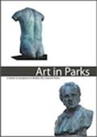

Dublin City Council have just released a guide to sculpture in city parks called Art in Parks. The guide is available as a free download below:

[http://www.dublincity.ie/RecreationandCulture/DublinCityParks/Documents/ArtinParksFinalPDF.pdf](http://lists.visualartists.ie/lt.php?c=1132&m=4172&nl=1&s=e97e60e0a85e4e4156f0ad241cfbea58&lid=85347&l=-http--www.dublincity.ie/RecreationandCulture/DublinCityParks/Documents/ArtinParksFinalPDF.pdf)

**\_\_\_\_\_\_\_\_\_\_\_\_\_\_\_\_\_\_\_\_\_\_\_\_\_\_\_\_\_\_\_\_\_\_\_\_\_\_\_\_\_\_\_\_\_\_\_\_\_\_\_\_\_\_\_\_\_\_\_\_\_\_\_\_\_\_\_\_\_\_\_\_\_\_\_**

**GOOGLE DAY & MENTORING REPORTS**

[](https://www.google.ie/url?q=http://journalofmusic.com/listing/26-03-13/google-arts-association-arts-audiences&sa=U&ei=qppjU5qaCIOd7QbSk4FA&ved=0CEgQ9QEwDg&usg=AFQjCNFAFO3jtgKYv3LGA9QfFSC3hbO3lw)

On **May 15th**, the annual Google @ the arts day will take place at Google, Dublin. 150 arts organisations from all over Ireland will be participating. The programme is available [here](http://newsletter.artscouncil.ie/xxsx0y73abc14rbsgtdsq9?a=6&p=47027405&t=17684704). Keep an eye on our website for photos and a report on the content of the day.

GOOGLE MENTORING REPORTS

We have just published reports on the Google mentoring scheme which partners experts from Google with selected arts organisations to assist in developing their digital marketing over a four month period. Click here to read how **The Irish Chamber Orchestra; The National Gallery of Ireland; The Civic Theatre with Gúna Nua Theatre Company and The Firkin Crane**, Cork, got on. All tips are free.

\*\*\*\*\*\*\*\*\*\*\*\*\*\*\*\*\*\*\*\*\*\*\*\*\*\*\*\*\*\*\*\*\*\*\*\*\*\*\*\*\*\*\*\*\*\*\*\*\*\*\*\*\*\*\*\*\*\*\*\*\*\*\*\*\*\*\*\*\*\*\*\*\*\*\*