**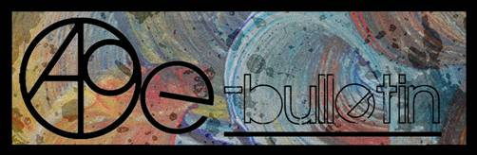**

**Kilkenny County Council Arts Office E-bulletin 27th June, 2014**

Dear All,   
  
Welcome to this week’s e-bulletin from Kilkenny County Council's Arts Office. Each bulletin is packed with the latest information on Kilkenny Arts Office activities, county events as well as news and opportunities for arts practitioners from around the country.

We have decided to shorten information included in the e-bulletin for easier use. This should particularly work well for those reading off tablets and smartphones.

This service will be provided fortnightly. To include an item in the next e-bulletin please send a brief outline of your advert with relevant contact details, including any websites or pages with links to [**julianne.morgan@kilkennycoco.ie**](mailto:julianne.morgan@kilkennycoco.ie) **before 25th June**. The next e-bulletin will be on **27th June**.

**PLEASE NOTE THE NEW EMAIL ADDRESS TO SEND INFORMATION FOR INCLUSION IN THE E-BULLETIN.**

While every effort has been made to ensure the accuracy of our information, we strongly advise readers to verify all details to their own satisfaction.

**It’s come to our attention that emails from Niamh Finn, Arts Administrator, may be going to your Spam. Niamh has changed her surname after marriage so please note her new email address is** [**niamh.brophy@kilkennycoco.ie**](mailto:niamh.brophy@kilkennycoco.ie)**and add it to your safe list and contacts for future reference.**

Regards,  
Julianne Morgan  
Arts Office,  
T: 056 7794938  
E: [Julianne.Morgan@kilkennycoco.ie](mailto:Julianne.Morgan@kilkennycoco.ie)   
W: [www.kilkennycoco.ie/eng/Services/Arts/](http://www.kilkennycoco.ie/eng/Services/Arts/)  
Kilkenny County Council Arts Office Partner Local Authority of the ArtLinks Programme [www.artlinks.ie](http://www.artlinks.ie)

**\_\_\_\_\_\_\_\_\_\_\_\_\_\_\_\_\_\_\_\_\_\_\_\_\_\_\_\_\_\_\_\_\_\_\_\_\_\_\_\_\_\_\_\_\_\_\_\_\_\_\_\_\_\_\_\_\_\_\_\_\_\_\_\_\_\_\_\_\_\_\_\_\_\_\_**

**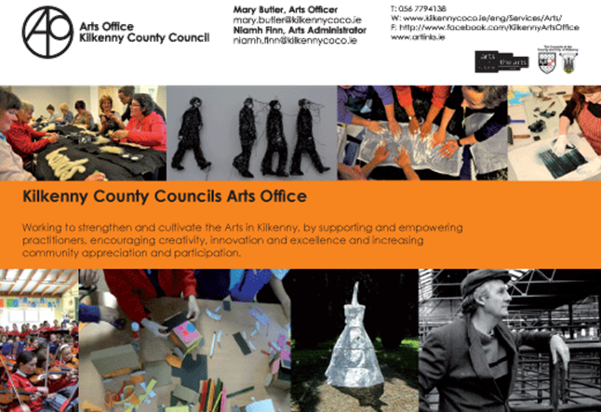**

**\_\_\_\_\_\_\_\_\_\_\_\_\_\_\_\_\_\_\_\_\_\_\_\_\_\_\_\_\_\_\_\_\_\_\_\_\_\_\_\_\_\_\_\_\_\_\_\_\_\_\_\_\_\_\_\_\_\_\_\_\_\_\_\_\_\_\_\_\_\_\_\_\_\_\_**

**Two more poems selected and published**

**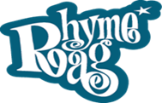**                     **cid:image027.jpg@01CF9205.44337AF0**

**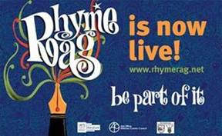**

Dear Poets,

I am delighted to announce that two more poems have been selected and published!

<http://www.rhymerag.net/category/poems/>

Keep the poems coming in as two more poems will be published next month.

Enjoy, thank you all again and best regards,

Mary



‘Wondering’ by Ella Barton, illustrated by Alé Mercado

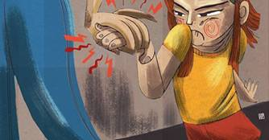

‘Hands’ by Ciara Delaney, illustrated by Alé Mercado

**BECOME PART OF IT, SUBMIT A POEM.....**[www.rhymerag.net](http://kk-moss/Sites/arts_office/Shared%20Documents/Julianne%20Morgan/E-bulletin/30th%20May%20e-bulletin/www.rhymerag.net)

Should you have any questions or require and further details please do not hesitate to contact me on 056 7794138 / [mary.butler@kilkennycoco.ie](mailto:mary.butler@kilkennycoco.ie)

Mary Butler, Arts Officer.

****            **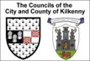**           **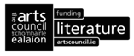**

**\_\_\_\_\_\_\_\_\_\_\_\_\_\_\_\_\_\_\_\_\_\_\_\_\_\_\_\_\_\_\_\_\_\_\_\_\_\_\_\_\_\_\_\_\_\_\_\_\_\_\_\_\_\_\_\_\_\_\_\_\_\_\_\_\_\_\_\_\_\_\_\_\_\_\_**

**Open Circle**

Collograph prints

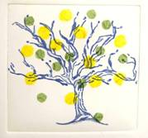

Rebecca Wright

View collograph prints made by Open Circle – Community Arts Collective during a recent series of workshops in Blackstack Studio at <http://miniurl.com/bc73d>. The project was supported by the Kilkenny Arts Office and the Kilkenny and Carlow Education and Training Board.

Open Circle - Social Fabric: Portraits of Kilkenny Women

**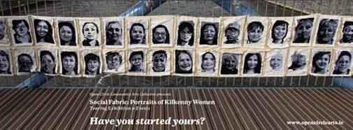**

‘Social Fabric: Portraits of Kilkenny Women’, forty hand embroidered portraits, is on display in Loughboy library, Kilkenny, for **the month of June**.

'Social Fabric: Portraits of Kilkenny Women' is a project initiated by the women of Open Circle Community Arts Collective. Participants of Open Circle invited other women from throughout Kilkenny to join them in the creation of this collaborative artwork. Textile artist Deirdre Harte responded to the group’s ideas with an embroidery project that was both collaborative and distinctly individual, a collection of portraits.

If you are interested in taking part in the next round of workshops contact [opencirclearts@gmail.com](mailto:opencirclearts@gmail.com) to find out how you can get involved.

More info at [http://tinyurl.com/n9zbg7u](http://tinyurl.com/n9zbg7u%20)

**\_\_\_\_\_\_\_\_\_\_\_\_\_\_\_\_\_\_\_\_\_\_\_\_\_\_\_\_\_\_\_\_\_\_\_\_\_\_\_\_\_\_\_\_\_\_\_\_\_\_\_\_\_\_\_\_\_\_\_\_\_\_\_\_\_\_\_\_\_\_\_\_\_\_\_**

**Siamsa**

**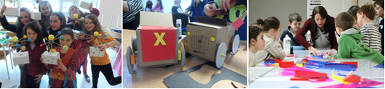**

Our booked out ‘Siamsa’ Summer three day programme for 5 to 12 year olds will run on **Monday 7th, Tuesday 8th, and Wednesday 9th July**. Participants will learn about the water cycle and plants by creating their own mini greenhouse garden, get down and dirty with the surprising science of soil, extract DNA from a strawberry and more curious discoveries!

Look at this beautiful little film of our creative SIAMSA participants: <http://youtu.be/U34xgnPNfQQ>

**\_\_\_\_\_\_\_\_\_\_\_\_\_\_\_\_\_\_\_\_\_\_\_\_\_\_\_\_\_\_\_\_\_\_\_\_\_\_\_\_\_\_\_\_\_\_\_\_\_\_\_\_\_\_\_\_\_\_\_\_\_\_\_\_\_\_\_\_\_\_\_\_\_\_\_**

**Kilkenny poetry broadsheet issue 14 – Launch, Friday 15th August**

**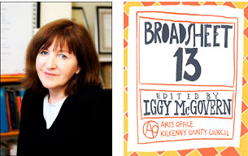**

This year's **Kilkenny Poetry Broadsheet** received record submissions, 192 poems from 77 poets! Join us in the Parade Tower on **Friday, 15th August**, as we present the 14th issue of Kilkenny Poetry Broadsheet, launched by former US Poet Laureate Billy Collins.

Copies ofthe **Kilkenny Poetry Broadsheet** Issue 14 will be available for FREE from Johns Green House, the festival box office and all of our libraries around the county.

W: <http://www.kilkennyarts.ie/events/details/kilkenny-poetry-broadsheet-launch/>

**\_\_\_\_\_\_\_\_\_\_\_\_\_\_\_\_\_\_\_\_\_\_\_\_\_\_\_\_\_\_\_\_\_\_\_\_\_\_\_\_\_\_\_\_\_\_\_\_\_\_\_\_\_\_\_\_\_\_\_\_\_\_\_\_\_\_\_\_\_\_\_\_\_\_\_**

**Kilkenny Events**

**\_\_\_\_\_\_\_\_\_\_\_\_\_\_\_\_\_\_\_\_\_\_\_\_\_\_\_\_\_\_\_\_\_\_\_\_\_\_\_\_\_\_\_\_\_\_\_\_\_\_\_\_\_\_\_\_\_\_\_\_\_\_\_\_\_\_\_\_\_\_\_\_\_\_\_**

**Upstairs Gallery – "Cognition" by Marilyn Gaffney**

**An exhibition of new works by Dublin based artist Marilyn Gaffney**

**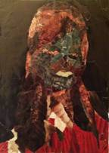**

*Negative*, 17x19cm, collage, Marilyn Gaffney 2013

Venue: The Upstairs Gallery, The Watergate Theatre, Parliament Street, Kilkenny City

Date: **June 1st- 30th, 10am-6pm week days, Saturday 2pm – 6pm**

Investigating the mental process of knowing through the process of painting forms as research within this new body of work. Awareness, perception, reasoning and judgment are obvious applications of conscious reasoning but thought takes many subtler forms, such as interpreting. Sensory input, guiding physical actions and empathizing with others.

Mobile: 0857053979

Email:   [gaffney.marilyn@gmail.com](mailto:gaffney.marilyn@gmail.com)

Website:  [www.marilyngaffney.blogspot.ie](http://www.marilyngaffney.blogspot.ie/)

For further information please check out [facebook.com/upstairsgallerykilkenny](http://facebook.com/upstairsgallerykilkenny)

Watergate: [www.watergatetheatre.com](http://www.watergatetheatre.com)

**\_\_\_\_\_\_\_\_\_\_\_\_\_\_\_\_\_\_\_\_\_\_\_\_\_\_\_\_\_\_\_\_\_\_\_\_\_\_\_\_\_\_\_\_\_\_\_\_\_\_\_\_\_\_\_\_\_\_\_\_\_\_\_\_\_\_\_\_\_\_\_\_\_\_\_**

[**Concert: Rebecca Storm**](http://kclr96fm.com/events/rebecca-storm/) **– Stoneyford Community Centre**

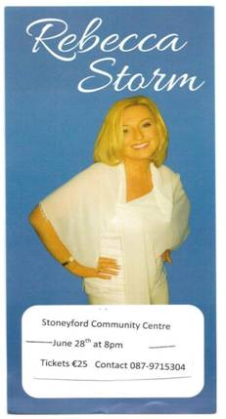

Venue: Community Centre, Stoneyford

Date & time: **Saturday 28th June - 8pm**

Tickets (**€25**) available from Fred on 087-9715304 and from Walsh’s Shop Stoneyford & O’Gradys Pub

**\_\_\_\_\_\_\_\_\_\_\_\_\_\_\_\_\_\_\_\_\_\_\_\_\_\_\_\_\_\_\_\_\_\_\_\_\_\_\_\_\_\_\_\_\_\_\_\_\_\_\_\_\_\_\_\_\_\_\_\_\_\_\_\_\_\_\_\_\_\_\_\_\_\_\_**

**Daithí Ó hUallacháin – Exhibition Hendersons – The Parade, during Kilkenny Arts Festival, 8th – 17th August 2014**

[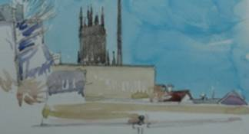](http://www.kilkennyarts.ie/events/details/daithi-o-huallachain-david-holohan-other-selections/)

Some quotes from Daithí’s previous shows; “I have watched Daithí’s work grow steadily. They have become technically more accomplished, more human understanding and they now have a density that is rare in contemporary portraiture.” Campbell Bruce, former professor of painting, National College of Art & Design.

“There is a fragility about both his images and the individuals and places they describe. He is an instinctive naturalist with a good eye.” Aidan Dunne

“There is a deceptive simplicity to Daithí’s works, often depicting a solitary figure or a partial profile, and yet they are also beautifully complex in their ability to capture the mood of a moment.” Tess Felder

**\_\_\_\_\_\_\_\_\_\_\_\_\_\_\_\_\_\_\_\_\_\_\_\_\_\_\_\_\_\_\_\_\_\_\_\_\_\_\_\_\_\_\_\_\_\_\_\_\_\_\_\_\_\_\_\_\_\_\_\_\_\_\_\_\_\_\_\_\_\_\_\_\_\_\_**

[**Fusion Summer Fest 2014 (ft. Original Rudeboys / Republic of Loose / Taken / The Scenes / Audio Fires / The Presidents & more)**](http://www.fusionsummerfest.com/)



Venue & admission: James Park, Kilkenny City, **5th July - 3pm**, **€33** [for 14 - 17 years old only]

Date: **Saturday 5th July**

**\_\_\_\_\_\_\_\_\_\_\_\_\_\_\_\_\_\_\_\_\_\_\_\_\_\_\_\_\_\_\_\_\_\_\_\_\_\_\_\_\_\_\_\_\_\_\_\_\_\_\_\_\_\_\_\_\_\_\_\_\_\_\_\_\_\_\_\_\_\_\_\_\_\_\_**

**Poetry  Reading**

**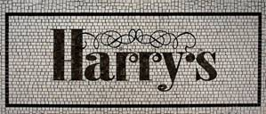**

\*\*\*\*\*\*\*

**First Tuesday of each month**

Time: **8 pm**

Venue:Harry’s Bar, Langton’s House Hotel

\*\*\*\*\*\*\*

Come along and read your poems or read your favourite poems or just listen and mingle.

\*\*\*\*\*\*\*

All are welcome

 Admission is free

**\_\_\_\_\_\_\_\_\_\_\_\_\_\_\_\_\_\_\_\_\_\_\_\_\_\_\_\_\_\_\_\_\_\_\_\_\_\_\_\_\_\_\_\_\_\_\_\_\_\_\_\_\_\_\_\_\_\_\_\_\_\_\_\_\_\_\_\_\_\_\_\_\_\_\_**

**Devious Theatre – Flood Back- July 8th, 9th, 10th**

**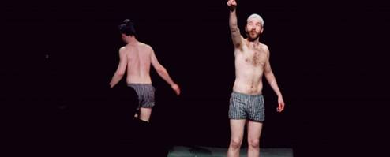**

We’ll be bringing John Doran and Kevin Mooney’s new show back for a limited run in Kilkenny this July. On **July 8th** and **9th** we’ll be bringing the show to the [Red Door Theatre](https://www.facebook.com/pages/Red-Door-Music-and-Arts/213467048695170?fref=ts) at The Bridgebrook Arms in Thomastown. We’re looking forward to heading back out to Thomastown after our brief run of [*War Of Attrition*](http://devioustheatre.com/past-shows/war-of-attrition-2013/) out there last year.

We’ll be following that up with a one night only performance in [The Watergate Theatre](http://www.watergatetheatre.com) on **July 10th** as part of a week-long festival of theatre as part of the Watergate’s 21st birthday celebrations. You can book your tickets at the Watergate box office or on **056-7761674**!

W: <http://devioustheatre.com/flood-back-20140520/>

**\_\_\_\_\_\_\_\_\_\_\_\_\_\_\_\_\_\_\_\_\_\_\_\_\_\_\_\_\_\_\_\_\_\_\_\_\_\_\_\_\_\_\_\_\_\_\_\_\_\_\_\_\_\_\_\_\_\_\_\_\_\_\_\_\_\_\_\_\_\_\_\_\_\_\_**

**Here Be Dragons – Workhouse. Callan – 27th / 28th June**

**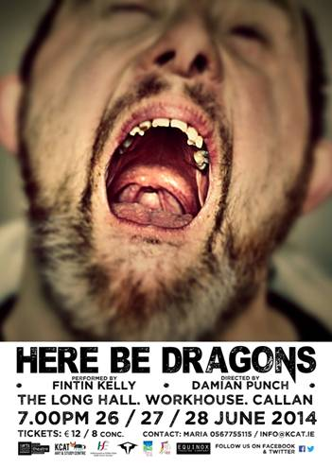**

Let yourself be taken on a theatrical journey of how one man views the world we live in. Devised by these two theatre professionals and shaped into a unique multi-media production that incorporates both film and live action, **HERE BE DRAGONS** promises to be a theatrical experience not to be missed.

**‘HERE BE DRAGONS’**, directed by Damian Punch, stars Fintin Kelly of Equinox Theatre Company, KCAT.

HERE BE DRAGONS runs as part of the Abhainn Rí Festival.

Venue: The Long Hall - The Workhouse, Callan, Co. Kilkenny

Dates:  **27th, 28th of June @ 7p.m** (40 min approx)

Tickets: **€12/8** - available from KCAT Art & Study Centre

To book or for more information please contact Maria or Joan

056 7755115 - [info@kcat.ie](http://kk-moss/Sites/arts_office/Shared%20Documents/Julianne%20Morgan/E-bulletin/13th%20June/info@kcat.ie)

**\_\_\_\_\_\_\_\_\_\_\_\_\_\_\_\_\_\_\_\_\_\_\_\_\_\_\_\_\_\_\_\_\_\_\_\_\_\_\_\_\_\_\_\_\_\_\_\_\_\_\_\_\_\_\_\_\_\_\_\_\_\_\_\_\_\_\_\_\_\_\_\_\_\_\_**

**Kilkenny School of Music – Calling Young Musicians, Enrol now for September**

**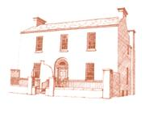**

Pre-instrumental foundation class: **€198 for year**

Beginner violin, cello, piano & wind: **€260 per term**

Solo instrumental lessons: **€360 per term**

W: <http://www.kilkennyschoolofmusic.net/>

**\_\_\_\_\_\_\_\_\_\_\_\_\_\_\_\_\_\_\_\_\_\_\_\_\_\_\_\_\_\_\_\_\_\_\_\_\_\_\_\_\_\_\_\_\_\_\_\_\_\_\_\_\_\_\_\_\_\_\_\_\_\_\_\_\_\_\_\_\_\_\_\_\_\_\_**

**Workshops with Tunde Toth in Inistioge, Co. Kilkenny**

**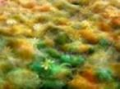**

**6th JULY** (Sunday): PAPERMAKING DAY

Fee:**€ 35** per workshop **OR €65** for the full day – INCLUDING all materials

**10am - 1pm**: HAND PAPERMAKING– beginners and/or some experience

Introducing traditional and contemporary techniques of making beautiful textured and decorated handmade papers from pure plant fibres and recycled materials.

**2.30 – 5.30pm**: SILK FIBRE PAPERMAKING– beginners and/or some experience

This workshop introduces contemporary techniques used in silk papermaking using a variety of raw silk fibres combined with plant fibres and dyes; creating unique, colourful, striking silk papers ideal for many projects.

CALL FOR INTEREST - ADVANCED LEVEL PAPER ART COURSE

Following a number of requests we are calling for artists, crafts practitioners, teachers etc. - participants with previous experience in hand papermaking processes.

Please let us know if you are interested in participating in a FULL DAY ADVANCED LEVEL PAPER ART COURSE and if the **28th JUNE (Saturday)** would suit you.

FULL WORKSHOP DESCRIPTIONS on: [www.tundetothpaperart.blogspot.com](http://www.tundetothpaperart.blogspot.com/)

CONTACT Tunde: 087-2543362

E-mail: [tundetune@gmail.com](mailto:tundetune@gmail.com)

W: [www.tundetoth.com](http://www.tundetoth.com)

Blog: <http://www.tundetothpaperart.blogspot.com>

**\_\_\_\_\_\_\_\_\_\_\_\_\_\_\_\_\_\_\_\_\_\_\_\_\_\_\_\_\_\_\_\_\_\_\_\_\_\_\_\_\_\_\_\_\_\_\_\_\_\_\_\_\_\_\_\_\_\_\_\_\_\_\_\_\_\_\_\_\_\_\_\_\_\_\_**

**Youthink  - Youth Art Exhibition - CALL OUT FOR SUBMISSIONS**

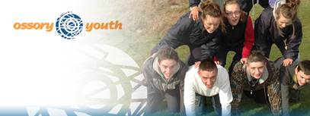

Venue: Desart Hall, New Street, Kilkenny

Date: **7th – 12th Aug**

Ossory Youth would like to inform you about an opportunity for young people to display their art in a public forum during Kilkenny Arts Festival (**7th – 12th August**)

The Youth Art Exhibition is the brainchild of ‘Youthink’, a youth group within Ossory Youth (Regional Youth Service).

The exhibition will take place from **Thurs 7th to Tues 12th August** and is open to the public. Opening times are **12 noon to 5pm**.  An exhibition launch will take place on **Thurs 7th Aug**.

The exhibition will comprise of both visual art (encompassing painting, sculpture and photography, etc) and poetry.  Submissions are welcomed from artists of secondary school age. **We are particularly inviting poetry submissions at this stage. Incorporating poetry creatively into the overall exhibition will involve the young people who submit poetry meeting with us to discuss options**.

If you are interested in participating or require additional information, please contact Patrick Bookle, Ossory Youth (087) 2129006 or [pbookle@ossoryyouth.com](mailto:pbookle@ossoryyouth.com) or contact any of the Youthink youth group.

**\_\_\_\_\_\_\_\_\_\_\_\_\_\_\_\_\_\_\_\_\_\_\_\_\_\_\_\_\_\_\_\_\_\_\_\_\_\_\_\_\_\_\_\_\_\_\_\_\_\_\_\_\_\_\_\_\_\_\_\_\_\_\_\_\_\_\_\_\_\_\_\_\_\_\_**

### Kilkenny County Council Community & Culture - Public Participation Network (PPN)

### cid:image199.png@01CF9205.44337AF0

***Do you want to have your voice heard???* Get involved with the newly established Public Participation Network (PPN)**

### A new framework for public engagement and participation, called the Public Participation Network (PPN) is currently being developed within each local authority area. The PPN will be the main link through which the local authority connects with the community, social inclusion and environmental sectors without prejudice to other consultation processes.

Municipal District Information meetings:

North MD: **Thursday, 26th June, 7.30PM** Castlecomer Demesne, Castlecomer

West MD: **Wednesday, 2nd July, 7.30 PM** Friary Hall, Callan

East MD: **Wednesday, 9th July, 7.30PM** Thomastown Community Centre, Thomastown

South MD: **Tuesday, 15th July, 7.30PM** Piltown Community Hall, Piltown

County Wide Plenary:

Wednesday, **30th July, 7.30 PM** Kilkenny River Court Hotel, Kilkenny

Public Seminar: **Monday,** **July 21st, 2014 @7PM**, Hotel Kilkenny

Dr. Sean Healy-Social Justice Ireland /Michael Ewing - National Environment Pillar

[www.socialjustice.ie](www.socialjustice.ie%20)                               [www.environmentpillar.ie](www.environmentpillar.ie%20)

The seminar aims to provide further in depth information and discussion about the new Public Participation Networks- the new framework for public participation and engagement in local decision making.

For further information please contact Kilkenny County Council Community and Culture Section:

Email: [community@kilkennycoco.ie](community@kilkennycoco.ie%20)

Tel: 056 7794931, Johns Green House, Johns Green, Kilkenny

### The information meetings and seminar are supported by KKCC Community & Culture Section.

All info at [http://tinyurl.com/o4hcv4m](http://tinyurl.com/o4hcv4m%20)

Info and seminar flyer at [http://tinyurl.com/o7eneam](http://tinyurl.com/o7eneam%20)

**\_\_\_\_\_\_\_\_\_\_\_\_\_\_\_\_\_\_\_\_\_\_\_\_\_\_\_\_\_\_\_\_\_\_\_\_\_\_\_\_\_\_\_\_\_\_\_\_\_\_\_\_\_\_\_\_\_\_\_\_\_\_\_\_\_\_\_\_\_\_\_\_\_\_\_**

**Hillside Studio**

Hillside Studio, Donoughmore, Ballyragget, Co. Kilkenny

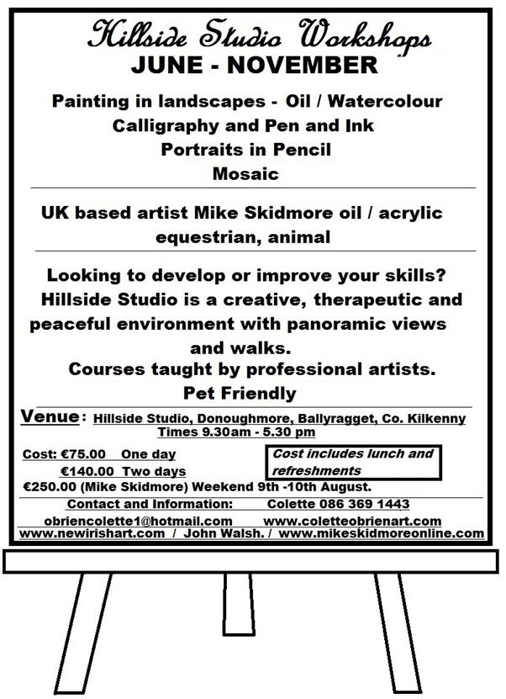

Workshop dates: **June - November**

Times: **9.30am – 5.30pm**

For more information, dates (all dates to suit students) and bookings, please call Colette on 086 3691443 or email [obriencolette1@hotmail.com](mailto:obriencolette1@hotmail.com)

**\_\_\_\_\_\_\_\_\_\_\_\_\_\_\_\_\_\_\_\_\_\_\_\_\_\_\_\_\_\_\_\_\_\_\_\_\_\_\_\_\_\_\_\_\_\_\_\_\_\_\_\_\_\_\_\_\_\_\_\_\_\_\_\_\_\_\_\_\_\_\_\_\_\_\_**

**Use of free, spacious, workshop space – Castlecomer Art & Craft Yard**

[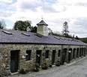](http://www.google.ie/url?url=http://www.clubhousehotel.com/culture-and-heritage.html&rct=j&frm=1&q=&esrc=s&sa=U&ei=OfurU-DpGsWg7Aai9YGACw&ved=0CBYQ9QEwAQ&usg=AFQjCNGPPtLRADnc0upWEUmR2YbmwcUGYg)

Use of free, spacious, workshop space in Castlecomer Art and Craft Yard (20 minute drive from Kilkenny, 30 mins from Carlow) **from Aug 1st for 2 weeks**, in return for manning the attached very quiet shop. No till or card machine and very few customers!

Contact Selina Gittins on 0876827348

# George McCutcheon – KCAT GALLERY

### kcat

### Gypsy Ray and George McCutcheon at the opening of his wonderful retrospective in KCAT Art & Study Centre

### A retrospective collection of work

### Date: Opening Saturday 21st June at 3pm – Sunday 29th (Open ****12pm - 5pm Daily)**** Venue: KCAT Gallery, Mill Lane, Co. Kilkenny

Showcasing the 'Father of KCAT', this exhibition will highlight the breadth of approaches employed by George over his creative life. Curated by George and the KCAT Studio, the selection will be a representation of the many facets to George's work including mosaic, drawing, painting and construction.

**To coincide with the exhibition a special 48 page publication on George and his work will be launched and available to buy for €10.**

More info at <http://tinyurl.com/ot3l6bk>

<http://www.kcat.ie/WP/>  
**\_\_\_\_\_\_\_\_\_\_\_\_\_\_\_\_\_\_\_\_\_\_\_\_\_\_\_\_\_\_\_\_\_\_\_\_\_\_\_\_\_\_\_\_\_\_\_\_\_\_\_\_\_\_\_\_\_\_\_\_\_\_\_\_\_\_\_\_\_\_\_\_\_\_\_**

**National Play Day at Woodstock Gardens - Saturday the 5th of July**

****

Come and join us in Woodstock on the **5th July** for some fun events taking place in celebration of National Play Day.  The theme is 'Going out to Play' with an emphasis on fun, outdoor activities to encourage children to engage with nature.

There will be mini beast quests, nature games, mud play, shelter building and forest crafts.  Also explore the edible plants in the woods in a 'Find it, Pick it, Cook it, Eat it Workshop'

Places are limited so early booking online is essential for all workshops.  No booking required for Scavenger Hunt, Mini Beast Quest and Nature Games.  Entry to all events and games is free.  Book online at [www.iregister.ie/krsp](http://www.iregister.ie/krsp)

Please view National Play Day Poster at link below for more details: [National Play Day Poster](http://www.woodstock.ie/wp-content/uploads/2014/06/National-Play-Day-Poster.pdf)

**\_\_\_\_\_\_\_\_\_\_\_\_\_\_\_\_\_\_\_\_\_\_\_\_\_\_\_\_\_\_\_\_\_\_\_\_\_\_\_\_\_\_\_\_\_\_\_\_\_\_\_\_\_\_\_\_\_\_\_\_\_\_\_\_\_\_\_\_\_\_\_\_\_\_\_**

**CATS THE MUSICAL – Friday, 27th June**

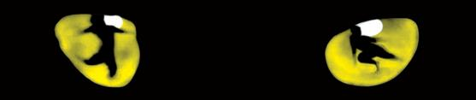

BY POPULAR DEMAND .."CATS THE MUSICAL" will be re-staged AGAIN on **Thursday 26th and Friday 27th June at 8pm** each night in Callan Parish Hall   
  
The show sold out for its initial run 19-21st of June - people have described the show as 'outstanding', 'amazing', 'breathtaking' so see for yourself ... Bookings on 0831187801 or pay at the door - tickets **€10**.

**\_\_\_\_\_\_\_\_\_\_\_\_\_\_\_\_\_\_\_\_\_\_\_\_\_\_\_\_\_\_\_\_\_\_\_\_\_\_\_\_\_\_\_\_\_\_\_\_\_\_\_\_\_\_\_\_\_\_\_\_\_\_\_\_\_\_\_\_\_\_\_\_\_\_\_**

**The Carice Singers - Concert at St. Canice’s Cathedral, Friday 22nd August 2014**

**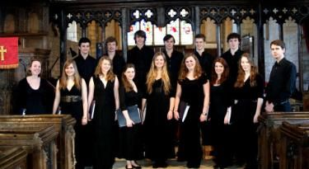**

We shall be performing in St. Canice’s Cathedral on the evening **of Friday 22nd August** as part of our tour of the Republic of Ireland, with a programme of music highlighting British composers who were influenced by Ireland.

Since its founding in 2011, the choir has given many acclaimed performances across the UK, and are the youngest ensemble to have recorded a disc for the record label Naxos. For more information on the choir, please visit our website: [www.thecaricesingers.co.uk](http://www.thecaricesingers.co.uk/).

We cannot wait to visit and perform in Kilkenny this summer.

With best wishes,

George Parris,

Musical Director -- The Carice Singers

[gp359@cam.ac.uk](mailto:gp359@cam.ac.uk)

tel. 07735 547262

**\_\_\_\_\_\_\_\_\_\_\_\_\_\_\_\_\_\_\_\_\_\_\_\_\_\_\_\_\_\_\_\_\_\_\_\_\_\_\_\_\_\_\_\_\_\_\_\_\_\_\_\_\_\_\_\_\_\_\_\_\_\_\_\_\_\_\_\_\_\_\_\_\_\_\_**

**Library News**

****

'Social Fabric: Portraits of Kilkenny Women'

Venue: Loughboy library

Date: **9th June – 30th June**

**Telephone:** 7794176/7794177

**Contact Person:** Caitriona Kenneally

**E mail:** [loughboy@kilkennylibrary.ie](mailto:loughboy@kilkennylibrary.ie)

Exhibition Space available for Artists

Venue: City Library

**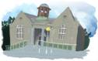**

Showcase your work at City Library. We have space to hang 6 to 12 works, depending on size. Contact Aisling Kelly on 056 779 4175 or [citylibrary@kilkennylibrary.ie](mailto:citylibrary@kilkennylibrary.ie) for more information.

Free art classes with Hazel

Venue: Ferrybank library

Date: **Fridays 10.30 -12 and 3 - 4**

Sketching & watercolours for adults. No experience required.

Calling all budding writers

Venue: Ferrybank library

A new creative writing group for adults will meet on Tuesday mornings starting in July. Register your interest now.

Contact Ferrybank library

**Telephone:** 051 897200

**Contact Person:** Patricia Nolan

**E mail:** [ferrybank@kilkennylibrary.ie](mailto:ferrybank@kilkennylibrary.ie)

**\_\_\_\_\_\_\_\_\_\_\_\_\_\_\_\_\_\_\_\_\_\_\_\_\_\_\_\_\_\_\_\_\_\_\_\_\_\_\_\_\_\_\_\_\_\_\_\_\_\_\_\_\_\_\_\_\_\_\_\_\_\_\_\_\_\_\_\_\_\_\_\_\_\_\_**

**The Brewery Project – Fund it campaign**

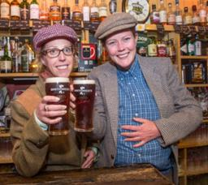

The Brewery Project are Ita Morrissey, Liselott Olofsson & Darragh Byrne. We are a Kilkenny based arts collective, together we are a theatre maker, ceramic artist and videographer. We have come together because we recognise a need for a creative community celebration to mark the rich history of Smithwick's brewery in light of its closure.[The Brewery Project](https://www.facebook.com/thebreweryproject?ref=stream) are looking for some support with their [Fund it](https://www.facebook.com/Fundit.ie) campaign so they can make a site specific theatre piece, a documentary and exhibition of works. This is a hugely collaborative & creative venture, please show your support.

**For more info and to view the Brewery Project Fund it campaign video, see** <http://fundit.ie/project/the-brewery-project>

**\_\_\_\_\_\_\_\_\_\_\_\_\_\_\_\_\_\_\_\_\_\_\_\_\_\_\_\_\_\_\_\_\_\_\_\_\_\_\_\_\_\_\_\_\_\_\_\_\_\_\_\_\_\_\_\_\_\_\_\_\_\_\_\_\_\_\_\_\_\_\_\_\_\_\_**

**Butler Gallery**

Felicity Clear

**[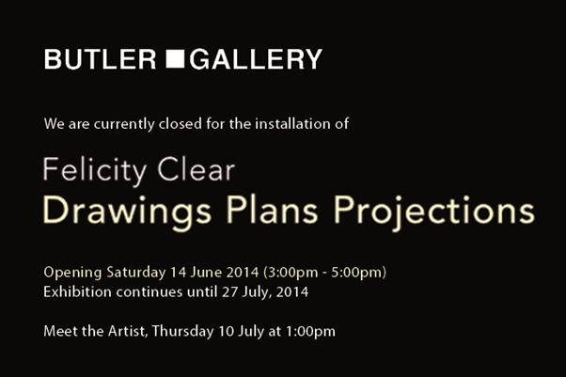](http://www.butlergallery.com/?p=4480)**

Date: **June 14 – July 27th, 2014**

The Butler Gallery is delighted to present Drawings Plans Projections, an exhibition by Felicity Clear, which includes wall drawings, structures and animation.

Culture club

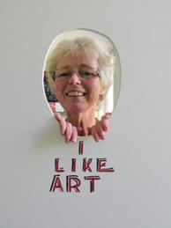

****

Application form available at: <http://tinyurl.com/mopqxxh>

W: <http://www.butlergallery.com/>

**\_\_\_\_\_\_\_\_\_\_\_\_\_\_\_\_\_\_\_\_\_\_\_\_\_\_\_\_\_\_\_\_\_\_\_\_\_\_\_\_\_\_\_\_\_\_\_\_\_\_\_\_\_\_\_\_\_\_\_\_\_\_\_\_\_\_\_\_\_\_\_\_\_\_\_**

**What’s happening in the Watergate?**

Irish Country Stars Summer Concert

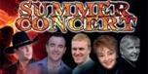

Date: **July 3rd**

Featuring award winning entertainers of Country & Irish Music including Robert Mizzell, Patrick Feeney, Nicky Kealy, Gloria & Dave Lawlor

Watergate Theatre Golf Classic

Date: **July 18th**

The Watergate will hold a Golf Classic at Kilkenny Golf Club on July 18th. Teams of 3 cost **€150** which includes a meal. If interested please call Gerry Cody on 087 2909451

Watergate Production presents Da by Hugh Leonard



Date: **July 21st – 26th**

Hugh Leonard’s hilarious comedy Da explores the relationship of Charlie, a successful playwright, with his adoptive father.

21st celebrations



The Watergate theatre will present a theatre trilogy in association with Brian Carr as part of its 21st celebrations. The three shows are ‘Some Flood’ presented by Kilkenny based Devious theatre; ‘The Secret Life of You and Me’ performed by Lowri Evans and ‘Foreign Bodies’ presented by Polish Theatre Ireland. Attend all three shows for **€39 / €33**.

Some Flood

  
Date(s): **10th Jul 2014**   
Time: **8:00 PM - 9:00 PM**

**Tickets: €15/€13**

The Devious Theatre Company presents ‘SOME FLOOD’ as part of The Watergate Theatre Trilogy In Association With Brian Carr. A Comedy About Surviving The Apocalypse, Madness And Tinned Food.

[Find on Facebook](https://www.facebook.com/devioustheatre?fref=ts) | [Follow On Twitter](https://twitter.com/devioustheatre) | [Official Website](http://devioustheatre.com/)

The Secret Life of You and Me

Date(s): **11th Jul 2014**Time: ***8:00 PM - 9:00 PM***

**Tickets: €16**

The Future presents ‘The Secret Life Of You And Me’ By Lowri Evans.

This is an engaging, and insightful look at how one young woman has looked at her life both retrospectively and to her future as she approaches her 30th birthday.

Find on Facebook | [Follow On Twitter](https://twitter.com/thefuturemcr) | [Official Website](http://www.the-future.co.uk/about/)

Foreign bodies

Date(s): **12th Jul 2014**   
Time: **8:00 PM - 9:00 PM**

**Tickets:** **€16**

Polish Theatre Ireland presents Foreign Bodies.

Written By Julia Holewinska

Displacement is a primary theme of Julia Holewinska’s play. It is an unsettling contemplation of identity politics during and after the fall of communist Poland.

[Find on Facebook](https://www.facebook.com/polishtheatreireland) | [Follow On Twitter](https://twitter.com/PTIdublin) | [Official Website](http://polishtheatre.wordpress.com/)

View more at <http://watergatetheatre.com/>

Want tickets? Call the box office now on 056-7761674 or click here to book online: [https://www.ctb.ie/tickets/watergate/?shows=%](https://www.ctb.ie/tickets/watergate/?shows=%25)

**\_\_\_\_\_\_\_\_\_\_\_\_\_\_\_\_\_\_\_\_\_\_\_\_\_\_\_\_\_\_\_\_\_\_\_\_\_\_\_\_\_\_\_\_\_\_\_\_\_\_\_\_\_\_\_\_\_\_\_\_\_\_\_\_\_\_\_\_\_\_\_\_\_\_\_**

**Callan Pictorial Past, Saturday 28th June, Parish Hall**

**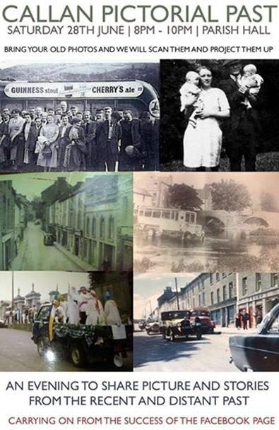**

Callan Pictorial Past Evening on **Saturday the 28th June** in the Parish Hall, raid the attics and bring all your old photos and stories, a free event to mingle and chat about the rich and varied history of our town Callan and its people.

**\_\_\_\_\_\_\_\_\_\_\_\_\_\_\_\_\_\_\_\_\_\_\_\_\_\_\_\_\_\_\_\_\_\_\_\_\_\_\_\_\_\_\_\_\_\_\_\_\_\_\_\_\_\_\_\_\_\_\_\_\_\_\_\_\_\_\_\_\_\_\_\_\_\_\_**

**National craft gallery**

Beauty is the First Test

****

**16th May 2014 – 9th July 2014**

Mathematical concepts underpin many craft techniques, especially around textile construction, and can be key tools for artistic development. This exhibition’s intention is to unlock and demystify maths by showing unique and stimulating works of art.

For more info of the above, please visit: <http://www.nationalcraftgallery.ie/exhibitions>

Tours: Beauty is the First Test

[Beauty is the First Test](http://nationalcraftgallery.cmail2.com/t/y-l-irdtddt-jlklezkr-yk/) is ideal for school groups and tours. Concerned with the close relationship between art and mathematics, this is an exciting exhibition with a strong educational theme.

**For** [more information](http://nationalcraftgallery.cmail2.com/t/y-l-irdtddt-jlklezkr-yu/) or to [**book a tour**](http://nationalcraftgallery.cmail2.com/t/y-l-irdtddt-jlklezkr-jl/) with our Education Department please contact: [events@nationalcraftgallery.ie](mailto:events@nationalcraftgallery.ie?body=Class%3A%0ANo%20of%20students%3A%0ATeacher%20Name%3A%0ATeacher%20Contact%20No%3A%0APreferred%20dates%3A%0APreferred%20time%3A%0AOther%20info%3A&subject=School%20tour) / Phone 056 7796151

Crafternoon Tour at National Craft Gallery, Kilkenny, **Saturdays @ 3pm** -  Booking Required

Ceramic Skills and Design Course Graduation Exhibition

Date: **18th July 2014 – 3rd August 2014**

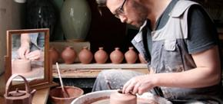

The Crafts Council of Ireland Ceramics Skills & Design Course is a unique programme designed to equip graduates with the practical skills to develop careers in the ceramics industry. The biennial graduation exhibition is an opportunity to spot stars of the future.

Read more at <http://www.nationalcraftgallery.ie/events>

For more information: [events@nationalcraftgallery.ie](mailto:events@nationalcraftgallery.ie) / 056 7796151

**\_\_\_\_\_\_\_\_\_\_\_\_\_\_\_\_\_\_\_\_\_\_\_\_\_\_\_\_\_\_\_\_\_\_\_\_\_\_\_\_\_\_\_\_\_\_\_\_\_\_\_\_\_\_\_\_\_\_\_\_\_\_\_\_\_\_\_\_\_\_\_\_\_\_\_**

**Music lessons – Piltown**

[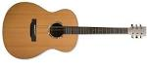](http://www.google.ie/url?url=http://www.guitar-guide-easy.com/guitars/acoustic/item/7-types-of-acoustic-guitars-knowing-instrument-better&rct=j&frm=1&q=&esrc=s&sa=U&ei=8QKjU6yANJCp7Ab8zICQAw&ved=0CBYQ9QEwAQ&sig2=OKfSg06dy6EwE472izDjfA&usg=AFQjCNFf742TPtYDj3VWj1vvusxge0Uz0A)

Guitar, traditional Irish flute and tin whistle lessons in Fiddown village for all ages and levels, individual and group lessons catered for along with Junior and Leaving cert music grinds.

For more information or to arrange a lesson, please contact Colin (guitar) on 087 – 2699404 or Sarah (flute/whistle) on 087 – 7948887.

**\_\_\_\_\_\_\_\_\_\_\_\_\_\_\_\_\_\_\_\_\_\_\_\_\_\_\_\_\_\_\_\_\_\_\_\_\_\_\_\_\_\_\_\_\_\_\_\_\_\_\_\_\_\_\_\_\_\_\_\_\_\_\_\_\_\_\_\_\_\_\_\_\_\_\_**

**Summer Chapter Room concerts – St. Canice’s Cathedral**

**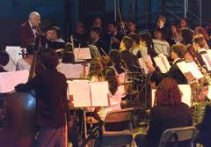**

**5pm, Sunday 29th June** - Camerata Kilkenny plays CPE Bach and Telemann

Tickets: **€10 / €5 concession**

Have a musical Summer - Malcolm Proud

E: [proudmussm@gmail.com](http://kk-moss/Sites/arts_office/Shared%20Documents/Julianne%20Morgan/E-bulletin/30th%20May%20e-bulletin/proudmussm@gmail.com)

**\_\_\_\_\_\_\_\_\_\_\_\_\_\_\_\_\_\_\_\_\_\_\_\_\_\_\_\_\_\_\_\_\_\_\_\_\_\_\_\_\_\_\_\_\_\_\_\_\_\_\_\_\_\_\_\_\_\_\_\_\_\_\_\_\_\_\_\_\_\_\_\_\_\_\_**

**Ballykeeffe Amphitheatre - Music is what feelings sound like…**

****

Mundy

* **Saturday, 12th July**
* Tickets **€20** (early bird until June 30th **€18**)

      Emily Brontë’s ‘Wuthering Heights‘ presented by Chapterhouse Theatre Company

* **Friday, July 18th**
* Tickets **€15**, concessions **€10**, families (2 adults, 2 children) **€45**

        Nathan Carter and Band

* **Thursday,** **7th August**
* Tickets **€30**, (early bird until 15th June **€27.50**)

      William Shakespeare’s ‘**A Midsummer Night’s Dream**‘ presented by Chapterhouse Theatre Company

* **Friday,** **August 8th**
* Tickets **€15**, concessions **€10**, families (2 adults, 2 children) **€45**

Climb Festival

* first weekend in September
* admission free, car park charges

W: <http://ballykeeffeamphitheatre.com/hello-world/>

**\_\_\_\_\_\_\_\_\_\_\_\_\_\_\_\_\_\_\_\_\_\_\_\_\_\_\_\_\_\_\_\_\_\_\_\_\_\_\_\_\_\_\_\_\_\_\_\_\_\_\_\_\_\_\_\_\_\_\_\_\_\_\_\_\_\_\_\_\_\_\_\_\_\_\_**

**Starlight 1D Musical Summer Camp**

**[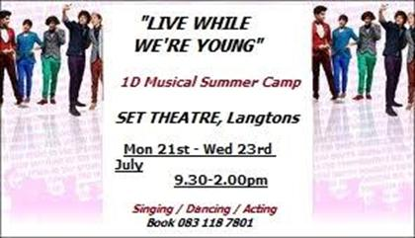](https://www.facebook.com/photo.php?fbid=10152133562662536&set=a.134554807535.118705.134544912535&type=1&relevant_count=1)**

STARLIGHT SUMMER CAMP 2014 @ Set Theatre **21st - 23rd July**   
  
Based on the songs of One Direction this fun musical workshop over three days features all the usual fun and laughter of Starlight's annual summer camps. Booking on 083 118 7801 - camp runs from **9.30am to 2.00pm** with a performance on the final day - Cost of the camp is **€ 60.00** (ask for family discounts)

**\_\_\_\_\_\_\_\_\_\_\_\_\_\_\_\_\_\_\_\_\_\_\_\_\_\_\_\_\_\_\_\_\_\_\_\_\_\_\_\_\_\_\_\_\_\_\_\_\_\_\_\_\_\_\_\_\_\_\_\_\_\_\_\_\_\_\_\_\_\_\_\_\_\_\_**

**Barn Owl Players present *War Brides & In the Shadow of the Glen***

****

Barn Owl Players present Theatre X 2, a night of two one act plays ‘War Brides’ by Marion Craig Wentworth and ‘In the Shadow of the Glen’ by JM Synge - it runs **June 26th -28th, 8pm** in The Barn, Barnstorm Theatre Company (behind St Canice's cathedral).

Tickets, priced **€12/€10**, can be booked on 0567751266

More details on <https://www.facebook.com/barnowlplayers>

**\_\_\_\_\_\_\_\_\_\_\_\_\_\_\_\_\_\_\_\_\_\_\_\_\_\_\_\_\_\_\_\_\_\_\_\_\_\_\_\_\_\_\_\_\_\_\_\_\_\_\_\_\_\_\_\_\_\_\_\_\_\_\_\_\_\_\_\_\_\_\_\_\_\_\_**

**Hole in the Wall**

**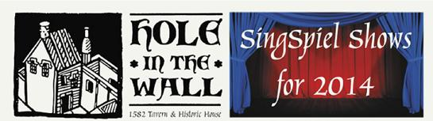**

Paris En Reve (PER)

Date: **July 13th (Bastille Day) (Sun)**

Venue: Archer Room of Hole in the Wall

Admission: **€15 on door** or from Hole in the Wall on weekends

This is a montage about the city of Paris and its nightlife with songs from ChAznavour (the story of Charles Aznavour (‘Emmenez Moi’, ‘La Boheme’, ‘Etre’, and Jacques Brel’s ‘Dans Le Port d’Amsterdam’ sung by Michael Conway) and footage from Hole in the Wall’s show - Being Edith Piaf).

RED

Date: **August 3rd (Sun)**

Venue: Archer Room of Hole in the Wall

Admission: **€15 on door** or from Hole in the Wall on weekends

The title for this SingSpiel is derived from the description Redlegs which was used to describe the original white slaves incarcerated in the Caribbean by Cromwellians in the 1600s. This is a detailed SingSpiel (based on 32 English language songs that reflect island life today also) and features additional newly composed songs, as Gaeilge, by Breege Phelan.

Join Me In The Pines (aka David Geraghty(Bell X1)) [support: Tiger Cooke]

[](http://joinmeinthepines.com/)

* + Date & time **: Friday 18th July, 8pm**
  + Venue: Hole In The Wall
  + Admission: **€10**

Ballad Session every Friday and most Saturdays **from 10.00pm**.

Call: 087 8075650

Facebook: [http://tinyurl.com/kkhvwse](http://tinyurl.com/kkhvwse%20)

W: <http://www.holeinthewall.ie/>

**\_\_\_\_\_\_\_\_\_\_\_\_\_\_\_\_\_\_\_\_\_\_\_\_\_\_\_\_\_\_\_\_\_\_\_\_\_\_\_\_\_\_\_\_\_\_\_\_\_\_\_\_\_\_\_\_\_\_\_\_\_\_\_\_\_\_\_\_\_\_\_\_\_\_\_**

**YIFM - Film Summer camps & Call for funding**

**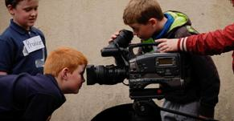**

How about a summer camp with a difference this year? Have you ever dreamed of working on a film set, of making your very own movie, of shouting those famous words ‘lights, camera, action!.’ Well, now is your chance.

### Dates for the summer camps are:

**June 30th – July 4th**  
**July 21st – July 25th**   
**July 28th – August 1st**

**Price: €140 (Snacks included)**

**Time: 9am – 5pm (Mon – Fri)**

**Junior Camp (9-12years)**

**Senior Camp (13-16years)**

Book online at <http://yifm.com/summer-camps-2014/>

Price: **€140**

Tel: 056 7764677

Funding

We are looking for funding to make an innovative film, made by 13-18 year olds from all over Ireland. However, it's a very expensive programme to run and we need the funding for equipment, licensing, accommodation, food, and insurance. If you pledge, you will get to choose from a variety of our rewards; a DVD copy of the movies produced by the NYFS, a YIFM t-shirt, or a mention in the credits of one of our films. As an added bonus, the more funding we receive, we will add more footage onto our film in progress "Conflict" that we gave you a teaser clip of in our ad!

See more at: <http://www.sponsume.com/project/national-youth-film-school>

**\_\_\_\_\_\_\_\_\_\_\_\_\_\_\_\_\_\_\_\_\_\_\_\_\_\_\_\_\_\_\_\_\_\_\_\_\_\_\_\_\_\_\_\_\_\_\_\_\_\_\_\_\_\_\_\_\_\_\_\_\_\_\_\_\_\_\_\_\_\_\_\_\_\_\_**

**Light Colour Sound Festival – 4th/5th July**

****

Light Colour Sound is Kilkenny's newest Irish summer festival and boasts two days of music, food, art, culture, literature, comedy, open forums, workshops and dance.

HMV will sponsor the Main Stage at the festival, which will feature performances by international and Irish acts including Dan le Sac vs Scroobuis Pip, And So I Watch You From Afar, Cathy Davey, Jerry Fish, Wallis Bird, Jape, O Emperor, R.S.A.G., Engine Alley, Minutes, Kila, Raglans, The Barley Mob, I Draw Slow, and Halves.

Light Colour Sound is proud to be a small independent festival, get your tickets before they sell out. On line <http://lightcoloursoundfestival.com/tickets/>

Tickets available from   
Rollercoaster records Kilkenny  
X-tra vision Kilkenny  
The Brewery Corner Kilkenny  
HMV Grafton st Dublin  
HMV Henry St Dublin  
The Book Shop Thomastown  
Hunter Gatherer Thomastown  
Hunter Gatherer Callan

W: [www.lightcoloursoundfestival.com](http://www.lightcoloursoundfestival.com/)

F: [http://tinyurl.com/l2du7jm](http://tinyurl.com/l2du7jm%20)

**\_\_\_\_\_\_\_\_\_\_\_\_\_\_\_\_\_\_\_\_\_\_\_\_\_\_\_\_\_\_\_\_\_\_\_\_\_\_\_\_\_\_\_\_\_\_\_\_\_\_\_\_\_\_\_\_\_\_\_\_\_\_\_\_\_\_\_\_\_\_\_\_\_\_\_**

## Music from the Movies with the National Youth Orchestra of Ireland

## mount juliet

## Date: Monday 7th and Tuesday 8th July 2014 Time : 8pm Tickets : €25 Each

## Venue: Mount Juliet

The National Youth Orchestra of Ireland return to Mount Juliet this July for a performance of some of the greatest music from the movies, by a talented ensemble of musicians. The concert is conducted and presented by Lyric FM’s Evelyn Grant.

W: <www.mountjuliet.ie>  
**\_\_\_\_\_\_\_\_\_\_\_\_\_\_\_\_\_\_\_\_\_\_\_\_\_\_\_\_\_\_\_\_\_\_\_\_\_\_\_\_\_\_\_\_\_\_\_\_\_\_\_\_\_\_\_\_\_\_\_\_\_\_\_\_\_\_\_\_\_\_\_\_\_\_\_**

**Level 7 Certificate in Performance – NUI Maynooth**

**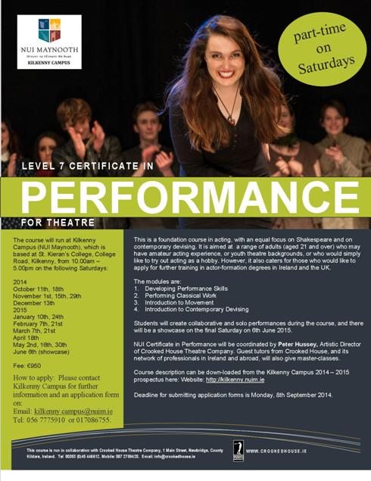**

Email: <Kilkenny.campus@nuim.ie>

W: <http://kilkenny.nuim.ie>

**\_\_\_\_\_\_\_\_\_\_\_\_\_\_\_\_\_\_\_\_\_\_\_\_\_\_\_\_\_\_\_\_\_\_\_\_\_\_\_\_\_\_\_\_\_\_\_\_\_\_\_\_\_\_\_\_\_\_\_\_\_\_\_\_\_\_\_\_\_\_\_\_\_\_\_**

**Kilkenny Violin Week 2014, 7th – 11th July 2014**

**[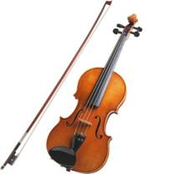](http://eofdreams.com/data_images/dreams/violin/violin-02.jpg)**

Kilkenny Violin Week is an exciting week long course of masterclasses, lessons, composition workshops and performances exclusively for violins!   
This summer the course will run in the Kilkenny School of Music from **7th-11th July 2014**.

W: <http://kilkennyviolinweek.weebly.com/>

To apply, click here <http://kilkennyviolinweek.weebly.com/contact.html>

**\_\_\_\_\_\_\_\_\_\_\_\_\_\_\_\_\_\_\_\_\_\_\_\_\_\_\_\_\_\_\_\_\_\_\_\_\_\_\_\_\_\_\_\_\_\_\_\_\_\_\_\_\_\_\_\_\_\_\_\_\_\_\_\_\_\_\_\_\_\_\_\_\_\_\_**

**Cleere’s theatre – Traditional Irish Music Session**

[](http://cleeres.com/?ref=logo)

Kilkenny’s longest Running Traditional Irish Music session, every Monday night all year round since 1989. Come and join our Musicians, Poets & Singers in a cosy neighbourhood bar. It’s not the same without you.

Date & time: **30th June, 21:30**

W: <http://cleeres.com/events-guide/>

**\_\_\_\_\_\_\_\_\_\_\_\_\_\_\_\_\_\_\_\_\_\_\_\_\_\_\_\_\_\_\_\_\_\_\_\_\_\_\_\_\_\_\_\_\_\_\_\_\_\_\_\_\_\_\_\_\_\_\_\_\_\_\_\_\_\_\_\_\_\_\_\_\_\_\_**

**Sessions House Arts Centre, Thomastown – What’s happening Next…**

**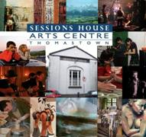**

Summer Programme 2014

July Theatre Camp for 10 - 12 year olds...  
Theatre Camp for 12 - 14 year olds  
Radio Playwriting Camp for 9 – 14 year olds

Aug Puppet Skills Camp

Details of each camp, dates, times, ages etc will be announced over the next couple of days.  
All camps will run either morning or evening over 5 days and will cost approx **€50** each. Places are limited on each camp so keep your eyes peeled, booking will open soon!

W: [https://www.facebook.com/home.php#!/SessionsHouseArtsCentre?fref=nf](https://www.facebook.com/home.php%23!/SessionsHouseArtsCentre?fref=nf)

**\_\_\_\_\_\_\_\_\_\_\_\_\_\_\_\_\_\_\_\_\_\_\_\_\_\_\_\_\_\_\_\_\_\_\_\_\_\_\_\_\_\_\_\_\_\_\_\_\_\_\_\_\_\_\_\_\_\_\_\_\_\_\_\_\_\_\_\_\_\_\_\_\_\_\_**

**Abhainn RíFestival, Callan, 20th-29th June 2014**

Programme

**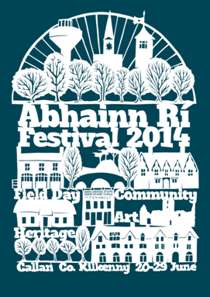**

Paper cut design by artist Paul Bokslag.

The Abhainn Ri Festival of Participation and Inclusion is proud to announce the programme for our 5th annual festival, running from the **20th - 29th June**. You can read and download our programme [here.](http://abhainnrifestival.cmail1.com/t/i-l-vwkit-ptldkjdu-j/) The festival opens with a Midsummer International Dinner & Dance on Friday 20th which promises to be a special night.

Abhainn Ri Festival – Artists Talk | Vagabond Reviews

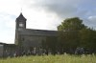

**Saturday 28th June | 4pm** | Callan Workhouse, Callan, Co. Kilkenny

As part of the Abhainn Ri Festival 2014 Architecture strand, Vagabond Reviews will deliver a presentation in Callan Workhouse on (In)Visible Labour Factorium.

Presented by Workhouse Assembly.

[www.workhouseassembly.com](http://www.workhouseassembly.com/)| [www.nimblespaces.org](http://www.nimblespaces.org/) | [www.landingplace.info](http://www.landingplace.info/) | [www.commonagecallan.com](http://www.commonagecallan.com/)

**Abhainn Ri Festival | Visual Arts Strand**



**22nd – 29th June | 12pm-5pm** | Callan, Co. Kilkenny

The Abhainn Ri Festival is proud to present visual arts exhibitions for its 2014 programme:

Retrospective | George McCutcheon | KCAT Art and Study Centre  
An exhibition of paintings, sculptures and mosaics, spanning more than twenty years by founding KCAT studio member.  
**Opened 3pm, Saturday 21st June.**

Dormant Structures | Helen Comerford | Macra na Feirme Hall  
A solo show of new work comprising of small scale encaustic drawings of the structure of trees, not from observation so much as from images left in memory.  
**Opened 6pm, Saturday 21st June.**

mirror source | ghost pulse | Caroline Doolin | The Friary  
Explores the translation of natural space and place via various forms of rational and non rational interface. An exhibition of video, sculpture and narrative re-telling.

Curated by Etaoin Holahan.  
**Opened 6pm, Saturday 21st June.**

More info at <http://abhainnrifestival.com/>

**\_\_\_\_\_\_\_\_\_\_\_\_\_\_\_\_\_\_\_\_\_\_\_\_\_\_\_\_\_\_\_\_\_\_\_\_\_\_\_\_\_\_\_\_\_\_\_\_\_\_\_\_\_\_\_\_\_\_\_\_\_\_\_\_\_\_\_\_\_\_\_\_\_\_\_**

**Learn Set Dancing, Parish Hall in Urlingford**

**[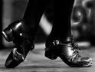](https://www.google.ie/url?url=https://www.dkit.ie/music/set-dancing-workshop&rct=j&frm=1&q=&esrc=s&sa=U&ei=K1WtU_GBIajB0QWH24Fg&ved=0CCAQ9QEwBg&usg=AFQjCNFVh6QvCFX5toL2XjUlHkOkUDefZg)**

Date: **Monday, 30th June**

Time: **8.15pm - 10.30pm**

**\_\_\_\_\_\_\_\_\_\_\_\_\_\_\_\_\_\_\_\_\_\_\_\_\_\_\_\_\_\_\_\_\_\_\_\_\_\_\_\_\_\_\_\_\_\_\_\_\_\_\_\_\_\_\_\_\_\_\_\_\_\_\_\_\_\_\_\_\_\_\_\_\_\_\_**

**Concert: Ceoltoiri Kilkenny (20+ talented musicians, singers & dancers)**



Wednesday **2nd July, 8.30pm to 10.30pm** (**Wednesday evening shows which commence on June 25th - August 6th inclusive**)

Venue: Parade Tower, Kilkenny Castle

Admission: **Adults €10 / Concession €8 / Children €5 / Group rate (10 or more) €7 per person**

Ceoltoiri Kilkenny, a group of over 20 talented musicians, singers and dancers will present a weekly colourful and exciting Irish Entertainment Show at the Parade Tower during the months of June, July and early August.

For further information or advance bookings please contact Noreen at 086 824 9618 or email - [noreenon@eircom.net](mailto:noreenon@eircom.net)

W: <http://www.kilkennycastle.ie/NewsEvents/Title,31403,en.html>

**\_\_\_\_\_\_\_\_\_\_\_\_\_\_\_\_\_\_\_\_\_\_\_\_\_\_\_\_\_\_\_\_\_\_\_\_\_\_\_\_\_\_\_\_\_\_\_\_\_\_\_\_\_\_\_\_\_\_\_\_\_\_\_\_\_\_\_\_\_\_\_\_\_\_\_**

**Courses / Training / Jobs**

**\_\_\_\_\_\_\_\_\_\_\_\_\_\_\_\_\_\_\_\_\_\_\_\_\_\_\_\_\_\_\_\_\_\_\_\_\_\_\_\_\_\_\_\_\_\_\_\_\_\_\_\_\_\_\_\_\_\_\_\_\_\_\_\_\_\_\_\_\_\_\_\_\_\_\_**

**Year of Irish Design 2015** (Dublin/various)

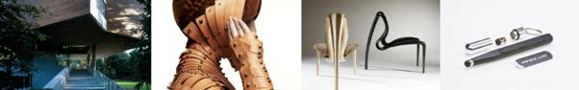

[National Co-ordinator (18 mos, full-time)](http://www.dccoi.ie/year-of-irish-design-2015/)  
[Events Co-ordinator (18 mos, full-time)](http://www.dccoi.ie/year-of-irish-design-2015/)  
[Communications Officer (18 mos, full-time)](http://www.dccoi.ie/year-of-irish-design-2015/)  
[Project Assistants x 2 (18 mos, full-time)](http://www.dccoi.ie/year-of-irish-design-2015/)

\* Roles 1 – 4 are 18 month Contracts for Service on a full time basis and will be Dublin based

[Tourism Advisor (18 mos, part-time)](http://www.dccoi.ie/year-of-irish-design-2015/)  
[Fashion & Textiles Advisor (18 mos, part-time)](http://www.dccoi.ie/year-of-irish-design-2015/)  
[Built Environment Advisor (18 mos, part-time)](http://www.dccoi.ie/year-of-irish-design-2015/)  
[Export Advisor (18 mos, part-time)](http://www.dccoi.ie/year-of-irish-design-2015/)  
\* Roles 5 – 8 are 18 month Contracts for Service on the basis of 1-2 days per week.

Deadline: **2nd July**

For further information please email:  
Nuala McGrath at [recruitment@dccoi.ie](mailto:recruitment@dccoi.ie?subject=YOID2015%20recruitment%20opportunities%20)  
Applications by email to: [recruitment@dccoi.ie](mailto:recruitment@dccoi.ie?subject=YOID2015%20recruitment%20opportunities%20)

**\_\_\_\_\_\_\_\_\_\_\_\_\_\_\_\_\_\_\_\_\_\_\_\_\_\_\_\_\_\_\_\_\_\_\_\_\_\_\_\_\_\_\_\_\_\_\_\_\_\_\_\_\_\_\_\_\_\_\_\_\_\_\_\_\_\_\_\_\_\_\_\_\_\_\_**

[**Stage Door Keeper**](http://www.theatreforum.ie/jobs-board/view/jobs/jobaction/show/job/stage-door-keeper-1/)

[](http://www.theatreforum.ie/)

The Helix is seeking to recruit a part-time casual Stage Door Keeper to monitor security, act as a customer service...

|  |
| --- |
| See job description at [Stage\_Door\_Job\_...](http://www.theatreforum.ie/uploads/tx_frjobs/Stage_Door_Job_Spec.pdf) |
| |  | | --- | |  | |

**\_\_\_\_\_\_\_\_\_\_\_\_\_\_\_\_\_\_\_\_\_\_\_\_\_\_\_\_\_\_\_\_\_\_\_\_\_\_\_\_\_\_\_\_\_\_\_\_\_\_\_\_\_\_\_\_\_\_\_\_\_\_\_\_\_\_\_\_\_\_\_\_\_\_\_**

**‘YOU CAN DANCE FESTIVAL’ Calls to Tender**

Artistic Direction & Management - You Can Dance Festival 2014 in the Arklow area for 2014. The management body for this programme is Wicklow County Arts Office.

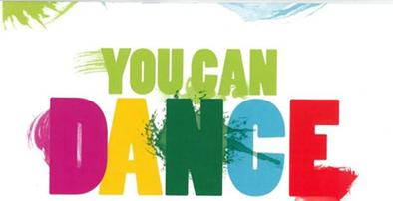

Tender Requirements of the successful party:

* To oversee the artistic direction and delivery of the You Can Dance 2014 Programme with the approval of the Arts Officer Wicklow County Council
* To engage practitioners to deliver the programme
* To manage the budget and payments to engaged practitioners
* To collate promotional material for the Festival

Booking for the Festival will be provided by Wicklow County Arts Office.

For further information, please email: [lizculloty.45@gmail.com](mailto:lizculloty.45@gmail.com)  Phone: 086 352 2227

**Closing Date: Tuesday July 8th at 12 Noon**

W: <http://www.wicklow.ie/arts-office>

F: [http://tinyurl.com/o9va3u7](http://tinyurl.com/o9va3u7%20)

**\_\_\_\_\_\_\_\_\_\_\_\_\_\_\_\_\_\_\_\_\_\_\_\_\_\_\_\_\_\_\_\_\_\_\_\_\_\_\_\_\_\_\_\_\_\_\_\_\_\_\_\_\_\_\_\_\_\_\_\_\_\_\_\_\_\_\_\_\_\_\_\_\_\_\_**

**Sirius Arts Centre seeks Artistic Director / CEO**



Sirius Arts Centre, Cobh, Co. Cork

Sirius Arts Centre is now recruiting for the lead position of Artistic Director – CEO to continue and develop its dynamic arts programme. The successful candidate will be responsible, in conjunction with the curatorial committee of the Sirius Board, for identifying and implementing five year cycles of Arts programming; along with overseeing the administration of the organisation, including financial operations and management of the staff and premises.

Interested candidates should forward a Cover Letter and CV to [artisticdirectorposition@gmail.com](artisticdirectorposition@gmail.com%20) no later than **2pm on Friday 18th July 2014**. Only applications including CV and Cover Letter will be considered. Interviews will be conducted 29th–31st July. Additional details relevant to the post will be supplied on request.

W: [www.siriusartscentre.ie](http://www.siriusartscentre.ie)

**\_\_\_\_\_\_\_\_\_\_\_\_\_\_\_\_\_\_\_\_\_\_\_\_\_\_\_\_\_\_\_\_\_\_\_\_\_\_\_\_\_\_\_\_\_\_\_\_\_\_\_\_\_\_\_\_\_\_\_\_\_\_\_\_\_\_\_\_\_\_\_\_\_\_\_**

**Carlow County Council Arts Service Call for Artists for Panel (2014-2019)**

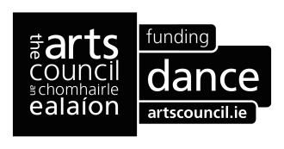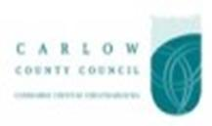

Carlow County Council Arts Service is seeking suitable artists to add to their Panel (2014-2019). We are seeking experienced artists who work in/with community contexts to build on the reputation County Carlow has of working with ‘Context’ ‘Place’ ‘Site’, ‘location’ and ‘its People’.

Eligibility and selection is dependent on experience to date. There is no maximum or minimum number of artists that can be placed on the Panel. However the following criteria for selection will apply: Your work must be of high standard, demonstrate capacity for artistic excellence and proven experience of engaging in/with community contexts.

**Extended Deadline 30th July 2014**

More info at [http://tinyurl.com/nd53p2b](http://tinyurl.com/nd53p2b%20)

**\_\_\_\_\_\_\_\_\_\_\_\_\_\_\_\_\_\_\_\_\_\_\_\_\_\_\_\_\_\_\_\_\_\_\_\_\_\_\_\_\_\_\_\_\_\_\_\_\_\_\_\_\_\_\_\_\_\_\_\_\_\_\_\_\_\_\_\_\_\_\_\_\_\_\_**

[**CE Scheme: Box Office / Front of House Assistant**](http://journalofmusic.com/listing/09-06-14/ce-scheme-box-office-front-house-assistant) **- Garter Lane Arts Centre (Waterford)**

[](http://www.google.ie/url?url=http://www.tripadvisor.ie/LocationPhotoDirectLink-g186637-d536220-i41460757-Garter_Lane_Arts_Centre-County_Waterford.html&rct=j&frm=1&q=&esrc=s&sa=U&ei=tkSkU8TRI42e7Aa8h4HQCA&ved=0CBYQ9QEwAQ&usg=AFQjCNEX9Czh38d69GII8-BB70to-G5txA)

The position will be in the above area. This is a developmental opportunity, no experience is necessary. Accredited training will be provided to support your career. It is a basic requirement that the box office/front of house assistant should have good literacy and numerical skills i.e. spelling, handwriting, reading and maths in order to carry out their duties. Good IT skills are essential for this position. Applicants must supply suitable character references and be prepared to complete a Garda vetting application form.

Search for this position here: <http://jobseeker.fas.ie>

**Deadline: 3rd July**

W: <www.garterlane.ie>

**\_\_\_\_\_\_\_\_\_\_\_\_\_\_\_\_\_\_\_\_\_\_\_\_\_\_\_\_\_\_\_\_\_\_\_\_\_\_\_\_\_\_\_\_\_\_\_\_\_\_\_\_\_\_\_\_\_\_\_\_\_\_\_\_\_\_\_\_\_\_\_\_\_\_\_**

### Volunteers for Music Together

### [Home](http://www.bettertogether.ie/)

### Music Together are looking for volunteers in music, singing, dance and video-ing for our annual summer workshop.Working with people with disabilities including writing songs, composing music, percussion pieces and dance routines.

The workshop will be held in Nazarene Community Church, Greystones, on **1st and 2nd August from 9.30 to 5pm** and there will be a performance on **Sunday 3rd August** in the Greystones/Bray area.

**Region: Greystones/Bray**  
Expiry date: **31/07/14**  
**W:** <http://www.activelink.ie/content/community-exchange/volunteering/16396>

**\_\_\_\_\_\_\_\_\_\_\_\_\_\_\_\_\_\_\_\_\_\_\_\_\_\_\_\_\_\_\_\_\_\_\_\_\_\_\_\_\_\_\_\_\_\_\_\_\_\_\_\_\_\_\_\_\_\_\_\_\_\_\_\_\_\_\_\_\_\_\_\_\_\_\_**

**Mosaic Children’s Art Programme at Galway Arts Centre | Arts facilitators Work Opportunity**

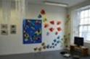

Mosaic children’s art programme at Galway Arts Centre are seeking arts facilitators to assist in delivering our workshops. You would need to be available during October and willing to travel around Ireland.

Child protection a must and relevant Garda vetting will need to be completed. Training will be provided in advance.

Please forward CV to [marina@galwayartscentre.ie](mailto:marina@galwayartscentre.ie)

F: [www.facebook.com/artscentrekids](http://lists.visualartists.ie/lt.php?c=1170&m=4210&nl=1&s=d3c261c0eeb6b48867f449d29e09414b&lid=89628&l=-http--www.facebook.com/artscentrekids)  
W: [www.galwayartscentrechildren.com/Contact-Us.html](http://lists.visualartists.ie/lt.php?c=1170&m=4210&nl=1&s=d3c261c0eeb6b48867f449d29e09414b&lid=89629&l=-http--www.galwayartscentrechildren.com/Contact-Us.html)

**\_\_\_\_\_\_\_\_\_\_\_\_\_\_\_\_\_\_\_\_\_\_\_\_\_\_\_\_\_\_\_\_\_\_\_\_\_\_\_\_\_\_\_\_\_\_\_\_\_\_\_\_\_\_\_\_\_\_\_\_\_\_\_\_\_\_\_\_\_\_\_\_\_\_\_**

[**Lino block printing Workshop**](https://www.facebook.com/events/1465300583709969/?ref=3&ref_newsfeed_story_type=regular)

**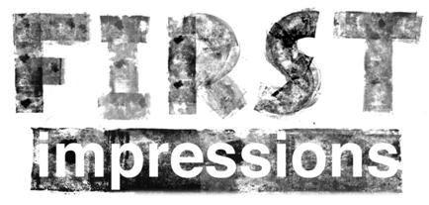**

Date & time: **12th July at 10:00**

Come and learn the Art of Lino-block printing in southpaw studios with Martin Fahy. This is a Full day workshop Cost... **€60 inc. materials (€20 deposit)** to book your spot. Email martin at [southpaw.eire@gmail.com](southpaw.eire@gmail.com%20) or phone 087 2451200.

[Southpaw studio / art school](https://www.facebook.com/southpawarts) in [Waterford, Ireland](https://www.facebook.com/pages/Waterford-Ireland/112027925490588)

**\_\_\_\_\_\_\_\_\_\_\_\_\_\_\_\_\_\_\_\_\_\_\_\_\_\_\_\_\_\_\_\_\_\_\_\_\_\_\_\_\_\_\_\_\_\_\_\_\_\_\_\_\_\_\_\_\_\_\_\_\_\_\_\_\_\_\_\_\_\_\_\_\_\_\_**

**The 27th John Hewitt International Summer School – Monday 28th July – Friday 1st August**



President of Ireland Michael D. Higgins will open the 27th John Hewitt International Summer School at The Market Place Theatre & Arts Centre, Armagh.

The five-day festival of culture and creativity will run from **Monday 28th July – Friday 1st August**, when the historic town of Armagh will be inundated with over 35 events.

**Tickets for all events can be booked through The Market Place Theatre Box Office by calling 028 3752 1821 or by booking online.**

View the full programme at [www.johnhewittsociety.org](http://www.johnhewittsociety.org)

**\_\_\_\_\_\_\_\_\_\_\_\_\_\_\_\_\_\_\_\_\_\_\_\_\_\_\_\_\_\_\_\_\_\_\_\_\_\_\_\_\_\_\_\_\_\_\_\_\_\_\_\_\_\_\_\_\_\_\_\_\_\_\_\_\_\_\_\_\_\_\_\_\_\_\_**

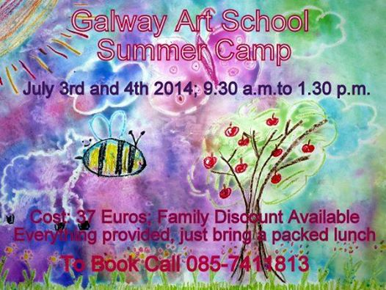

**\_\_\_\_\_\_\_\_\_\_\_\_\_\_\_\_\_\_\_\_\_\_\_\_\_\_\_\_\_\_\_\_\_\_\_\_\_\_\_\_\_\_\_\_\_\_\_\_\_\_\_\_\_\_\_\_\_\_\_\_\_\_\_\_\_\_\_\_\_\_\_\_\_\_\_**

# Willie Clancy Summer School 2014 - Saturday 5th July to Sunday 13th July, 2014

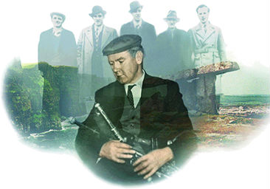

Scoil Samhraidh Willie Clancy is a week-long summer school in traditional music and set dance held annually at Miltown Malbay, Co. Clare.

Registration

Except for Uilleann pipes, the first opportunity for enrolment is on **Saturday 5th July between 2.00 pm and 6.00 pm** in the Community Hall, Miltown Malbay.  Enrolment will continue on **Sunday, 6th July from 7.00 pm to 9.00 pm**. Students may also enrol at the Community Hall or at the various venues on Monday morning **at 9.00 am**.

Piping students should pre-register by contacting Na Píobairí Uilleann at 15 Henrietta Street, Dublin 1.  Tel: 01-8730093. Email: <info@pipers.ie>

**Fee**  
The fee of **€140** covers all classes, workshops (morning), lectures (afternoons), and evening recitals.  
Registered students are entitled to reduced admission of **€5** to all céilithe.  
Registered students have free admission to lectures **(€6**) and all recitals **(€10**) plus free admission to afternoon two-hand dance classes, the Cape Breton dance workshops, the Irish and Scots Gaelic language classes, and reduced admission **(€5**) to all céilithe.

For a full listing of workshops, see <http://www.scoilsamhraidhwillieclancy.com/index.html>

**\_\_\_\_\_\_\_\_\_\_\_\_\_\_\_\_\_\_\_\_\_\_\_\_\_\_\_\_\_\_\_\_\_\_\_\_\_\_\_\_\_\_\_\_\_\_\_\_\_\_\_\_\_\_\_\_\_\_\_\_\_\_\_\_\_\_\_\_\_\_\_\_\_\_\_**

|  |  |
| --- | --- |
| **The Stinging Fly Fiction Workshop**  **with Sean O'Reilly**  20 week course  Starts: **Monday September 28th 2014** (introductory session)  Times: Twenty weekly workshops on Monday evenings from **6.30pm – 8.30pm**  Four Saturday sessions (dates/times/speakers TBC)  Venue: The Irish Writers’ Centre, 19 Parnell Square, Dublin 1  Cost of workshop: **€1500/€1450** IWC members (A **€200** deposit will be payable once a place on the workshop has been offered and accepted. The cost of the course includes free membership of the Irish Writers' Centre and current members receive a **€50** discount. Workshop fee also includes free admission to one Publishing Day seminar at the Irish Writers’ Centre during 2015.  Deadline for Applications: **8th August 2014**  Are you in the early stages of writing a novel or short-story collection? If so, we are looking for people like you to participate in The Stinging Fly Fiction Workshop offered in association with the Irish Writers' Centre. | **Stinging Fly** |

See the [attached PDF](http://www.stingingfly.org/sites/default/files/attachments/The%20Stinging%20Fly%20Fiction%20Workshop%20with%20Sean%20O%27Reilly.pdf) for more detailed information.

**\_\_\_\_\_\_\_\_\_\_\_\_\_\_\_\_\_\_\_\_\_\_\_\_\_\_\_\_\_\_\_\_\_\_\_\_\_\_\_\_\_\_\_\_\_\_\_\_\_\_\_\_\_\_\_\_\_\_\_\_\_\_\_\_\_\_\_\_\_\_\_\_\_\_\_**

#### 

#### The Creative Writer's Workshop: Memories into Memoir Writing Course & Retreat in Markree Castle, Co. Sligo, Ireland

#### http://www.thecreativewritersworkshop.com/../../img/cliffsmoher.jpg

Venue: Markree Castle, Collooney, Co. Sligo

**Dates**: **Sept 2014, Mon 1 to Fri 5**

4 day residential Memoir Writing Course and Retreat in a 14th Century Castle set in the heart of W.B. Yeats countryside amidst 500 acres of secluded woodlands and gardens. This four day writing retreat is for the writer that wants to tap into life experiences and ancestral history to write memoir, or to use those experiences to translate into fiction.

**Cost: €835 + Workbook €40 euro  
Total: €875 euro including Single Room en suite  
Note:** Participant Partners are welcome to share the Markree Castle experience – without partaking in the Writing Workshop.  
ie: Accommodation (sharing room with partner)  
:Meals as outlined  
At a rate of **€295** extra for 2nd person

**Discounts** apply if you join Fiction Workshop W151 and this workshop. Details upon application.

[Click here to Apply](http://www.thecreativewritersworkshop.com/?p=writing-courses-online-application)

**\_\_\_\_\_\_\_\_\_\_\_\_\_\_\_\_\_\_\_\_\_\_\_\_\_\_\_\_\_\_\_\_\_\_\_\_\_\_\_\_\_\_\_\_\_\_\_\_\_\_\_\_\_\_\_\_\_\_\_\_\_\_\_\_\_\_\_\_\_\_\_\_\_\_\_**

# Musical Theatre Intensive – Lir, National academy of dramatic art

# musical theatre

Duration: Two weeks

Date: **28th July – 8th August**

Time: **10.00am - 5.00pm**

Fees: **€1250**

### This two week intensive Musical theatre Course is aimed at intermediate and advanced level performers/singers who have already received some formal vocal training and want to pursue Musical Theatre as an interest or a career

To book a place on this course:  
**E:** [info@thelir.ie](mailto:info@thelir.ie)  
**T:** 0035318962559

W: <http://www.thelir.ie/courses/view/musical-theatre-intensive>

**\_\_\_\_\_\_\_\_\_\_\_\_\_\_\_\_\_\_\_\_\_\_\_\_\_\_\_\_\_\_\_\_\_\_\_\_\_\_\_\_\_\_\_\_\_\_\_\_\_\_\_\_\_\_\_\_\_\_\_\_\_\_\_\_\_\_\_\_\_\_\_\_\_\_\_**

**SUMMER CAMP: County Limerick Youth Theatre**

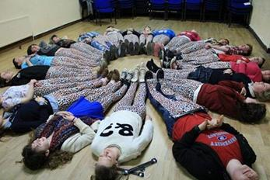

Date & time: **TUESDAY 19TH AUGUST - FRIDAY 22ND AUGUST inclusive, 11am - 4pm daily**  
Bring a packed lunch and drinks

**€20 Members** / **€40 non-members**   
(Subsidised by Ballyhoura Development Ltd - bursaries available for families in need)

This year the theatre summer camp will take place in The HoneyFitz Theatre, Lough Gur

BOOKINGS:  
To book contact Fiona on 086 824 6915  
Email: <fionaqp1@gmail.com>

**\_\_\_\_\_\_\_\_\_\_\_\_\_\_\_\_\_\_\_\_\_\_\_\_\_\_\_\_\_\_\_\_\_\_\_\_\_\_\_\_\_\_\_\_\_\_\_\_\_\_\_\_\_\_\_\_\_\_\_\_\_\_\_\_\_\_\_\_\_\_\_\_\_\_\_**

**Ballet Ireland’s 14th Annual Summer School:** **“Let’s Make a Ballet”**

**[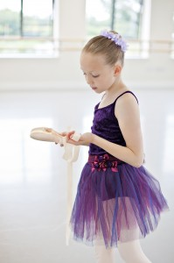](http://www.balletireland.ie/wp-content/uploads/2014/01/BALLET_IRELAND-206.jpg)**

This year it’s all about shoes!!!

Drawing on inspiration from the original tale, *The Elves and the Shoemaker*, this year’s participants will have an unforgettable time creating a ballet with professional dancers from Ballet Ireland. Each participant will have the opportunity to take part in daily workshops in dance, music, mime and drama.

The summer school is suitable for children age 6+ with or without dance training. Participants are divided into groups: 6-8yrs, 9-11yrs and those aged 12 and over.

**VISUAL**, Carlow: **Monday 18 – Friday 22nd August**  
Cost: **€70**  
Booking: 059 917 2400 | [www.visualcarlow.ie](http://www.visualcarlow.ie/)

**The Source Arts Centre**, Thurles: **Monday 7 – Friday 11th July**  
Cost: **€80 or €75** siblings per student for 2 children from the same family  
Booking: 0504 90204 | [www.thesourceartscentre.ie](http://www.thesourceartscentre.ie/)

**\_\_\_\_\_\_\_\_\_\_\_\_\_\_\_\_\_\_\_\_\_\_\_\_\_\_\_\_\_\_\_\_\_\_\_\_\_\_\_\_\_\_\_\_\_\_\_\_\_\_\_\_\_\_\_\_\_\_\_\_\_\_\_\_\_\_\_\_\_\_\_\_\_\_\_**

**Filmbase**

[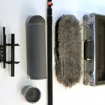](http://filmbase.ie/wp-content/uploads/2013/08/Equipment_Sound_Mics_1-278x185.jpg)

## [Hands on – Sound for TV & Film](http://filmbase.ie/hands-on-sound-for-tv-film/)

#### Dates: 19th & 20th July, 1 Weekend

#### Fee: €270 Members / €300 Non-Members

This hands-on course offers tuition from an experienced professional who will take students through the basics guiding you through common situations, errors and best practice.

[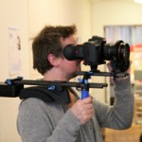](http://filmbase.ie/wp-content/uploads/2013/08/Equipment_Grip_Redrock_3-278x185.jpg)

# 5 Day DSLR Filmmaking

Dates: **Autumn Dates TBC**

#### Fee: €445 members / €485 non-members

The most exciting development on the filmmaking scene in a while is the advancement of DSLR filmmaking. This 5 day hands-on intensive DSLR Camera course is designed to give you the confidence to start shooting on digital as soon as possible!

More info at <http://filmbase.ie/5-day-dslr-filmmaking/>

W: <http://filmbase.ie/>  
**\_\_\_\_\_\_\_\_\_\_\_\_\_\_\_\_\_\_\_\_\_\_\_\_\_\_\_\_\_\_\_\_\_\_\_\_\_\_\_\_\_\_\_\_\_\_\_\_\_\_\_\_\_\_\_\_\_\_\_\_\_\_\_\_\_\_\_\_\_\_\_\_\_\_\_**

# Digital Film-Making Courses - FETAC/QQI Level 3 Media Expression 3N0792



The New Media Institute is a FETAC/QQI registered provider delivering workshops and courses in community projects, youth centres, youth organisations and schools including Transition Year - training learners how to make short films. We provide all the equipment (e.g. HD camera, lighting, audio, editing etc) to make it as convenient and accessible as possible.

Our courses can also be delivered non-accredited and we also offer half-day and one-day Workshops.

If you would like to discuss whether this is something that would suit your centre/school or group and learning goals, please contact us using the details below.

Phone: 086-8549635 or 087-2445505  
Email: [frances@tnmi.net](frances@tnmi.net%20 )or [info@tnmi.net](mailto:info@tnmi.net)

For more information on our courses, see the website: [www.tnmi.net](http://www.tnmi.net/)

**Closing Date:** On-going

**\_\_\_\_\_\_\_\_\_\_\_\_\_\_\_\_\_\_\_\_\_\_\_\_\_\_\_\_\_\_\_\_\_\_\_\_\_\_\_\_\_\_\_\_\_\_\_\_\_\_\_\_\_\_\_\_\_\_\_\_\_\_\_\_\_\_\_\_\_\_\_\_\_\_\_**

# Working with Children and Adults Through Arts

[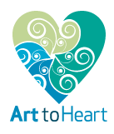](http://www.arttoheart.ie/)

**Venue: Rockforest, The Burren, Tubber, Co. Clare**Date: **August 11th - 15th**  
Time: **10am to 4pm**.

**Fee**: The programme costs **€500**. Concessions **€350** (students, unemployed, part-time workers). (Booking fee **€50**).

Fee covers training, art material, tea and coffee. Lunch **€50** (optional).

This training programme is for adults. If you are a parent, youth leader, social or health worker, teacher, child care worker or artist who wants to learn more about how to nurture, foster and develop your own creative potential, this training programme is for you.

No artistic experience is necessary to attend the programme.

At the end of the course an in-house accreditation certificate will be awarded to participants.

The training course has been developed and will be led by **Jole Bortoli** the director of Art to Heart.

See Jole's biography on <http://www.arttoheart.ie/about-us/>

**\_\_\_\_\_\_\_\_\_\_\_\_\_\_\_\_\_\_\_\_\_\_\_\_\_\_\_\_\_\_\_\_\_\_\_\_\_\_\_\_\_\_\_\_\_\_\_\_\_\_\_\_\_\_\_\_\_\_\_\_\_\_\_\_\_\_\_\_\_\_\_\_\_\_\_**

**Basic Techniques for Painting and Drawing Workshop with Tadhg McGrath at NCAD**



National College of Art & Design, 100 Thomas Street, Dublin 8  
Date: **June 30th – July 4th**  
Time: **10am – 4pm**, Mon-Fri  
Cost: **€240**

To book, please email: <cead@ncad.ie>  
Phone: 01 636 4214

Full details on the course can be found [here](http://i.imgur.com/sKX218U.jpg).

[www.ncad.ie/continuing-education](http://www.ncad.ie/continuing-education)

## \_\_\_\_\_\_\_\_\_\_\_\_\_\_\_\_\_\_\_\_\_\_\_\_\_\_\_\_\_\_\_\_\_\_\_\_\_\_\_\_\_\_\_\_\_\_\_\_\_\_\_\_\_\_\_\_\_\_\_\_\_\_\_\_\_\_\_\_\_\_\_\_\_\_\_

**DIY Analog Electronics Workshops for musicians & artists at Steambox**



Maker will be running Introduction to DIY Analog Electronics Workshops in Steambox, School Street, Dublin 8.

Date: **Saturday 26th July**.

These workshops, aimed at complete beginners, provide the student with all the skills and knowledge required to begin working on their own projects at home. They will learn how to solder, understand circuit diagrams, prototype on a breadboard, and how to use a sensor to control parameters of a circuit. They will also become familiarised with basic electronic components and principles. During the workshop we will show the student how to build a small amplifier and either a Light Theremin or Fuzz guitar pedal (which they will take home with them).

The cost of the workshop (including all materials) is **€90**.

More information and sign-up can be found here: [www.maker.ie/workshops](http://maker.ie/workshops)

## \_\_\_\_\_\_\_\_\_\_\_\_\_\_\_\_\_\_\_\_\_\_\_\_\_\_\_\_\_\_\_\_\_\_\_\_\_\_\_\_\_\_\_\_\_\_\_\_\_\_\_\_\_\_\_\_\_\_\_\_\_\_\_\_\_\_\_\_\_\_\_\_\_\_\_

**Lightroom for Photographers Workshop at The Library Project**



The Library Project, Temple Bar, Dublin 2

Module 1: Practical File and Colour Management for Photographers | **Sunday 6th July, 12 – 2pm**

In this module you’ll learn about file management, Lightroom’s library different workflows and backup options.

Module 2: Developing the digital negative in Lightroom | **Sunday 6 July, 2.30 – 4.30pm**

In this module you will learn how to make the most of your RAW images using Lightroom’s Develop module.

More info at [http://tinyurl.com/nwldqwv](http://tinyurl.com/nwldqwv%20)

## \_\_\_\_\_\_\_\_\_\_\_\_\_\_\_\_\_\_\_\_\_\_\_\_\_\_\_\_\_\_\_\_\_\_\_\_\_\_\_\_\_\_\_\_\_\_\_\_\_\_\_\_\_\_\_\_\_\_\_\_\_\_\_\_\_\_\_\_\_\_\_\_\_\_\_

**Weekend Etching Course with Norah Brennan at Lorg Printmakers**



Dates and Times: **June 28th & 29th from 10am to 4pm.**Lorg Printmakers, Unit 8, Ballybane Enterprise Centre, Ballybane, Galway

Costs: **€100 for Members, €130 for Non Members** (The **€30** for Non Members is a once off payment and covers insurance for a year of class participation with Lorg Printmakers). A **€50** Deposit MUST be paid to secure a place in the course!

Course Description: The Beginner’s Etching Course will cover the basics of the intaglio process known as etching. The course will start with a demonstration of how to properly prepare a copper plate before delving into a discussion of the two different types of ground, soft and hard. A demonstration of how to etch, ink and proof print an etched image will then be shown.

[www.lorgprintmakers.com](http://lists.visualartists.ie/lt.php?c=1166&m=4206&nl=1&s=d3c261c0eeb6b48867f449d29e09414b&lid=89242&l=-http--www.lorgprintmakers.com)

## \_\_\_\_\_\_\_\_\_\_\_\_\_\_\_\_\_\_\_\_\_\_\_\_\_\_\_\_\_\_\_\_\_\_\_\_\_\_\_\_\_\_\_\_\_\_\_\_\_\_\_\_\_\_\_\_\_\_\_\_\_\_\_\_\_\_\_\_\_\_\_\_\_\_\_

## ****Puppet Animation Workshop for Theatre/Arts Practitioners and Teachers****

## [IMG_9357](http://branar.ie/wp-content/uploads/IMG_9357.jpg)

## Date: 15th July 2014. Time: 10am sharp to 5pm (lunch will be provided.)  Location: Branar, Unit 3 Ballybrit Industrial Estate, Old Monivea Road, Galway  Email: [joanne@branar.ie](mailto:joanne@branar.ie).( Book by 4th July) Exploring the use of puppet animation as a means of expressing a non-lingual story for theatre. Branar Téatar do Pháistí presents a 1 day workshop exploring the techniques of hand-manipulated puppets.  This is an opportunity for professionals to work with Marc Mac Lochlainn, a practitioner with significant experience in the creation and presentation of work for children through the medium of puppetry. \_\_\_\_\_\_\_\_\_\_\_\_\_\_\_\_\_\_\_\_\_\_\_\_\_\_\_\_\_\_\_\_\_\_\_\_\_\_\_\_\_\_\_\_\_\_\_\_\_\_\_\_\_\_\_\_\_\_\_\_\_\_\_\_\_\_\_\_\_\_\_\_\_\_\_

**Call for Submissions / Residencies**

**\_\_\_\_\_\_\_\_\_\_\_\_\_\_\_\_\_\_\_\_\_\_\_\_\_\_\_\_\_\_\_\_\_\_\_\_\_\_\_\_\_\_\_\_\_\_\_\_\_\_\_\_\_\_\_\_\_\_\_\_\_\_\_\_\_\_\_\_\_\_\_\_\_\_\_**

## PhotoIreland Festival 2014: ‘Drinking the Fix’ Exhibition at the In-spire Galerie | Call for Submissions



In-spire Galerie, 56 Lower Gardiner Street, Dublin 1

Due to the success of last year’s exhibition, In-spire are proud to announce another amazing photographic feast and invite all photography devotees to their beautiful old Georgian venue, which once again will be showing thought provoking work.

The exhibition will run from the **10th to 25th July**. The opening night will be on **Thursday the 10th July 6-9pm**.

SUBMISSION GUIDELINES  
To submit please send to <info@inspiregalerie.com>

**The deadline for submissions is the 5th July 2014, 5pm**

**W:** <http://miniurl.com/b4d57>

**\_\_\_\_\_\_\_\_\_\_\_\_\_\_\_\_\_\_\_\_\_\_\_\_\_\_\_\_\_\_\_\_\_\_\_\_\_\_\_\_\_\_\_\_\_\_\_\_\_\_\_\_\_\_\_\_\_\_\_\_\_\_\_\_\_\_\_\_\_\_\_\_\_\_\_**

**7th International Artist’s Book Triennial Vilnius 2015 | Call for Submissions**

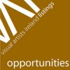

The “7th International Artist’s Book Triennial Vilnius 2015″ organised in order to promote artist’s books all over the world and to make exchanges between artists.

Exhibition theme: “Error” {mistake}

**Deadline: 15th November 2014.**

No Entry Fee.

Main Prize – The personal Artist’s Books Exhibition in Vilnius in 2018 together with the “8th International Artist’s Book Triennial Vilnius 2018″.

Entry form: [http://submit.bookart.lt/entry-form/](http://lists.visualartists.ie/lt.php?c=1166&m=4206&nl=1&s=e97e60e0a85e4e4156f0ad241cfbea58&lid=89204&l=-http--submit.bookart.lt/entry-form/)

Please, fill the Entry Form online and submit picture of your artist’s book by internet, and we will make the Virtual Artist’s Books Exhibition in our web site from all received artist’s books.

More info: [http://artistsbook.lt/blog/2013/09/24/7th-artists-book-triennial-vilnius-2015/](http://lists.visualartists.ie/lt.php?c=1166&m=4206&nl=1&s=e97e60e0a85e4e4156f0ad241cfbea58&lid=89205&l=-http--artistsbook.lt/blog/2013/09/24/7th-artists-book-triennial-vilnius-2015/)

**\_\_\_\_\_\_\_\_\_\_\_\_\_\_\_\_\_\_\_\_\_\_\_\_\_\_\_\_\_\_\_\_\_\_\_\_\_\_\_\_\_\_\_\_\_\_\_\_\_\_\_\_\_\_\_\_\_\_\_\_\_\_\_\_\_\_\_\_\_\_\_\_\_\_\_**

**Creative Nature - Artist Call Out**

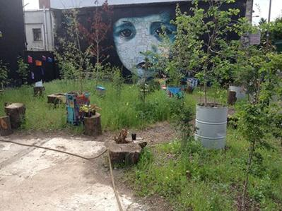  
  
Create Nature is a highly visual city biodiversity & arts garden created for Limerick City of Culture 2014 on the corner of Thomas Street and Anne's street in Limerick city.  
  
The garden acts a centralised platform to showcase artists’ work.  
  
If you are an artist with a project that needs an outside garden space for a show, performance, music event or exhibition opening please contact us.  
  
Contact: Diarmuid  
E: <creative.nature2014@gmail.com>

**\_\_\_\_\_\_\_\_\_\_\_\_\_\_\_\_\_\_\_\_\_\_\_\_\_\_\_\_\_\_\_\_\_\_\_\_\_\_\_\_\_\_\_\_\_\_\_\_\_\_\_\_\_\_\_\_\_\_\_\_\_\_\_\_\_\_\_\_\_\_\_\_\_\_\_**

**One Act Plays: Call for Submissions**

[](http://www.theatreforum.ie/)

RED Wednesday Arts are currently seeking submissions of one act plays for development and production.

Ideally submitted pieces will have a running time of between 50 and 75 minutes and require no more than 3 performers. However, we are open to ideas falling outside of the ideals so long as there is an interesting and engaging story being told.

**Closing date: 20th July 2014**

**More info at** [http://tinyurl.com/maw5lcc](http://tinyurl.com/maw5lcc%20)

**\_\_\_\_\_\_\_\_\_\_\_\_\_\_\_\_\_\_\_\_\_\_\_\_\_\_\_\_\_\_\_\_\_\_\_\_\_\_\_\_\_\_\_\_\_\_\_\_\_\_\_\_\_\_\_\_\_\_\_\_\_\_\_\_\_\_\_\_\_\_\_\_\_\_\_**

**6 Month Residency at Galway Arts Centre | Call for Applications**

galway-arts-centre

Galway Arts Centre, Dominick St., Galway

Galway Arts Centre is now open for submissions from professional visual artists for its six month studio residency. The 4.8m x 5m studio is available from **July 14 2014 – January 14 2015 at €20 per week**. The secure studio is accessible 24 hours a day with internet access, heat & light included in the rental amount.

To apply, please send a CV, artist’s statement & images/ video clips of recent work in one PDF document to [gacsubmissions@gmail.com](mailto:gacsubmissions@gmail.com) by **12 noon on Monday 30th June**. The successful applicant will be informed by email on **2nd July 2014**.

W: [www.galwayartscentre.ie](http://lists.visualartists.ie/lt.php?c=1166&m=4206&nl=1&s=e97e60e0a85e4e4156f0ad241cfbea58&lid=89215&l=-http--www.galwayartscentre.ie)

**\_\_\_\_\_\_\_\_\_\_\_\_\_\_\_\_\_\_\_\_\_\_\_\_\_\_\_\_\_\_\_\_\_\_\_\_\_\_\_\_\_\_\_\_\_\_\_\_\_\_\_\_\_\_\_\_\_\_\_\_\_\_\_\_\_\_\_\_\_\_\_\_\_\_\_**

**IMMA Residency Open Call 2014**

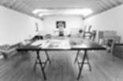

IMMA, Royal Hospital, Military Rd, Kilmainham, Dublin 8

IMMA is delighted to announce that we are opening the online application system to accept proposals for the residency programme on **Monday 30th June at 14.00 GMT/Irish Time**.

We are inviting applications from national and international art practitioners, through which residencies will be awarded for 2015.

The annual open call is an important opportunity for arts professionals to showcase their practice to IMMA.

**The closing date for applications is 30th July 2014 at 14.00 GMT/Irish Time.**

Successful applicants will be notified in Autumn 2014. Please note there is an administration fee of **€10** payable for each application submitted.

Our online system will be accessible through our website at the following address: [www.imma.ie/en/subnav\_13.htm](http://lists.visualartists.ie/lt.php?c=1166&m=4206&nl=1&s=e97e60e0a85e4e4156f0ad241cfbea58&lid=89216&l=-http--www.imma.ie/en/subnav_13.htm)

**\_\_\_\_\_\_\_\_\_\_\_\_\_\_\_\_\_\_\_\_\_\_\_\_\_\_\_\_\_\_\_\_\_\_\_\_\_\_\_\_\_\_\_\_\_\_\_\_\_\_\_\_\_\_\_\_\_\_\_\_\_\_\_\_\_\_\_\_\_\_\_\_\_\_\_**

**Writers' Residency Week**

Tin Jug Studio, Birr, County Offaly

October 2014

Applications are sought for a new Writers' Residency in the Midlands of Ireland. This residency-cum-retreat is in the Georgian heritage town of Birr. The opportunity is for professional writers who are seeking a short break from daily routines; it is for those who feel the need to re-invigorate themselves into completing current work; and it is also for writers who may simply need inspiration, through a change of place and stimuli. [www.tinjugstudio.com](http://www.tinjugstudio.com)

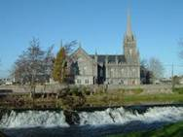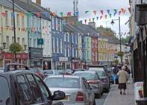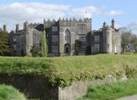

**WHO MAY APPLY?**

The residency bursary is open to professional published writers of any genre such as literary fiction, poetry, playwrights, journalism or travel writing. There are three places available, for newly published or experienced writers from across the 32 counties.

**Note:**

This pilot residency is being sponsored by Offaly County Council's Arts Office.

**FINAL DATE FOR RECEIPT OF APPLICATIONS**

**Closing date is Monday June 30th at 5pm**

Applications are preferred in hard copy (so as to include samples of published work) to

Rosalind Fanning, Saint Brendan Street, Birr, County Offaly.

Applications may also be accepted by email, with appropriate links to published work and inquires are welcome to [info@tinjugstudio.com](mailto:info@tinjugstudio.com)

For more into, please email Sinéad O'Reilly •  Arts Officer, [arts@offalycoco.ie](mailto:arts@offalycoco.ie)

**\_\_\_\_\_\_\_\_\_\_\_\_\_\_\_\_\_\_\_\_\_\_\_\_\_\_\_\_\_\_\_\_\_\_\_\_\_\_\_\_\_\_\_\_\_\_\_\_\_\_\_\_\_\_\_\_\_\_\_\_\_\_\_\_\_\_\_\_\_\_\_\_\_\_\_**

### Retreat House/Residency in the Glens of Antrim

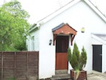

Retreat house/residency opportunity in the Glens of Antrim, north of Ireland. The residency offers a self contained cottage in a beautiful stress free location in the scenic Glens of Antrim. It is a place for artists to think, plan, work, walk, and be inspired. There are limited opportunities to engage with the local community. The venue is operated by an established artist, Raymond Watson. The venue is newly established and is happy to receive ideas from artists as to how the residency can be improved.

To arrange a stay, contact: <raymie.watson@gmail.com>

W: [www.irishartworld.com](http://www.irishartworld.com)

**\_\_\_\_\_\_\_\_\_\_\_\_\_\_\_\_\_\_\_\_\_\_\_\_\_\_\_\_\_\_\_\_\_\_\_\_\_\_\_\_\_\_\_\_\_\_\_\_\_\_\_\_\_\_\_\_\_\_\_\_\_\_\_\_\_\_\_\_\_\_\_\_\_\_\_**

## [RHA SCHOOL: Artists Studios 2015 | Call for Applications](http://visualartists.ie/jobs-ops/studios/rha-school-artists-studios-2015-call-applications/)



The RHA School will award six successful applicants an artist’s studio at a subsidised rent, for six months in 2015.The six months are allocated from January to June, or July to December.

Each studio measures approximately 4.7m x 4.9m and is fully equipped with a sink and storage units. There is also a common room, wifi and kitchen facilities available to the studios. The studios have 24 hour secure access and are non-residential studios.

The subsidised cost of each studio to the awarded artists is **€200 per month**, all heat and utility costs are included in this.

Artists wishing to be considered should apply by completing the application form from the RHA’s website including:

* A current CV
* A covering letter
* Six images of their work
* A list of images submitted

**Applications deadline: Friday 26th September 2014**

Any questions or requests for further information can be forwarded to Fernando Sanchez, Academy Co-ordinator Phone 01 6612558. Email [fernando@rhagallery.ie](mailto:fernando@rhagallery.ie)

W: [www.rhagallery.ie/school/artists-studios-2015](http://www.rhagallery.ie/school/artists-studios-2015/)

**\_\_\_\_\_\_\_\_\_\_\_\_\_\_\_\_\_\_\_\_\_\_\_\_\_\_\_\_\_\_\_\_\_\_\_\_\_\_\_\_\_\_\_\_\_\_\_\_\_\_\_\_\_\_\_\_\_\_\_\_\_\_\_\_\_\_\_\_\_\_\_\_\_\_\_**

### Hong Kong Graphic Art Fiesta 2014 – Call for entries

### hong kong

### W: <http://www.open-printshop.org.hk/GAF2014/>

**\_\_\_\_\_\_\_\_\_\_\_\_\_\_\_\_\_\_\_\_\_\_\_\_\_\_\_\_\_\_\_\_\_\_\_\_\_\_\_\_\_\_\_\_\_\_\_\_\_\_\_\_\_\_\_\_\_\_\_\_\_\_\_\_\_\_\_\_\_\_\_\_\_\_\_**

### 2ha Magazine | Open Call for Submissions

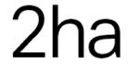

2ha is a magazine interested in the suburbs.

Over the next 12 months, 2ha plans to produce four new editions, on a quarterly basis, in accordance with the following outline of themes and publications:

#07 Suburbia + Cinema  
#08 Suburbia + Modernism  
#09 Suburbia + Sport  
#10 Suburbia + Capital

2ha magazine would like to announce an open call for submissions to its upcoming series of issues. Original submissions on any aspect or interpretation of these themes are welcomed.

More information about 2ha can be found on our website – [www.2ha.ie](http://www.2ha.ie).

Should you have any queries, please get in touch by email at <editor@2ha.ie>.

**\_\_\_\_\_\_\_\_\_\_\_\_\_\_\_\_\_\_\_\_\_\_\_\_\_\_\_\_\_\_\_\_\_\_\_\_\_\_\_\_\_\_\_\_\_\_\_\_\_\_\_\_\_\_\_\_\_\_\_\_\_\_\_\_\_\_\_\_\_\_\_\_\_\_\_**

# V   I   S   U   A   L      A    R   T   S      O   P   E   N     2 0 1 4

# Enniskillen Visual arts Open 2014 - Open call deadline 30.06.14

# cid:image240.jpg@01CF9205.44337AF0

**VENUE:**

The Higher Bridges Gallery,

Clinton Centre, Belmore Street, Enniskillen

Applications are now being sought from artists working in any medium including painting, print, photography, sculpture, installation, video, light, sound, performance and multimedia.

Works will be sited at the Higher Bridges Gallery in Enniskillen, running from the

11 September – 11October 2014.

**Fee: £10.00** per piece of work with a maximum of five pieces permitted per artist.

Applicants should email an expression of interest as well as their Artistic CV & 5 Jpeg images of recent art work to: The Arts Officer for Fermanagh District Council at:

[diane.henshaw@fermanagh.gov.uk](diane.henshaw@fermanagh.gov.uk%20)

**Deadline extended to 4th July 2014 at 12pm**

W: <http://www.fermanagh.gov.uk/news/visual-arts-open-2014.html>

**\_\_\_\_\_\_\_\_\_\_\_\_\_\_\_\_\_\_\_\_\_\_\_\_\_\_\_\_\_\_\_\_\_\_\_\_\_\_\_\_\_\_\_\_\_\_\_\_\_\_\_\_\_\_\_\_\_\_\_\_\_\_\_\_\_\_\_\_\_\_\_\_\_\_\_**

**Calling all secret keepers!**

****  
Tell me something I don't know....  
Tell me a secret…  
  
We are now accepting submissions of secrets to be anonymously included in upcoming issues of 'a secret' magazine! Selected secrets will be anonymously combined with photographs in upcoming issues of the magazine in order to create alternate contexts and interpretations of chosen imagery.  
  
If you have something you want to get off your chest and you’re ok with the possibility of seeing your secret in future issues of a secret then please submit or ask via tumblr (totally anonymous option available).  
  
Go to [http://asecretphoto.tumblr.com/ask](http://l.facebook.com/l.php?u=http%3A%2F%2Fasecretphoto.tumblr.com%2Fask&h=aAQG3QG8O&enc=AZM1ipancs3nR86wuo5HNVyIFcmuF0es1nDDt7nZFvc5wjdsxyS534ogFYCtG-yENFgpxCk4Eh4bhJ_qP0-4_Z_dacAcYUt7NJD_gtK6Jd6LaFXnNRfaJCQ2a60_4T5TKVighxiGJ8oOkDDRWqpM6S6n&s=1) and check the 'ask anonymously' box to submit completely anonymously.   
  
Thank you!

**\_\_\_\_\_\_\_\_\_\_\_\_\_\_\_\_\_\_\_\_\_\_\_\_\_\_\_\_\_\_\_\_\_\_\_\_\_\_\_\_\_\_\_\_\_\_\_\_\_\_\_\_\_\_\_\_\_\_\_\_\_\_\_\_\_\_\_\_\_\_\_\_\_\_\_**

**Art Commission for Ethicon Biosurgery, Limerick**



Ethicon Biosurgery is part of J&J, and has recently opened their Irish plant in Limerick.

To mark the opening of the Irish plant, Ethicon would like to commission a piece of art for the entrance / reception area.

Budget: **The overall value of the commission is €18,000.**

The selection process will take the form of a two-stage competition. It is open to all interested professional artists. Selection will be based on the information supplied, establishing the competence of the artists to carry out the commission.

The closing date for receipt of Stage 1 submissions is **12 noon Friday 11th July 2014.**

[Full details can be downloaded here:](http://lists.visualartists.ie/lt.php?c=1164&m=4204&nl=1&s=d3c261c0eeb6b48867f449d29e09414b&lid=88810&l=-http--visualartists.ie/wp-content/uploads/2014/06/ART_COMMISSION_FOR_ETHICON_BIOSURGERY.pdf)

**\_\_\_\_\_\_\_\_\_\_\_\_\_\_\_\_\_\_\_\_\_\_\_\_\_\_\_\_\_\_\_\_\_\_\_\_\_\_\_\_\_\_\_\_\_\_\_\_\_\_\_\_\_\_\_\_\_\_\_\_\_\_\_\_\_\_\_\_\_\_\_\_\_\_\_**

**Paper Visual Art | Call for Submissions**

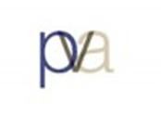

Paper Visual Art (PVA), the journal of contemporary art criticism, is currently seeking submissions.

Under a new editorial team, PVA is seeking reviews of exhibitions (of 700-1200 words), but also longer-form essays and articles on the visual arts. PVA will also consider pieces of creative fiction, personal essays, dialogues, interviews, or other forms of writing that relate in some way to contemporary art themes and issues.

Please see submission guidelines at [http://papervisualart.com/?page\_id=38](http://lists.visualartists.ie/lt.php?c=1170&m=4210&nl=1&s=d3c261c0eeb6b48867f449d29e09414b&lid=89632&l=-http--papervisualart.com/--Q-page_id--E-38) for more details.

**\_\_\_\_\_\_\_\_\_\_\_\_\_\_\_\_\_\_\_\_\_\_\_\_\_\_\_\_\_\_\_\_\_\_\_\_\_\_\_\_\_\_\_\_\_\_\_\_\_\_\_\_\_\_\_\_\_\_\_\_\_\_\_\_\_\_\_\_\_\_\_\_\_\_\_**

**The Poetry Society – Foyle Young Poet of the Year – closing 31/07/14**

The Poetry Society has announced the launch of the Foyle Young Poets of the Year Award 2014, the world’s largest and most prestigious award for young poets aged 11 to 17 years old.

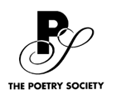

Last year’s competition attracted entries from a staggering 7,478 young people from 75 countries worldwide, making it one of the largest literary competitions in the world.

Any young person writing in English can enter the competition, whether they have been writing for a long time or just started, and the competition is free to enter.

Full details on entering the competition can be found at [www.foyleyoungpoets.org.](http://www.foyleyoungpoets.org./)

**\_\_\_\_\_\_\_\_\_\_\_\_\_\_\_\_\_\_\_\_\_\_\_\_\_\_\_\_\_\_\_\_\_\_\_\_\_\_\_\_\_\_\_\_\_\_\_\_\_\_\_\_\_\_\_\_\_\_\_\_\_\_\_\_\_\_\_\_\_\_\_\_\_\_\_**

### RTE Guide/Penguin Short Story Competition

[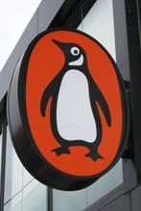](http://www.writing.ie/writing-comps/rte-guidepenguin-short-story-competition/)

The RTE Guide/Penguin Ireland Short Story Competition is now open for entries. Winning stories will be published in the RTE Guide.

Rules: All entries for the 2014 RTÉ Guide/Penguin Ireland Short Story Competition should be original, unpublished and previously not broadcast short stories in English, of 2,000 words or less.

**The closing date is 6pm on Friday, July 11th.** Entries are welcome from anywhere in the world.

Send your entries to:  
RTÉ Guide/Penguin Ireland  
Short Story Competition, PO  
Box 1480, RTÉ, Donnybrook,  
Dublin 4

or you can email to: <rteguide@rte.ie>, making sure to label your entry ‘Short Story Competition’

More info at <http://www.writing.ie/writing-comps/rte-guidepenguin-short-story-competition/>

**\_\_\_\_\_\_\_\_\_\_\_\_\_\_\_\_\_\_\_\_\_\_\_\_\_\_\_\_\_\_\_\_\_\_\_\_\_\_\_\_\_\_\_\_\_\_\_\_\_\_\_\_\_\_\_\_\_\_\_\_\_\_\_\_\_\_\_\_\_\_\_\_\_\_\_**

### Saveas Writers International Writing Competition

[](http://www.writing.ie/writing-comps/saveas-writers-international-writing-competition/)

The Bigger Picture – Reflections on the Great War

This year marks the centenary of the outset of the Great War and entries are invited of short works of poetry or prose written in response to any work of art associated with World War One. “Work of art” in this context can be a painting, a song, a poem, even a film or a soundtrack to a film. The interpretation of the term is entirely up to the entrant.

Closing date: **23rd August 2014**(entries postmarked this date will be accepted)

First Prize **£50** / Second Prize **£30** / Third Prize **£20**

Entry fees: **£2 per poem. £3 per prose piece**Poems: maximum length 50 lines. Prose: maximum length 3,000 words

Find out more about the Saveas Writers Group at their [website here.](http://www.saveaswriters.co.uk/)

More info at [http://tinyurl.com/pm5r66n](http://tinyurl.com/pm5r66n%20)

**\_\_\_\_\_\_\_\_\_\_\_\_\_\_\_\_\_\_\_\_\_\_\_\_\_\_\_\_\_\_\_\_\_\_\_\_\_\_\_\_\_\_\_\_\_\_\_\_\_\_\_\_\_\_\_\_\_\_\_\_\_\_\_\_\_\_\_\_\_\_\_\_\_\_\_**

**Designer Mart, Cow’s Lane | Call for Crafts People**



Designer Mart are seeking crafts people across all art-forms, designers and artists to become part of Temple Bar Cultural Trust’s outdoor design and craft market.

Designer Mart takes place **every Saturday from 10am – 5pm** on Cow’s Lane, located in the Old City area of Temple Bar. There are a variety of pitch sizes available starting at **€130** per month, with a special “start up” offer of three months for the price or two, for a limited period.

Request a Designer Mart application form by email to: <designermart.application@gmail.com>

**\_\_\_\_\_\_\_\_\_\_\_\_\_\_\_\_\_\_\_\_\_\_\_\_\_\_\_\_\_\_\_\_\_\_\_\_\_\_\_\_\_\_\_\_\_\_\_\_\_\_\_\_\_\_\_\_\_\_\_\_\_\_\_\_\_\_\_\_\_\_\_\_\_\_\_**

**Birr Vintage Week & Arts Festival – Open Submission Exhibition | Call for Entries**

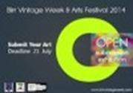

The exhibition is open to artists working in all media and will be selected & launched by Cabrini Lynch – Artist / Curator.

**Deadline for submissions: Monday 21st July.**

Submission of work to: The Maltings, Castle Street, Birr Co Offaly: 11am – 1pm, 2pm – 5pm.

Email: <art.birrvintageweek@gmail.com>

[www.birrvintageweek.com](http://www.birrvintageweek.com)

## \_\_\_\_\_\_\_\_\_\_\_\_\_\_\_\_\_\_\_\_\_\_\_\_\_\_\_\_\_\_\_\_\_\_\_\_\_\_\_\_\_\_\_\_\_\_\_\_\_\_\_\_\_\_\_\_\_\_\_\_\_\_\_\_\_\_\_\_\_\_\_\_\_\_\_

# Féile an Phobail, August – Expression of Interest for Artists/Musicians – closing 30/06/14



Artists are invited to submit expressions of interest for consideration in our August festival in the heart of West Belfast, which runs from **31st July – 10th August**.

Expressions of interest to include:

* Description of type of art work delivery such as performance, mural art, dance, music, etc..
* Short artist biography
* Any other material that may give a better oversight such as a portfolio, media coverage, photographs, testimonials, etc.

If interested please contact: [kevin@feilebelfast.com](kevin@feilebelfast.com%20) Tel: 02890 313440

Artists must be available to works in a community / youth environment within West Belfast anytime.

## \_\_\_\_\_\_\_\_\_\_\_\_\_\_\_\_\_\_\_\_\_\_\_\_\_\_\_\_\_\_\_\_\_\_\_\_\_\_\_\_\_\_\_\_\_\_\_\_\_\_\_\_\_\_\_\_\_\_\_\_\_\_\_\_\_\_\_\_\_\_\_\_\_\_\_

**Oral Testimony Works**

**Everyone has a different view, everyone has a different story**

[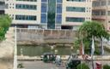](https://oraltestimony.files.wordpress.com/2014/06/view-one-s.jpg)[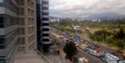](https://oraltestimony.files.wordpress.com/2014/06/view-3-s.jpg)[](https://oraltestimony.files.wordpress.com/2014/06/view-2-s.jpg)

Would you like to take part in a small global film project with Turner prize-winning artist Gillian Wearing and Oral Testimony Works?    
 We are looking for 20 people around the world, who have access to a video camera or can shoot video on their phone, and have a view from a window they want to share. The brief is very simple and will be emailed to everyone who signs up.    
    
To take part email [info@oraltestimony.org](mailto:info@oraltestimony.org) before **30th June** to receive instructions.

More info at <http://oraltestimony.org/blog/>

## \_\_\_\_\_\_\_\_\_\_\_\_\_\_\_\_\_\_\_\_\_\_\_\_\_\_\_\_\_\_\_\_\_\_\_\_\_\_\_\_\_\_\_\_\_\_\_\_\_\_\_\_\_\_\_\_\_\_\_\_\_\_\_\_\_\_\_\_\_\_\_\_\_\_\_

**Gstaad Film Festival 2015 | Seeking Short Art Films**

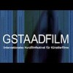

The Gstaad Film Festival, founded in 2004 in Gstaad, Switzerland, is an international film festival for short art films. The juried festival awards excellence in short art filmmaking.

Entry for artists is free, and selected artists will be awarded travel and prize money (exact figures to be confirmed, but these will comply with Visual Artists’ Ireland payment guidelines at the very least). To enter please visit [www.gstaadfilm.com/entry-form.html](http://www.gstaadfilm.com/entry-form.html)

Stay up to date with news at our Facebook page: [www.facebook.com/gstaadfilm](http://www.facebook.com/gstaadfilm)

Any enquiries can be directed to Shane, coordinator, at <shane@wandelbar-art-international.com>

W: [http://tinyurl.com/paskrgk](http://tinyurl.com/paskrgk%20)

**\_\_\_\_\_\_\_\_\_\_\_\_\_\_\_\_\_\_\_\_\_\_\_\_\_\_\_\_\_\_\_\_\_\_\_\_\_\_\_\_\_\_\_\_\_\_\_\_\_\_\_\_\_\_\_\_\_\_\_\_\_\_\_\_\_\_\_\_\_\_\_\_\_\_\_**

**Final Call for Entries & Cinema Expo - 5th Underground Cinema Film Festival**



This is the final call for the 5th Underground Cinema Film Festival.  Entries must be submitted to us by **5pm June 30th**.  You can download an application for UCFF 2014 from or website or if you wish you can even make your submission online. To do this visit [www.ucff.ie](http://underground-cinema.us2.list-manage.com/track/click?u=747d259a2b9a0c2c60289f3b6&id=179082cd32&e=f0ab090790)

[Submit Your Film Online](http://underground-cinema.us2.list-manage.com/track/click?u=747d259a2b9a0c2c60289f3b6&id=953cd9f696&e=f0ab090790)

Underground cinema expo

The Underground Cinema Expo is a chance for film makers to meet face to face some of the country’s leading service providers.

If you are a service provider to the film industry and would like a stand free of charge at this year’s expo, then please send an email to [dave@underground-cinema.com](mailto:dave@underground-cinema.com) expressing your interest.

**\_\_\_\_\_\_\_\_\_\_\_\_\_\_\_\_\_\_\_\_\_\_\_\_\_\_\_\_\_\_\_\_\_\_\_\_\_\_\_\_\_\_\_\_\_\_\_\_\_\_\_\_\_\_\_\_\_\_\_\_\_\_\_\_\_\_\_\_\_\_\_\_\_\_\_**

**Awards / Bursaries / Schemes**

**\_\_\_\_\_\_\_\_\_\_\_\_\_\_\_\_\_\_\_\_\_\_\_\_\_\_\_\_\_\_\_\_\_\_\_\_\_\_\_\_\_\_\_\_\_\_\_\_\_\_\_\_\_\_\_\_\_\_\_\_\_\_\_\_\_\_\_\_\_\_\_\_\_\_\_**

**The Arts Council – Funding**

**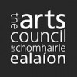**

Visual artists in prisons scheme

Maximum awarded: **€2,400**

This scheme provides financial support to selected visual artists to conduct workshops over a period of 10 days in the education units in any of the Republic’s prisons.

Writers in schools scheme

Maximum awarded: **€304**

The Writers in Schools Scheme part-funds visits by writers and storytellers to schools throughout the Republic of Ireland.

[Writers in prisons scheme](http://www.artscouncil.ie/funds/Writers-in-prisons-scheme/)

Maximum awarded: **€1,000**

The scheme offers writers the opportunity to work with prisoners in prison/detention centres and complements an existing arts and education programme in the Education Units within the prison system.

Beyond Borders

Closing date: **Thursday, 10th July, 2014**

Maximum awarded: **£15, 000**

This opportunity stimulates collaboration between organisations and bands/ensembles in England, Northern lreland, the Republic of Ireland, Scotland and Wales. It enables music creators to produce exceptional new material to be performed in at least three of these countries.

Funding of up to **£15,000** is available for projects that include new commissions, recordings and repeat performances of music written in the past five years.  
  
To apply and for more information please go to <http://miniurl.com/59c34>

More info of the above funding and contact details at <http://miniurl.com/4b062>

**\_\_\_\_\_\_\_\_\_\_\_\_\_\_\_\_\_\_\_\_\_\_\_\_\_\_\_\_\_\_\_\_\_\_\_\_\_\_\_\_\_\_\_\_\_\_\_\_\_\_\_\_\_\_\_\_\_\_\_\_\_\_\_\_\_\_\_\_\_\_\_\_\_\_\_**

**The Arts Council - Awards**

Travel and training award

Closing date: **There are no formal deadlines for the Travel and Training Award.**

Maximum awarded: **€3,000**

The objective of the travel and training outbound award is to support individuals who wish to avail of training and other professional development opportunities abroad (outside the Island of Ireland).

Bursary Awards

Opens Tuesday **17th June**

Deadline: **Thursday, 17th July 2014, 5.30pm**

The following awards are available:

• YPCE Bursary Award - [Young people, children, and education bursary award](http://www.artscouncil.ie/Funds/Young-people,-children,-and-education-bursary-award/)

• Traditional Arts Bursary Award

• Literature Bursary Award (English Language)

• Visual Arts Bursary Award

The Arts Council provides Bursary Awards in order to assist individual artists in the development of their art practice.

View all at <http://www.artscouncil.ie/en/funding_deadlines.aspx>

Project Awards

Opens **29th July**

Deadline: **28th August**

• Music Project Award - Maximum award **€35,000**

• Opera Project Award - Maximum award **€70,000**

• Theatre Project Award - Maximum award **€150,000**

• Visual Arts Project Award - Maximum award **€40,000**

Project award

Please note that the Arts Council will only be running one round of the Project Award in Visual Arts in 2015. This means that the upcoming deadline of **28th August 2014** for the Project Award Round 1 2015 will be the only available award for visual arts projects taking place in 2015.

Read more at [http://www.artscouncil.ie/Funds/Visual-arts-project-award](http://lists.visualartists.ie/lt.php?c=1162&m=4202&nl=1&s=e97e60e0a85e4e4156f0ad241cfbea58&lid=88351&l=-http--www.artscouncil.ie/Funds/Visual-arts-project-award)

**\_\_\_\_\_\_\_\_\_\_\_\_\_\_\_\_\_\_\_\_\_\_\_\_\_\_\_\_\_\_\_\_\_\_\_\_\_\_\_\_\_\_\_\_\_\_\_\_\_\_\_\_\_\_\_\_\_\_\_\_\_\_\_\_\_\_\_\_\_\_\_\_\_\_\_**

|  |  |  |  |
| --- | --- | --- | --- |
| **Reality Bites**   |  | | --- | |  | | **cid:image176.jpg@01CF91F3.BDFFC490** |   Reality Bites is a scheme to enable the making of short documentaries.  The scheme aims to encourage experimentation and the realisation of fresh approaches to non-fiction filmmaking.  Closing date: **Tuesday, July 1st,2014**  Budget per film: **Maximum €15, 000**  More info and application details at <http://miniurl.com/cf2c6> |  |

**\_\_\_\_\_\_\_\_\_\_\_\_\_\_\_\_\_\_\_\_\_\_\_\_\_\_\_\_\_\_\_\_\_\_\_\_\_\_\_\_\_\_\_\_\_\_\_\_\_\_\_\_\_\_\_\_\_\_\_\_\_\_\_\_\_\_\_\_\_\_\_\_\_\_\_**

**Fundit.ie Update**

**[cid:image177.gif@01CF91F3.BDFFC490](http://fundit.ie/)**  
   
[Fund it](http://cts.vresp.com/c/?BusinesstoArts/a038446613/608128ad7e/e285aeb424) has provided a platform for 633 projects across the creative industries to be funded by their fans, followers, families and friends.  
   
46,000 people from all over the world have pledged money to Irish creative ideas and €2.3m has been paid out to successful projects. It’s worth considering if Fund it should be part of your broad funding landscape.

**\_\_\_\_\_\_\_\_\_\_\_\_\_\_\_\_\_\_\_\_\_\_\_\_\_\_\_\_\_\_\_\_\_\_\_\_\_\_\_\_\_\_\_\_\_\_\_\_\_\_\_\_\_\_\_\_\_\_\_\_\_\_\_\_\_\_\_\_\_\_\_\_\_\_\_**

# 

|  |
| --- |
| **Calling** |

# Calling Young Musicians - £5,000 NI Young Musicians' Platform Awards

# [https://encrypted-tbn2.gstatic.com/images?q=tbn:ANd9GcQ0RZApAPviF7PbckGp7zk3Ol0cZ8zfu0e9Po9tWtR_KxDO9Nkc5loNGMw](http://www.google.ie/url?url=http://en.wikipedia.org/wiki/File:Arts_Council_of_Northern_Ireland.PNG&rct=j&frm=1&q=&esrc=s&sa=U&ei=oA-kU-v1GcTb7Abkw4HQDQ&ved=0CBgQ9QEwAg&sig2=McDDFJUO3ySoCRMRvAYy-Q&usg=AFQjCNHt8-MpAIM3y3ow5x-mPvLCdSbyvA)

The Arts Council of Northern Ireland in collaboration with BBC Northern Ireland is calling for applications for the Northern Ireland Young Musicians's Platform Award. Five awards, worth **£5,000 each**, plus professional mentoring and performing opportunities, are available to raise the skills and profile of exceptional, talented young musicians.

**Who can apply?**

Individual classical, jazz and traditional musicians who reside in or originate from Northern Ireland.

Instrumentalists aged 18 to 26 years and singers aged 18 to 29 years may apply.

**Applications open Friday 20th June** **& close Thursday 2nd October 2014.**

Download the programme [Guidance Notes and Application Form.](https://s5.newzapp.co.uk/t/gtl_pg.aspx?LID=ODgzMTUxNyw1MzgwMDc1MDQsMTQ=)

Click here for the [News Release](https://s5.newzapp.co.uk/t/gtl_pg.aspx?LID=ODgzMTUxOCw1MzgwMDc1MDQsMTQ=)

# Or phone the Arts Council on Tel: 028 9038 5200.

|  |  |
| --- | --- |
|  |  |

**\_\_\_\_\_\_\_\_\_\_\_\_\_\_\_\_\_\_\_\_\_\_\_\_\_\_\_\_\_\_\_\_\_\_\_\_\_\_\_\_\_\_\_\_\_\_\_\_\_\_\_\_\_\_\_\_\_\_\_\_\_\_\_\_\_\_\_\_\_\_\_\_\_\_\_**

# Limerick Ar****ts Office Offering Two Bursaries for Tyrone Guthrie Centre****

****

Limerick Arts Office is offering 2 bursaries for the Tyrone Guthrie Centre. Each Bursary covers all board and lodging expenses for a week. The Tyrone Guthrie Centre at Annaghmakerrig is a residential workplace for artists, dedicated to supporting and facilitating creativity within a welcoming and trusted environment.

[Download your application form here.](http://lists.visualartists.ie/lt.php?c=1162&m=4202&nl=1&s=e97e60e0a85e4e4156f0ad241cfbea58&lid=88365&l=-http--visualartists.ie/wp-content/uploads/2014/06/Tyrone_Guthrie_Limerick_CoCo.pdf)

CLOSING DATE FOR APPLICATIONS: **No later than 5PM FRIDAY 4th JULY**

# All applications to Limerick Arts Office must be submitted electronically to [artsoffice@limerick.ie](mailto:artsoffice@limerick.ie) and marked clearly as ‘TGB 14’ \_\_\_\_\_\_\_\_\_\_\_\_\_\_\_\_\_\_\_\_\_\_\_\_\_\_\_\_\_\_\_\_\_\_\_\_\_\_\_\_\_\_\_\_\_\_\_\_\_\_\_\_\_\_\_\_\_\_\_\_\_\_\_\_\_\_\_\_\_\_\_\_\_\_\_

# Art Universe – Scholarship Opportunities – International Physical Theatre Laboratory 2014, 4 Week Creative Lab

**[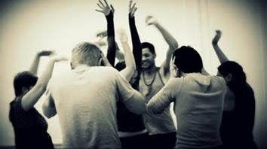](https://picasaweb.google.com/globtheatre)**

**“ArtUniverse” in partnership with the International University ”Global Theatre Experience” (IUGTE)** have announced several partial scholarships for professional dancers, choreographers, actors and circus performers.

International Physical Theatre Laboratory 2014

Project Dates and Location:

**July 7-12** – Styria, Austria [View Post](http://comartspartner.org/news/opportunities/art-universe-scholarship-opportunities-international-physical-theatre-laboratory-2014/)  
Each scholarship grant covers up to **€400** (four hundred) of the total participation fee.

**December 15-22** – Tuscany, Italy  
Each scholarship grant covers up to **€300.00** (three hundred) of the total participation fee.

The scholarship application should be submitted to <iugte.projects@gmail.com>

More info at <http://www.artuniverse.org/news>

# \_\_\_\_\_\_\_\_\_\_\_\_\_\_\_\_\_\_\_\_\_\_\_\_\_\_\_\_\_\_\_\_\_\_\_\_\_\_\_\_\_\_\_\_\_\_\_\_\_\_\_\_\_\_\_\_\_\_\_\_\_\_\_\_\_\_\_\_\_\_\_\_\_\_\_

**Reminder: 2014 DCC / VAI Critical Art Writing Award**

**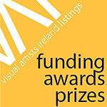**

DCC / VAI Critical Art Writing Award was launched in 2012 and is a developmental opportunity for writers.

For the 2014 DCC / VAI Critical Art Writing Award, art writers are invited to consider the significance of cities as contexts for festival-type visual arts programming. Writers are asked to propose an abstract that considers issues around ‘festivalisation’ – nationally and internationally – with an emphasis on Dublin as a context in terms of history, current events and / or future potential.

**Application closing date: 5pm, Friday 4th July 2014**

Applications should be addressed to: [jason@visualartists.ie](mailto:jason@visualartists.ie)

Late applications will not be accepted; applicants will receive confirmation of receipt.

The DCC / VAI Critical Art Writing Award is supported by Dublin City Council Arts Office, The LAB and VAI’s Professional Development training programmes.

Read more at <http://tinyurl.com/l535p4j>

**\_\_\_\_\_\_\_\_\_\_\_\_\_\_\_\_\_\_\_\_\_\_\_\_\_\_\_\_\_\_\_\_\_\_\_\_\_\_\_\_\_\_\_\_\_\_\_\_\_\_\_\_\_\_\_\_\_\_\_\_\_\_\_\_\_\_\_\_\_\_\_\_\_\_\_**

# Bord Gáis Energy Irish Book Awards - Writing.ie Short Story of the Year



Last year we were delighted to welcome a new category in the Bord Gáis Energy Irish Book Awards – a much anticipated recognition of a form that Irish writers excel at – the **Writing.ie Short Story of the Year Award.**

Full Terms and Conditions can be found [**here**.](http://www.writing.ie/the-writing-ie-short-story-of-the-year-award-terms-conditions/)

**Submissions for the 2014 award are now being accepted. To submit a story, please click** [here.](http://www.writing.ie/the-writing-ie-short-story-of-the-year-award-entry-form/)

**\_\_\_\_\_\_\_\_\_\_\_\_\_\_\_\_\_\_\_\_\_\_\_\_\_\_\_\_\_\_\_\_\_\_\_\_\_\_\_\_\_\_\_\_\_\_\_\_\_\_\_\_\_\_\_\_\_\_\_\_\_\_\_\_\_\_\_\_\_\_\_\_\_\_\_**

**Of Interest**

# \_\_\_\_\_\_\_\_\_\_\_\_\_\_\_\_\_\_\_\_\_\_\_\_\_\_\_\_\_\_\_\_\_\_\_\_\_\_\_\_\_\_\_\_\_\_\_\_\_\_\_\_\_\_\_\_\_\_\_\_\_\_\_\_\_\_\_\_\_\_\_\_\_\_\_

**Kilkenny Arts Festival**

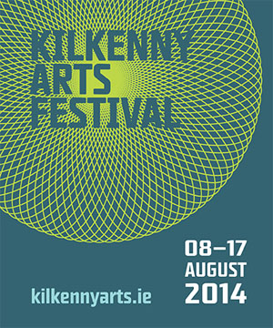

A world of magic in Ireland's medieval city awaits as the 2014 Kilkenny Arts Festival takes place from **8-17th August** this year.  
  
For our full festival programme, take a look online at <http://kilkennyarts.ie>. Find us also on Facebook or follow @kilkennyarts on Twitter using the #kaf2014 hashtag.

**View video at** <https://www.youtube.com/watch?v=aLOFFtzrDzE>

# \_\_\_\_\_\_\_\_\_\_\_\_\_\_\_\_\_\_\_\_\_\_\_\_\_\_\_\_\_\_\_\_\_\_\_\_\_\_\_\_\_\_\_\_\_\_\_\_\_\_\_\_\_\_\_\_\_\_\_\_\_\_\_\_\_\_\_\_\_\_\_\_\_\_\_

**Michelle Boyle To Represent Ireland at the 2014 UNESCO Edition of Art Camp**



UNESCO ‘Colours of the Planet’ Art Camp Biennial 2014 4th Edition:  
**July 12th-24th 2014 Ordino**Principality of Andorra.

Michelle Boyle has been selected by The National Commission and Permanent Delegation (Ireland) and The Andorran National Commission for UNESCO to represent Ireland at the 2014 UNESCO Edition of Art Camp which will broadly address the strategic issue of Cultural Diversity and Peace.

Thirty three nominated artists from around the world will gather to promote dialogue and understanding in this unique project promoting multicultural diversity and intercultural dialogue through art.

[www.artcampcolorsplaneta.blogspot.ie](http://lists.visualartists.ie/lt.php?c=1166&m=4206&nl=1&s=e97e60e0a85e4e4156f0ad241cfbea58&lid=89184&l=-http--www.artcampcolorsplaneta.blogspot.ie)

[www.michelleboyle-artist.com](http://lists.visualartists.ie/lt.php?c=1166&m=4206&nl=1&s=e97e60e0a85e4e4156f0ad241cfbea58&lid=89185&l=-http--www.michelleboyle-artist.com)

# \_\_\_\_\_\_\_\_\_\_\_\_\_\_\_\_\_\_\_\_\_\_\_\_\_\_\_\_\_\_\_\_\_\_\_\_\_\_\_\_\_\_\_\_\_\_\_\_\_\_\_\_\_\_\_\_\_\_\_\_\_\_\_\_\_\_\_\_\_\_\_\_\_\_\_

**Frank Abruzzese at Wexford Arts Centre**

*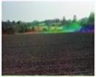*

Live Load**14 June – 12 July 2014**Wexford Arts Centre, Cornmarket, Co. Wexford

**Artist Talk: Frank Abruzzese will present a talk on his current exhibition on** **Saturday 28th June at 2pm**.

Wexford Arts Centre is delighted to announce the launch of Live Load, an exhibition of photographic work by contemporary artist Frank Abruzzese.

Abruzzese’s work is process driven, and seeks to demonstrate photography’s power to reveal as much as it hides. His work is informed by interests in engineering and problem solving, new technologies, science fiction, landmarks, traces and monuments.

W: [www.wexfordartscentre.ie](http://lists.visualartists.ie/lt.php?c=1167&m=4207&nl=1&s=d3c261c0eeb6b48867f449d29e09414b&lid=89385&l=-http--www.wexfordartscentre.ie)

# \_\_\_\_\_\_\_\_\_\_\_\_\_\_\_\_\_\_\_\_\_\_\_\_\_\_\_\_\_\_\_\_\_\_\_\_\_\_\_\_\_\_\_\_\_\_\_\_\_\_\_\_\_\_\_\_\_\_\_\_\_\_\_\_\_\_\_\_\_\_\_\_\_\_\_

**Blaise Smith ARHA – ‘ELEVATION’  - June 5th – July 3rd 2014**

**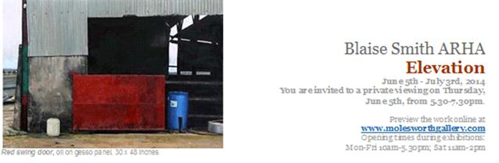**

# \_\_\_\_\_\_\_\_\_\_\_\_\_\_\_\_\_\_\_\_\_\_\_\_\_\_\_\_\_\_\_\_\_\_\_\_\_\_\_\_\_\_\_\_\_\_\_\_\_\_\_\_\_\_\_\_\_\_\_\_\_\_\_\_\_\_\_\_\_\_\_\_\_\_\_

|  |
| --- |
| **Prepare for IMPACT**  [http://www.audiencesni.com/download/images/impact-final%20web%20page%20resized.jpg](http://www.audiencesni.com/IMPACT-2014) |
|  |
|  |
|  |
| Audiences NI and UTV are joining forces to host a press and media day for the arts sector on **25th June** at UTV studios in Belfast. |
|  |
| 'Impact' will bring Audiences NI members together with leaders in local and international print, broadcast and digital media and will explore the changing landscape of the press from traditional print to digital copy and how the arts and cultural sector can engage effectively with the media in Northern Ireland and beyond. |
| |  | | --- | |  |  |  |  | | --- | --- | | [Register](https://s5.newzapp.co.uk/t/gtl_pg.aspx?LID=ODgyMjQ1NSw1MzY5MTA2NjksMTQ=) |  | |

**\_\_\_\_\_\_\_\_\_\_\_\_\_\_\_\_\_\_\_\_\_\_\_\_\_\_\_\_\_\_\_\_\_\_\_\_\_\_\_\_\_\_\_\_\_\_\_\_\_\_\_\_\_\_\_\_\_\_\_\_\_\_\_\_\_\_\_\_\_\_\_\_\_\_\_**

**Wildlife Photographer of the Year Exhibition at The chq Building, IFSC**



**27th June – 31st August**Venue: The chq Building, IFSC, Dublin Docklands  
Opening hours: **Mon-Fri 10am-6.30pm, Sat: 10am-6pm, Sun: noon-6pm**  
Admission: **Adult €6.50 / Concessions €5.50 / Child €3.50** / Discounted family tickets available.

The world-renowned exhibition, on loan from the Natural History Museum in London, will open at The chq Building on **27th June 2014** featuring 100 awe-inspiring images, from fascinating animal behaviour to breathtaking wild landscapes. The exhibition will be on display until **31st August 2014**.

Irish photographer Peter Delaney, originally from Wicklow, is a runner-up finalist in this year’s exhibition with his image “Showdown.

The exhibition at The chq Building in Dublin Docklands forms part of a global tour.

W: [www.wpy.ie](http://lists.visualartists.ie/lt.php?c=1167&m=4207&nl=1&s=d3c261c0eeb6b48867f449d29e09414b&lid=89389&l=-http--www.wpy.ie)

**\_\_\_\_\_\_\_\_\_\_\_\_\_\_\_\_\_\_\_\_\_\_\_\_\_\_\_\_\_\_\_\_\_\_\_\_\_\_\_\_\_\_\_\_\_\_\_\_\_\_\_\_\_\_\_\_\_\_\_\_\_\_\_\_\_\_\_\_\_\_\_\_\_\_\_**

**Tax and Self Employment for Artists**

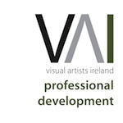

Are you a self-employed artist? Do you work part time as an employee and as an artist for the rest of the time? Are you practicing as an artist but also unemployed?

Our newly updated article on [Tax and Self Employment](http://lists.visualartists.ie/lt.php?c=1170&m=4210&nl=1&s=d3c261c0eeb6b48867f449d29e09414b&lid=89621&l=-http--visualartists.ie/the-manual-a-survival-guide-for-visual-artists/the-financial-side/tax-and-self-employment/) guides you through all you need to know with regard to your personal financial responsibilities and obligations to Revenue… from keeping good books and records to filing your tax returns. The article covers: Recording Income & Expenses, Allowable & Disallowable Expenses, sample accounts, Tax bands and Tax credits, PRSI and Social Insurance Benefits, the Universal Social Charge, Filing Your Tax Return, Preliminary Tax, Voluntary Contributions, The Artists Tax Exemption, Apportioning Income and Awards and Grants.

[Tax and Self-Employment for Artists](http://lists.visualartists.ie/lt.php?c=1170&m=4210&nl=1&s=d3c261c0eeb6b48867f449d29e09414b&lid=89621&l=-http--visualartists.ie/the-manual-a-survival-guide-for-visual-artists/the-financial-side/tax-and-self-employment/) is part of [The Manual – Survival Guide for Visual Artists](http://lists.visualartists.ie/lt.php?c=1170&m=4210&nl=1&s=d3c261c0eeb6b48867f449d29e09414b&lid=89622&l=-http--visualartists.ie/the-manual-a-survival-guide-for-visual-artists/) providing information on all aspects of professional development.

**\*\*\*\*\*\*\*\*\*\*\*\*\*\*\*\*\*\*\*\*\*\*\*\*\*\*\*\*\*\*\*\*\*\*\*\*\*\*\*\*\*\*\*\*\*\*\*\*\*\*\*\*\*\*\*\*\*\*\*\*\*\*\*\*\*\*\*\*\*\*\*\*\*\*\***